Slide 1

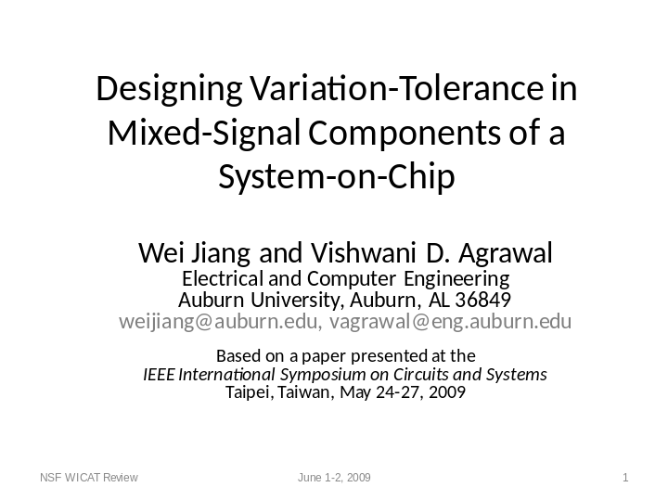

In this research, we develop a design for testability method that is tolerant to process-variation. It is relevant to nanoscale technologies whose large process variation can significantly affect the linearity of on-chip mixed-signal components. We describe a post-fabrication off-line technique in which built-in test circuitry measures the device nonlinearity errors and stores the correction parameters, to be used for performance correction during run time.

Slide 2

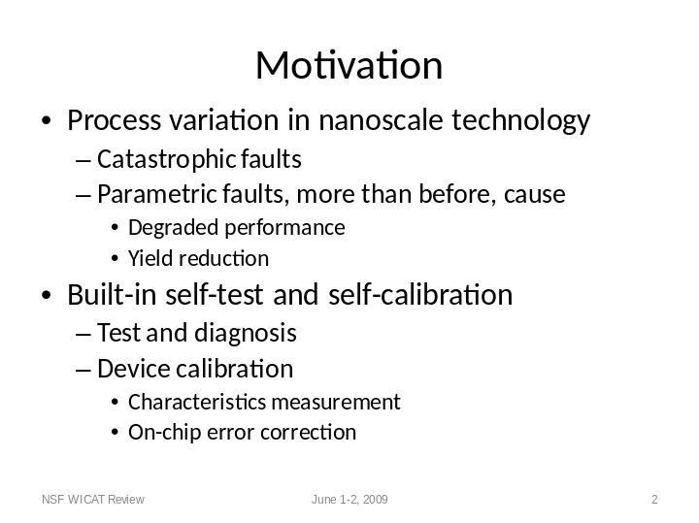

Submicron MOS technologies have features that are smaller than 90 nanometers. Some of the so-called nanometer technologies will soon have features of 32, or even 22, nanometer dimensions. The parameter variation in these technologies is higher than before. It can be 20 to 40%. All semiconductor devices are affected by process defects. In the past many defects were characterized by catastrophic faults that rendered the device unusable. With increased process variations, the device yield will be very low unless some sort of correction can be provided. The focus of this paper is to provide a built-in test and self-calibration capability through design. In an off-line test, the test circuitry will measure the performance errors and save correction parameters. The device will be rejected as failed device only if the errors were beyond the capability of the correction circuitry. For correctable devices during the run time, the stored parameters will be used by the built-in correction circuitry to provide correct operation. The added hardware may include:

1. Measurement circuit.
2. Storage for saving correction parameters.
3. Correction circuit.

Slide 3

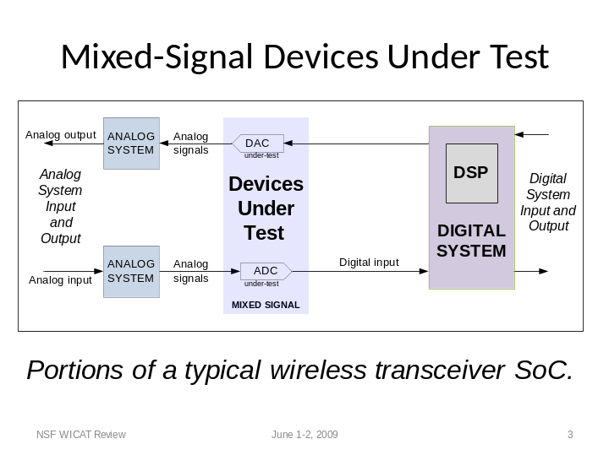

Our target components under test are digital-to-analog converter (DAC) and analog-to-digital converter (ADC). These are found in many mixed-signal applications typically implemented on system-on-chip (SoC). A part of a wireless transceiver is shown here. The DAC and ADC provide interfaces between analog and digital subsystems. This is important, because we will use the digital signal processor (DSP), which is already on the chip, for analyzing the measurement data and finding the correction parameters, as well as for managing the self-test. We assume that the DSP has been tested either by built-in self-test or by an external test; such test techniques for digital circuits are well-known.

Slide 4

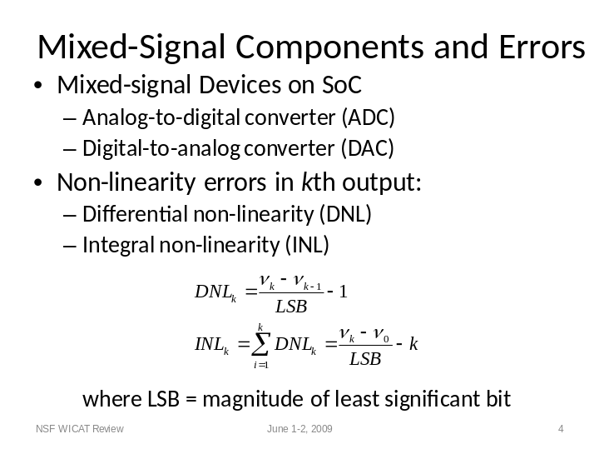

Given that our targets are the ADC and DAC on the SoC, the most common correctable errors caused by process variation in these are the linearity errors. Here, we will discuss the test of DAC. More details of DAC as well as those of ADC can be found in the paper in the ISCAS’09 proceedings. A DAC converts a digital binary code to its analog magnitude. For example, a four-bit DAC will have four-bit inputs, 0000, 0001, 0010 all the way to 1111. The number of input codes is 16, or 2 raised to the power the number of DAC input bits, which is 4 here. Correspondingly, the DAC will produce analog output voltages 0, x, 2x, all the way to 15x. Here the magnitude x is known as the least significant bit or LSB. In practice, the analog outputs of a DAC may not be exactly 0, x, 2x, etc. The code errors for each code indexed as k are characterized as shown here. For example, for a four-bit code, k will range from 0 to 15. The errors are expressed as differential nonlinearity error, or DNL, and integral nonlinearity error, or INL. Our objective in this work is to characterize the INL error for the entire set of input codes and reduce them, if possible, to less than ±0.5 LSB.

Slide 5

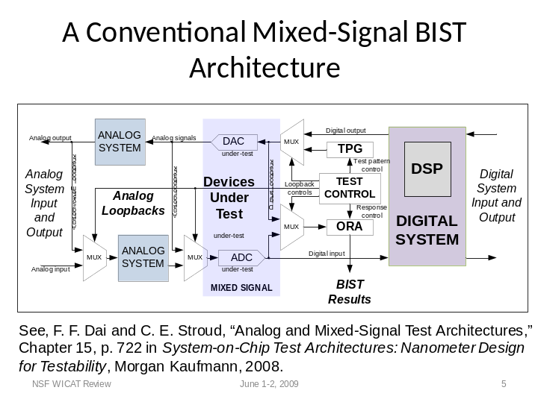

This shows a typical mixed-signal built-in self-test (BIST) architecture. The added BIST components include a test pattern generator (TPG), an output response analyzer (ORA) and a test controller, which controls the MUXes, also added for test, for making three loopbacks to test all parts of the system. Details of this scheme can be found in the cited reference. This is basically a go/no-go test. The main innovations in our work are:

1. A digital signal processor (DSP), assumed to be present on the SOC, will be used as controller of the test circuitry. This DSP is also assumed to have been tested and found to be fault-free. Typically, that can be accomplished either by a built-in self test of digital circuitry or by an external digital test. Both techniques are well known.
2. We will add built-in circuitry for off-line measurement of integral nonlinearity error (INL). The INL error will be analyzed by the DSP to extract correction parameters as polynomial coefficients.
3. The polynomial coefficients will be stored in an added register.
4. On-line correction circuitry will use the saved polynomial coefficients to add corrections to the DAC output.
5. The device will be called faulty by the off-line measurement only if the INL error magnitude exceeds certain limit that is correctable by the provided hardware.

Slide 6

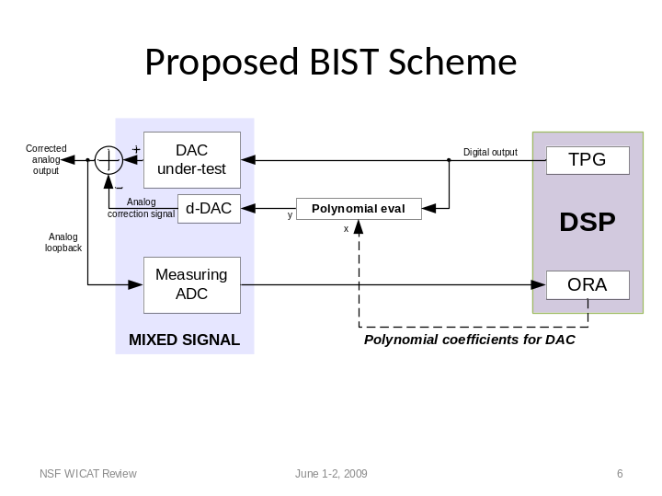

This is the proposed design for DAC test and calibration. The test is conducted off-line. It may be done when the SOC is manufactured and repeated during system maintenance throughout the lifetime of the device. The basic features are as follows:

1. The DSP provides the test pattern generation (TPG) capability. It successively generates all input codes for the DAC.
2. The DAC outputs, which are analog voltages, are converted into digital form by a measuring ADC. These are then analyzed by an output response analyzer (ORA) implemented within the DSP. If the error is correctable, a polynomial is fitted to the error. Otherwise, the circuit fails.
3. The polynomial coefficients are stored in an added hardware register and evaluator shown as “polynomial eval” block in the center of the diagram. This completes the off-line test and calibration.
4. During the operation of the circuit, the polynomial evaluator takes the normal input code of the DAC and with the help of a dithering-DAC generates correction to the DAC output.
This procedure is explained next.

Slide 7

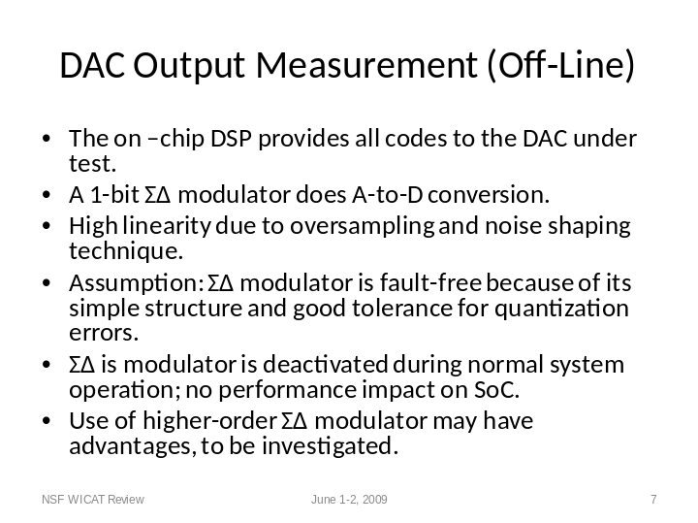

The measuring ADC consists of a sigma-delta modulator and a digital filter. The sigma-delta modulator employs oversampling and noise-shaping techniques. It can achieve high linearity with sufficient oversampling ratio (OSR). We do this measurement only in the off-line test stage. The sigma-delta modulator is assumed to be fault-free. This assumption may be justified because its structure is simple and only 1-bit comparator and converter are used. However, our future research will address the testing of this block. A noise-shaping technique moves the quantization error to higher band and thereafter allows its removal by a low-pass filter. The measuring ADC is only used for the off-line test procedure. It measures the DAC under test outputs for the DSP-generated test codes and supplies them back to the DSP, which computes INL error for each code. The results are then analyzed by a polynomial fitting algorithm in the DSP. The first-order sigma-delta modulator and high sampling rate may increase the measurement time. To reduce this time, a higher-order sigma-delta modulator could be used. However, that will bring its own non-linearity error in the measurement. Such non-linearity error cannot be separated from the INL error of DAC-under-test and thus accuracy of the final result would be affected.

Slide 8

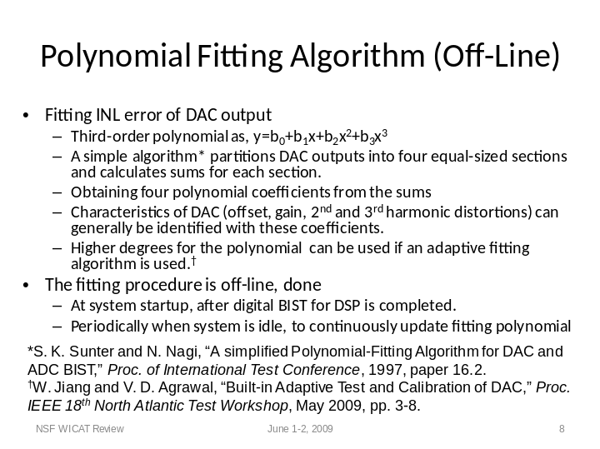

A simple way to remove INL errors from the DAC output is to store INL errors for all input digital codes. For a high-resolution DAC this will need massive data storage which is impractical for an SoC. So a fitted polynomial function is used to replace actual INL errors. For example, for a 14-bit DAC, only four polynomial coefficients may be stored instead of several thousand values. We use a third-order polynomial interpolation algorithm proposed by Sunter and Nagi at ITC’97*. This algorithm, which determines four coefficients for a third-order polynomial, also identifies unfixable faulty DAC units. The objective of the polynomial fitting is to reduce the maximum INL to within 0.5 LSB. A calibrated DAC can be considered as fault-free if no INL exceeds 0.5 LSB. Sometimes a higher order polynomial (greater than degree 3) may have to be used. In our ongoing research, we have developed an adaptive fitting algorithm that makes a tradeoff between fitting quality and the calibration hardware overhead.

Slide 9

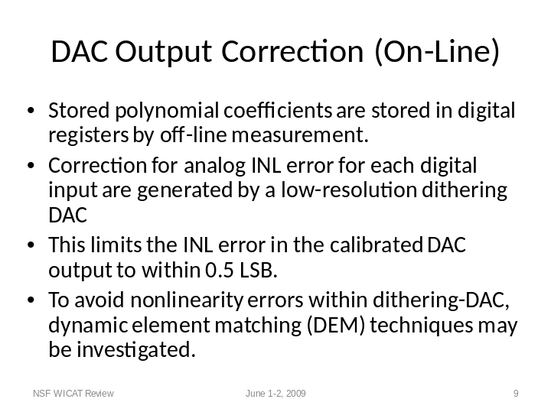

A dithering DAC is used to correct the non-linearity errors at DAC output. Using a low-resolution dithering DAC, calibration data is generated for each code using the stored polynomial coefficients. The dithering DAC is of low-resolution and low-cost and contains sufficient storage for polynomial coefficients. The INL error of the corrected DAC output must be less than 0.5 LSB. The analog output range of the dithering DAC is maximum allowable INL error at the output of the on-chip DAC-under-test. This range is pre-defined. If better performance and more linear output is required, then a dynamic element matching technique could be employed to remove some non-linearity errors of dithering DAC itself. But this requires more hardware, adding to the test overhead.

Slide 10

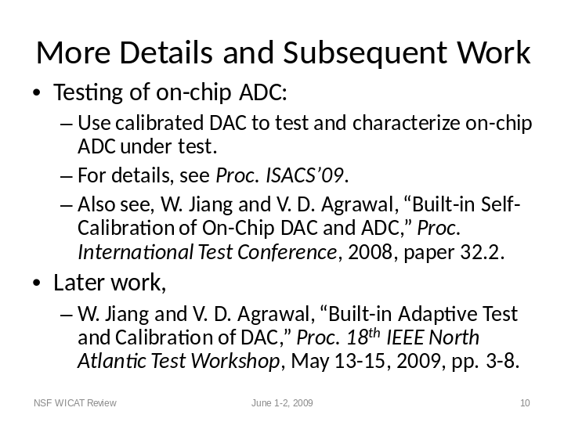

More details of the work presented, including ADC calibration, can be found in the ISCAS’09 proceedings. Some details of this self-test and calibration technique were first reported in another recent paper presented at the International Test Conference in October 2008.
The degree of error fitting polynomial can be made adaptive for improved error tolerance. See, a recent paper presented by the authors at the 18th IEEE North Atlantic Test Workshop as referenced here.

Slide 11

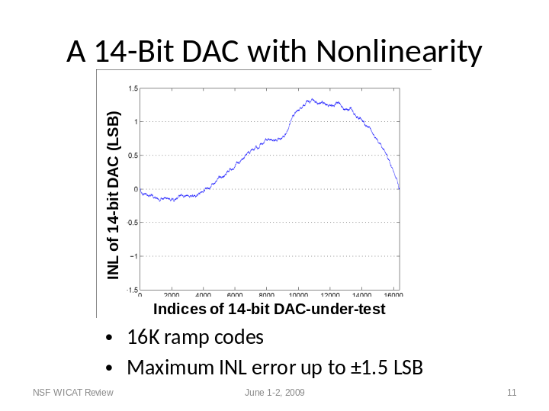

Next, we show a Matlab simulation result. We consider an on-chip 14-bit DAC under test. This shows the simulated error introduced in the DAC output. The x-axis gives an index that corresponds to the decimal integer value of the input code. The y-axis is the INL error that is within ±1.5 LSB. The error here was obtained as a specified Matlab function. This is purely arbitrary and any other function could have been used. The important thing to note is that the maximum INL error is kept within ±1.5 LSB, which was the correctable range in our example. This range is a design parameter for the test and calibration hardware, as explained in the paper.

Slide 12

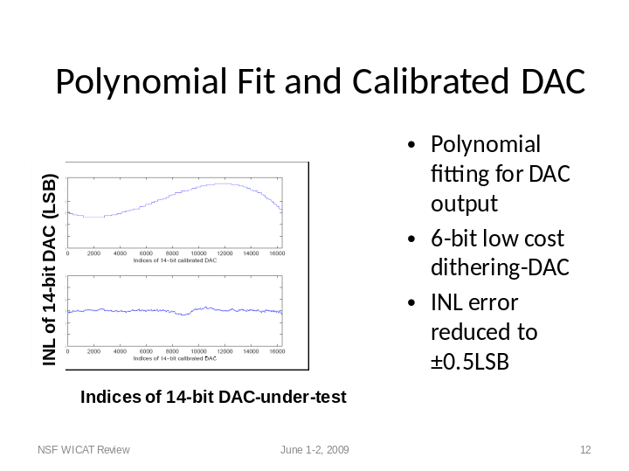

Best-fit polynomial coefficients were obtained for the previously shown INL error. The top graph here shows the corresponding polynomial. The lower graph shows the INL error of the DAC when the polynomial coefficients were used by a 6-bit dithering DAC for error correction.
In this case, the INL error in the corrected output is less than ±0.5 LSB. However, not all shapes of INL error can be corrected by a third-degree polynomial. In general, a higher degree polynomial may be needed, as demonstrated by our later work.

Slide 13

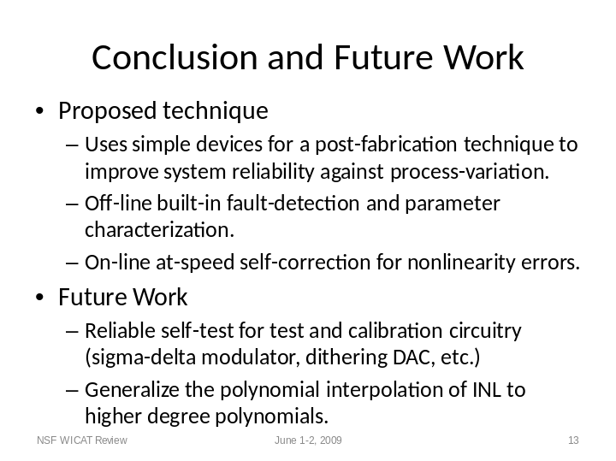

This poster illustrates a built-in test and calibration technique. With process-variation increase, as is expected for nanoscale technologies, such methods will become essential. Our research leads to several conclusions:

1. The polynomial interpolation of error and correction is a practical method. However, the degree of the polynomial should not be fixed but should be determined for the actual errors present in the device.
2. Assumptions made about the correctness and linearity of test circuitry should be examined and justified.
3. Either a self test or an external test for the test circuitry is required.

Slide 14



