Duluth YPAC Project Design Design

by Derrf Seitz (for COMP6626 Project)

Abstract 3
Keywords 3
Introduction 4
Vocabulary 5
User Interviews 7
Original System 7
Strategic Goals 8
Entity Model 9
User Model 11
User Profiles 12
Design Decisions 13
User Actions 14
Usage Scenarios 16
Visitor Views a Topic 16
Club Member Views a Previous Event 16
Director Creates an Event 16
Teacher Sends a Message to her Class 16
Navigation Maps 18
Multiple Sites 18
Pathfinders Visitor Home 20
Common Links 21
Pathfinders Club Member Home 22
Topic Areas Menu 23
Calendar 24
Club Member 25
Class 26
Club Administration Home 27
Administration Manage X 28
Page Mockups 29
Youth Ministries Home Page 29
Pathfinders Visitor Home 30
Pathfinders Club Member Home 31
Pathfinders Knots 32
Pathfinders Calendar 33
Pathfinders Event 34
Pathfinders Club Member (View Mode) 35
Pathfinders Class 36
Adventurers Visitor Home 37
Club Administration Home 38
Implementation Constraints 39
Futures 39
References 40

Abstract
YPAC is a mnemonic that stands for Youth, Pathfinders, Adventurers, and Camp. YPAC is an umbrella term that encompasses a suite of closely related Christian youth organizations. This document presents a requirements analysis and user interaction design for a new club web site for a local Pathfinders club. The design is intentionally generic in order to create design patterns and components that can be reused to build other YPAC-related clubs. Besides the Adventurers and Pathfinders clubs, YPAC also includes the Teen Leadership Training and Master Guide organizations.

Keywords
- Adventurers
- Christian youth club
- Dynamic calendar
- Entity management
- Master Guide
- Pathfinders
- Teen Leadership Training
- Web site design
- YPAC

Introduction
Pathfinders is a Christian young people's organization for youth in school grades 5 to 10, with local clubs spanning the globe. It integrates boys and girls of all nationalities with a consistent, structured, and fun environment designed to promote their mental, emotional, social, and spiritual development. Activities include camping, arts and crafts, community service, recreation, and leadership training. The youth progress by earning "honors", which are achieved by completing a wide variety of in-depth, hands-on modules.

Teen Leadership Training (TLT) is a closely related organization for grades 9 to 12. TLT clubs focus on developing leadership skills.

Master Guide is another closely related organization targeted toward older teens and adults. The Master Guides curriculum is an advanced training program that is both broad and in-depth. It typically takes two to three years to complete the program requirements. Master Guides often become Pathfinder, TLT, or Adventurer club directors.

Adventurers is another closely related organization for children in school grades 1 to 4. It follows the same growth strategies as Pathfinders, except tailored for this younger age bracket. One key differentiator between the clubs is that the parents are intimately involved in the Adventurers club, whereas, in the Pathfinders club, the older youth enjoy more independence and social interaction. For the Adventurers, the parents partner with their children during the class periods by helping them do the crafts and activities. Periodically, special topic sessions are held for the parents to help them learn better parenting skills.

The local Pathfinders club's current (original) web site that is very rudimentary, offering only basic club information. The Adventurers club has a single, almost empty, page that is linked to from the Pathfinders site. The TLT and Master Guide clubs do not have a web site.

I was approached by the Director of the local Pathfinders club to create a new version of the site. The reason I was asked is because of my professional software skills and also because I am the new Director of the previously mentioned Adventurers club. Although new to the position of Adventurer Director, I am a Master Guide and have served as a Christian youth teacher for many years.

This document presents the user interaction design for three YPAC-related web sites: a new club site for Pathfinders, a new club site for Adventurers, and an Administration site that controls the content presented in the club sites. TLT and Master Guide web sites will be included in a future phase, but for this project they are out of scope.

Vocabulary
This section provides definitions of domain terms.

- Adventurer - a young person who is a member of an Adventurers club. Youth in school grades 1 to 4 are eligible.

- Award - the achievements earned by Adventurers. They are cloth patches that are sewn onto a sash to display the young person's achievement "story".

- Calendar - a visual calendar that shows activity information. For past activities, a link to a picture gallery may be provided.

- Dress Uniform - the uniform worn by Adventurers and Pathfinders during formal events. The style for Adventurers is markedly different from the style for Pathfinders.

- Eager Beavers - a club for children in kindergarten that meets along with the Adventurers, even though they are formally not members of the Adventurers club. In this design, Eager Beavers are treated as part of the Adventurers club.

- Event - a scheduled club event. Events are planned to be interesting, educational, and fun.

- Field Uniform - the uniform worn by Adventurers and Pathfinders during informal and recreational events. The style for Adventurers is markedly different from the style for Pathfinders.

- Honor - the achievements earned by Pathfinders. They are cloth patches that are sewn onto a sash to display the young person's achievement "story".

- Level - Adventurers and Pathfinders progress through a series of levels. Each level is worked on in a class setting for one year. The Adventurers program progresses through the following 4 levels: Busy Bee, Sunbeam, Builder, and Helping Hands. The Pathfinders program progresses through the following 6 levels: Friend, Companion, Explorer, Ranger, Voyager, and Guide.

- Master Guide - a .member of a Master Guide club. Older teens and adults are eligible.

- Pathfinder - a member of a Pathfinders club. Youth in school grades 5 to 10 are eligible.

- Sash - a black cloth strip onto which achievement patches are sewn for display as part of the formal "dress" uniform.

- Teen Leader - a .member of a Teen Leadership Training (TLT) club. Youth in school grades 9 to 12 are eligible.

- Topic - a focused information area. Topics areas include:

  - Bible Bowl
  - Bible topics
  - Books
  - Games
  - Health
  - Honor requirements
  - Knots
  - Level Requirements
  - Nature
  - Pathfinders

YPAC - a mnemonic that stands for Youth, Pathfinders, Adventurers, and Camp. YPAC is an umbrella term that encompasses the following suite of closely related Christian youth organizations: Adventurers, Pathfinders, Teen Leadership Training, and Master Guide.

User Interviews
This section summarizes the findings from interviews with the Pathfinder Director and the original Pathfinder web site administrator to discuss the needs for the new site. The following primary needs have been expressed:

- Overhaul the site navigation, page layouts, and style.

- Add needed content such as award and honor requirements.

- Make the calendar dynamically updateable - The calendar is created as a Microsoft Word document that uses Word's calendar document template. Changes require the entire calendar file to be resubmitted to the site administrator.

- Add a database to record youth data such as achievements and current level.

- Create an Adventurers club site.

Original System
This section summarizes the state of the original system. The original web site can be viewed at http://www.duluthpathfinders.com/.

The original site consists of several pages of basic information, a calendar of events for the current month, and a small set of pictures from some recent events. Some navigational problems exist when viewing the pictures. Since there is no database, all the information must be manually edited within static HTML pages. There is virtually no Adventurers site--only a single sparse page.

Strategic Goals
This section highlights some key strategic goals for the system.

Usefulness - Many user needs are not met by the original site. The new site must be useful and provide real benefit to each of the identified user types.

One-stop shopping - We want our site to become know in the wider Pathfinder community as a very useful place to visit. There is a tendency in many sites to be disproportionably weighted with external links, like stickers plastered all over racing cars. Our strategy is to gradually begin hosting these information nuggets directly within our site. In most cases, this will require the recreation of this content.

Higher ground - Our site will present some Biblical content areas that will serve as a source of hope, purity, and inspiration to young people. We want the content quality of these pages to be another point of wider recognition.

Plan for reuse - Our site will be designed in a generic way so that it may be reused by other new clubs needing a head-start toward their own web site. An initial test of this goal will occur in our own project due to the need for the parallel Pathfinders and Adventurers sites. We will build the Pathfinders site first, and then leverage the generic components to create the Adventurers site.

Security - Due to the unsafe world we live in, we will take particular caution in the area of securing information about our youth from public viewing. Visitors will be able to surf the site for general information, but a login will be required to see information about club members or club events. A permissions scheme will be used to differentiate user types so that actions may be appropriately guarded.

Entity Model
This section provides a model of the domain entities.

See diagram on next page.

The lines between the entities represent associations. The numbers show multiplicity according to the following legend:

Symbol | Meaning
1 | one occurrence
0..* | zero or more occurrences
1..* | one or more occurrences

For example, the diagram indicates that a club has zero or more classes, and that each class belongs to one club.

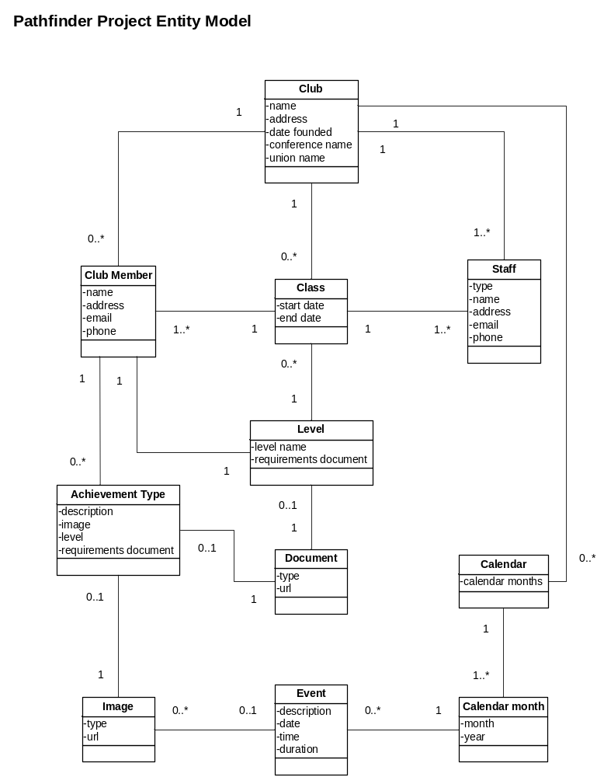

User Model
This section provides a model of the user types.

The open arrows indicate that one type of user is a subtype of a more general user category. For example, a teacher is a type of staff, which in turn is a type of user. User is the most general type.

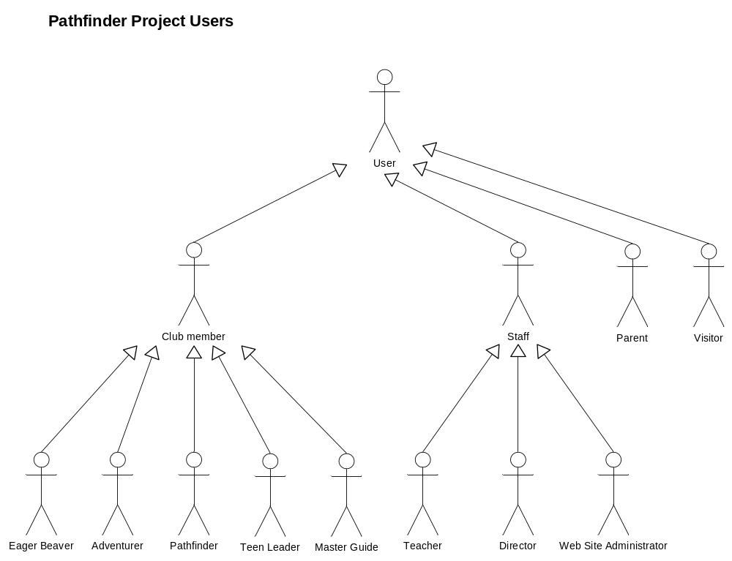

User Profiles
This section describes each of the user types.

Adventurer - a member of an Adventurer club. See vocabulary section.

Club member - a young person who joins a club. To join a club, a registration form must be filled out, a health form must be filled out, and a registration fee must be paid to cover the cost of supplies. Club members belong to a class based on their school grade.

Director - a person who leads a club.

Eager Beaver - kindergarten age children who are treated the same as Adventurers, even though they are technically not yet old enough to be Adventurers. See vocabulary section.

Master Guide - a member of a Master Guide club. See vocabulary section.

Pathfinder - a member of a Pathfinder club. See vocabulary section.

Staff - a person who serves in a club support capacity. Staff are elected each year by the local church that hosts the club.

Parent - a parent of a club member.

Teacher - a person who teaches a club class.

Teen Leader - a member of a TLT club. See vocabulary section.

User - anyone who visits a club web site.

Visitor - anyone who visits a club web site, who is not a club member, staff, or parent. An example would be a Pathfinder from another club. Another example is someone who has heard about Pathfinders and wants more information.

Web site administrator - a person who maintains a club web site.

Note that user types correspond to roles. A single individual may play more than one role. For example, in the Adventurers club there is one Pathfinder who serves as a teacher. Therefore, this person plays the roles of Pathfinder and teacher at various times.

Design Decisions
This section records significant design decisions.

- The layout will be a fixed size layout targeting the 800 x 600 screen resolution. If the user resizes the screen to be smaller, it will be clipped rather than dynamically adjusted so that the layout will be preserved.

- The home page functionality will reflect the visitor user type. From the home page, a login is required before other role-specific actions are shown. The reason for this is to allow visitors to browse "public" topics without being confused by restricted links.

- Parents will login using the same user ID and password as their child and, therefore, will appear to the system as a club member, with the same access rights.

- All external links will be consolidated in a single related links page. The reason for this is to highlight the fact that the majority of our content is directly provided by our site.

- The use of confirmation pages will be minimized. The normal mode of confirmation will be a successful navigation to a new or refreshed view. User confirmation is required only when potential data loss would result if the action were taken in error. This scheme is based on the Hub navigation pattern [Baxley].

- The scheme for handling entity Create, Read, Update, and Delete (CRUD) functionality will be to break it into two parts. The first part, corresponding to Read, will be called the View for that entity. The second part, corresponding to Create, Update, and Delete, will be called entity Management. For each entity, one page will handle its View aspect and another page will handle its Management aspect. See the page mockups for examples. Note that some entities, such as Calendar and Level, are provided automatically with the system and do not have any associated management actions.

User Actions
This section lists the user actions supported by the system along with their associated user permission rights.

Note: If you are viewing this table from within Microsoft Word, make sure you are in Print Layout View, because the column headers use a vertical font.

An "X" in the following table indicates that a user with the associated user type has permission to perform the associated action:

User Type  Action | Visitor | Club member | Parent | Teacher | Director | Web Site Administrator
Add achievement to club member |  |  |  |  | X | X
Add club member to class |  |  |  |  | X | X
Login and logout |  | X | X | X | X | X
Manage achievements |  |  |  |  | X | X
Manage clubs |  |  |  |  |  | X
Manage classes |  |  |  |  | X | X
Manage club members (1) |  | X | X |  | X | X
Manage events |  |  |  |  | X | X
Manage staff |  |  |  |  | X | X
Promote class |  |  |  |  | X | X
Remove achievement from club member (2) |  |  |  |  | X | X
Remove club member from class |  |  |  |  | X | X
Send e-mail to class members |  |  |  | X | X
Send e-mail to everyone (3) |  |  |  |  | X
View calendar |  | X | X | X | X | X
View class |  |  |  | X | X | X
View club information | X | X | X | X | X | X
View club member (4) |  | X | X | X | X | X
View event |  | X | X | X | X | X
View links to related sites | X | X | X | X | X | X
View staff |  | X | X | X | X | X
View topics | X | X | X | X | X | X

Notes:

1. Club members can only update their own demographic information.
2. This is to handle the case where the achievement was added by mistake.
3. Here, "everyone" is defined to be the union of the club members and staff.
4. Club members can only view their own information.

Usage Scenarios
This section presents some representative usage scenarios for the Pathfinders club.

Visitor Views a Topic
To view a topic, a visitor begins at the Pathfinders Visitor Home page. On that page is a table that lists the topic areas along with a brief description of each topic area. The visitor clicks on a topic area and is taken to the menu page for that topic area. On that page is a similar table that lists the topics within that topic area. The visitor clicks on a topic and is taken to the page for that topic.

Club Member Views a Previous Event
To view pictures for a previous event, a club member begins at the Pathfinders Visitor Home page. The club member enters login information in the Login box on that page and then hits the Login button. The club member is taken to the Pathfinders Club Member Home page. The club member then clicks on the Calendar link at the top of the page and is taken to the Calendar page for the current month. The club member navigates from there using the Previous month button to arrive at the month of interest. The club member then scans the list of events until the event of interest is located. The club member clicks on this event and is taken to the Event Detail page for that event. If there are pictures for that event, the club member will see the thumbnail images for the first 10 pictures. To view a larger version of a picture, the club member clicks on the thumbnail and a larger version appears in a new browser window. To look through all the pictures, the club member uses the First, Previous, Next, and Last picture buttons.

Director Creates an Event
To add a new event to the calendar, a director begins at the Administration Login page. After successfully logging in, the director is taken to the Manage Club page, where the director selects a club from a list of clubs. The Administration home page for that club appears. The director clicks on the Manage Events link and is taken to the Manage Events page. The director clicks the Add Event button and is taken to an update mode Event Details page. The director enters the event information and clicks the Save button. The system adds the event and returns the director to the Manage Events page.

If the director wants to see the event in the calendar, a separate browser instance can be used to view the Pathfinders web site Calendar page. Refreshing the page will cause it to update itself with any new events that have been added to the club's database.

Teacher Sends a Message to her Class
To send an e-mail message to all the students in her class, a teacher logs into the Pathfinders web site. From the home page, the teacher clicks on the My Class link at the top of the page. The teacher is taken to the Class page for her class. To begin the e-mail, the teacher clicks the Send E-mail button. The registered e-mail program is executed and its Send To field is pre-filled with the latest database e-mail addresses of all the students in her class. The teacher then uses the e-mail program to compose and send the message to her class.

Navigation Maps
The following sections present a set of navigation maps that illustrates the primary user-interface pages and the main navigational paths that interconnect them.

Multiple Sites
This map shows the highest-level entry points into the youth ministry web sites that make up the YPAC community. These sites are:

Youth Ministries site - this site provides links to all the youth ministry web sites. It is not necessary to enter a given site via this page. Each site's home page can be directly entered; that is why the diagram includes multiple Start points.

Pathfinders site - this is the site for the Pathfinders club.

Adventurers site - this is the site for the Adventurers. The Adventurers site will be a parallel design of the Pathfinders site. The differences between the sites are:

- Different content. For example, the Adventurer classes and class members are different from the Pathfinder ones.

- Different color schemes.

- The Adventurers site has a style that is targeted to fit the younger children.

Because these are the only differences, no other navigation maps are shown for the Adventurers site.

Administration site - this site is used by Directors and Web Site Administrators to manage the content of the club sites. This is the site where club-related create, update, delete, add, and remove functionality is performed. A create action is used to create a new instance of an entity. An update action is used to make changes to an existing entity. A delete action is used to delete an instance of an entity. An add action is used to associate one existing entity with another existing entity. A remove action is used to remove an association that was established by a add action.

Teen Leadership Training site - this is the site for the TLT club. This site will be implemented in a future project phase.

Master Guide site - this is the site for the Master Guide club. This site will be implemented in a future project phase.

See diagram on next page.

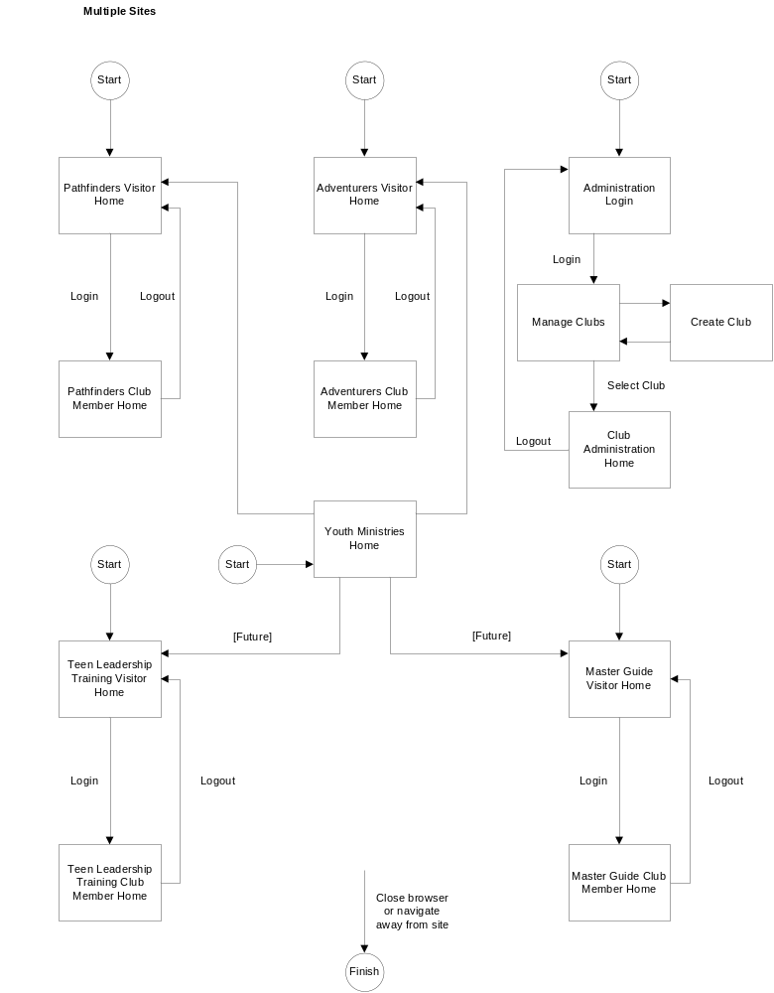

Pathfinders Visitor Home
This map shows the Pathfinders site pages that can be reached from the visitor version of the home page.

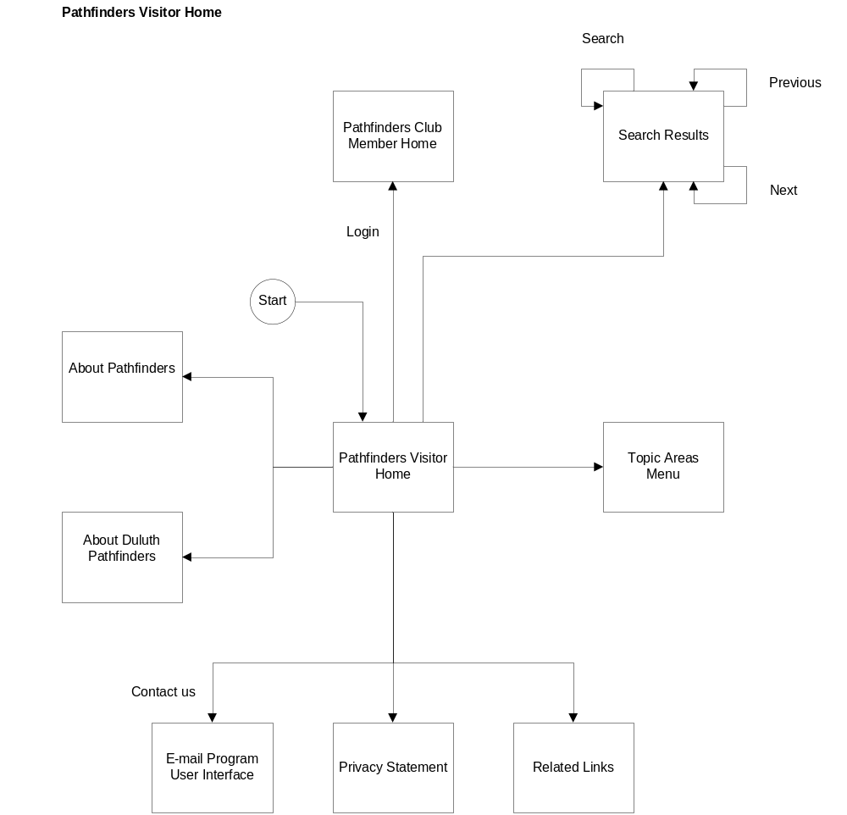

Common Links
This map shows the common links that are available from every page for a logged in club member or other authorized user. These common navigational routes are not repeated on the navigation maps for logged in users.

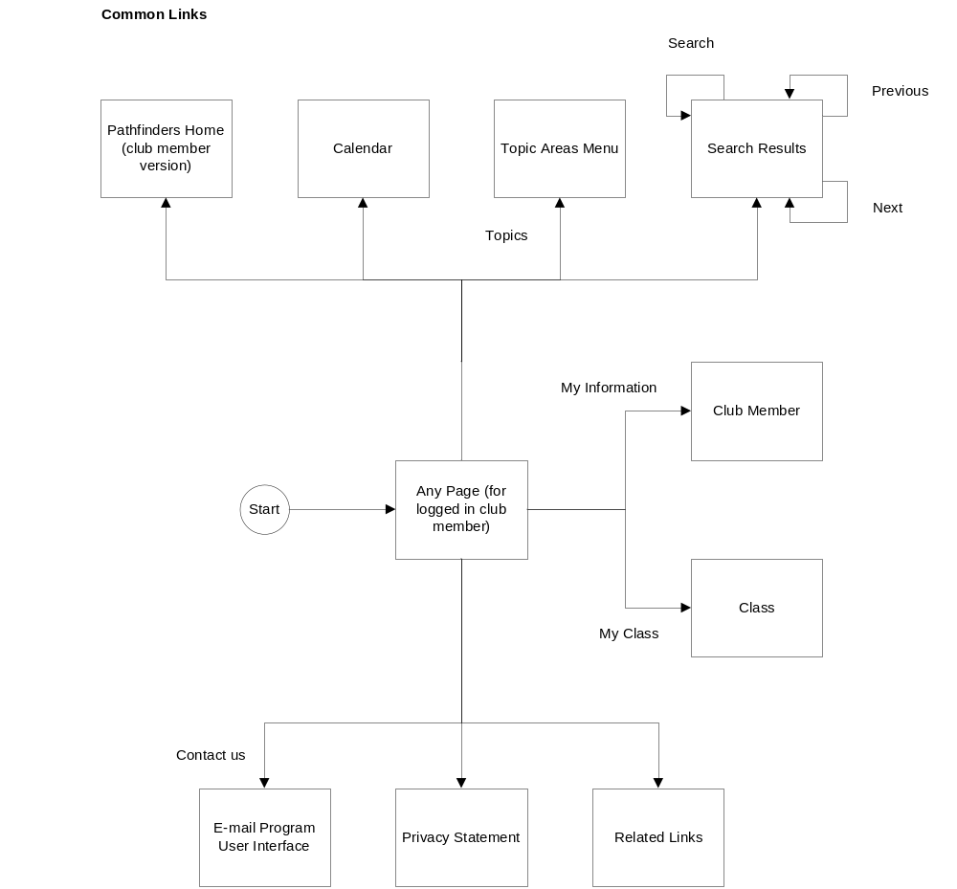

Pathfinders Club Member Home
This map shows the Pathfinders site pages that can be reached from the club member version of the home page. Again note that the common links are elided.

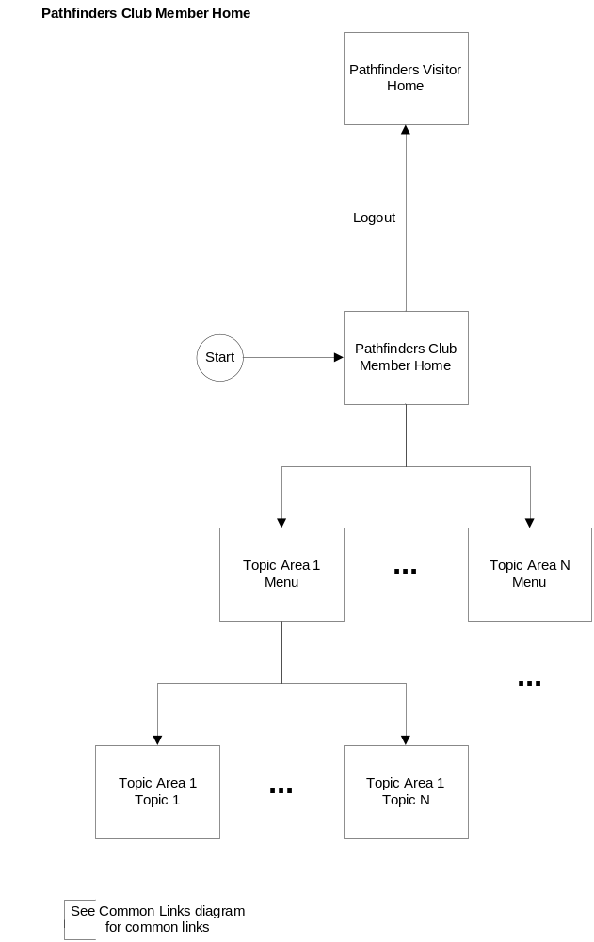

Topic Areas Menu
This map shows the pages that can be reached from the Topic Areas Menu page.

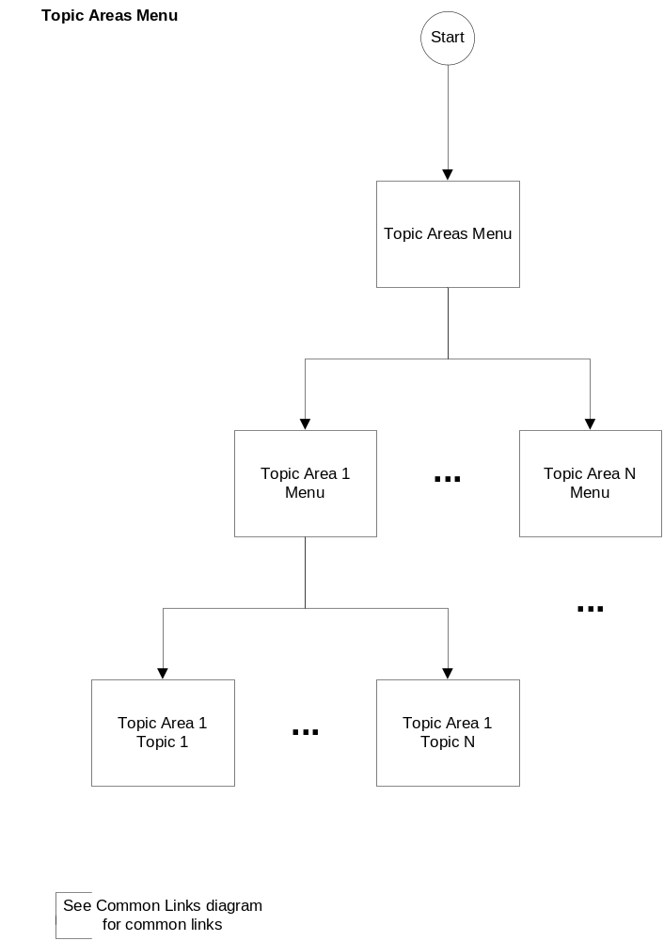

Calendar
This map shows the pages that can be reached from the Calendar page.

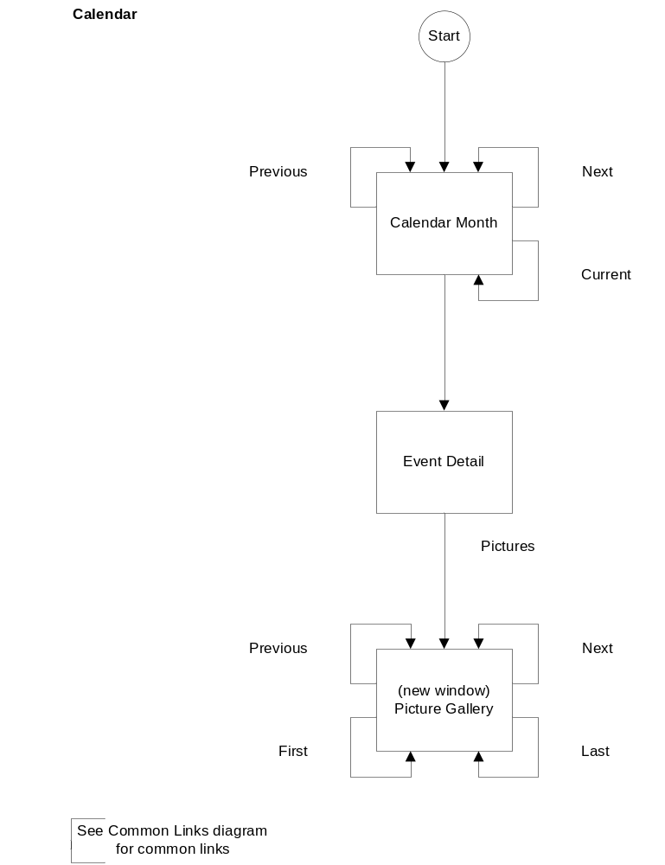

Club Member
This map shows the pages that can be reached from the Club Member page.

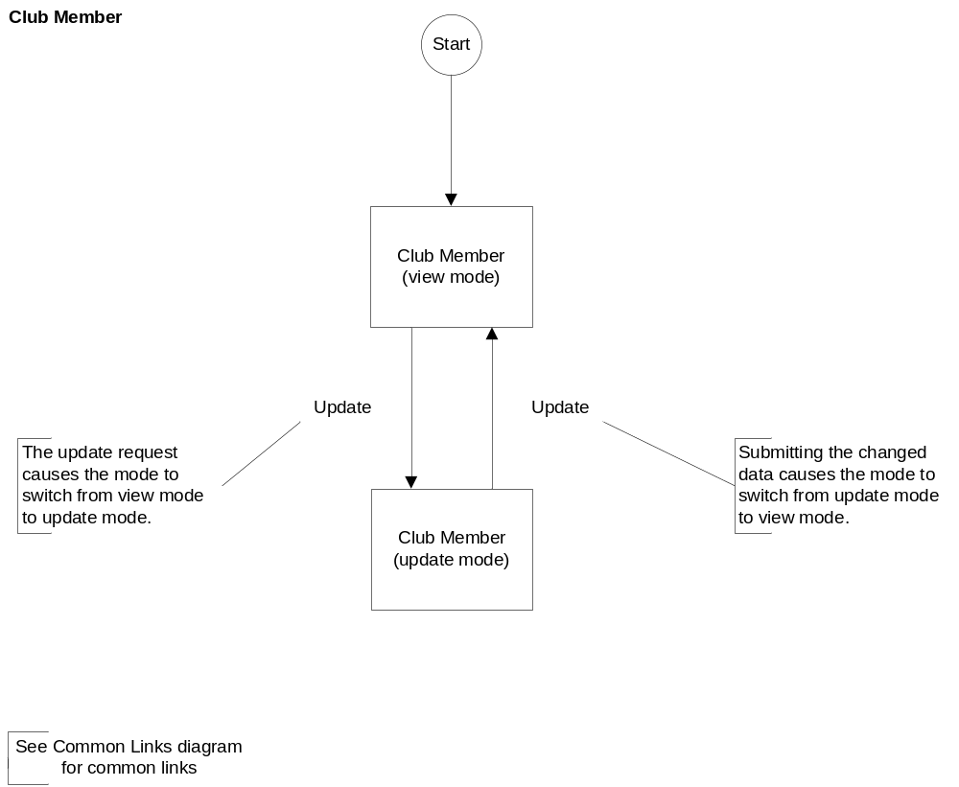

Class
This map shows the pages that can be reached from the Class page.

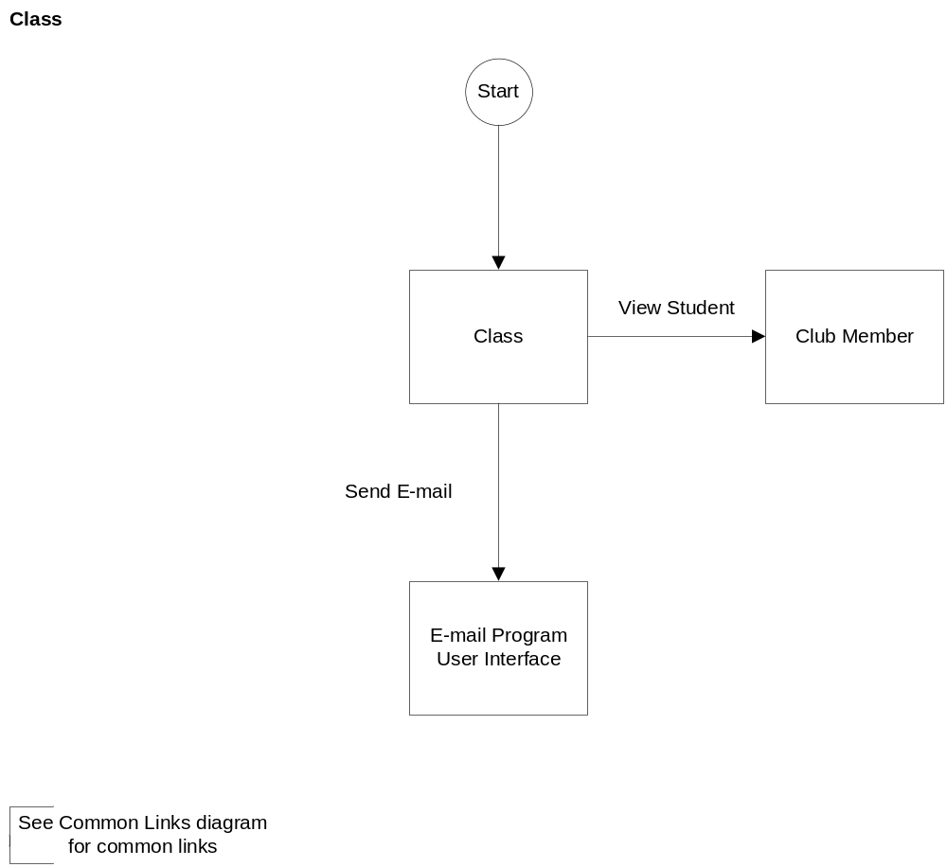

Club Administration Home
This map shows the Administration site pages that can be reached from the Club Administration home page.

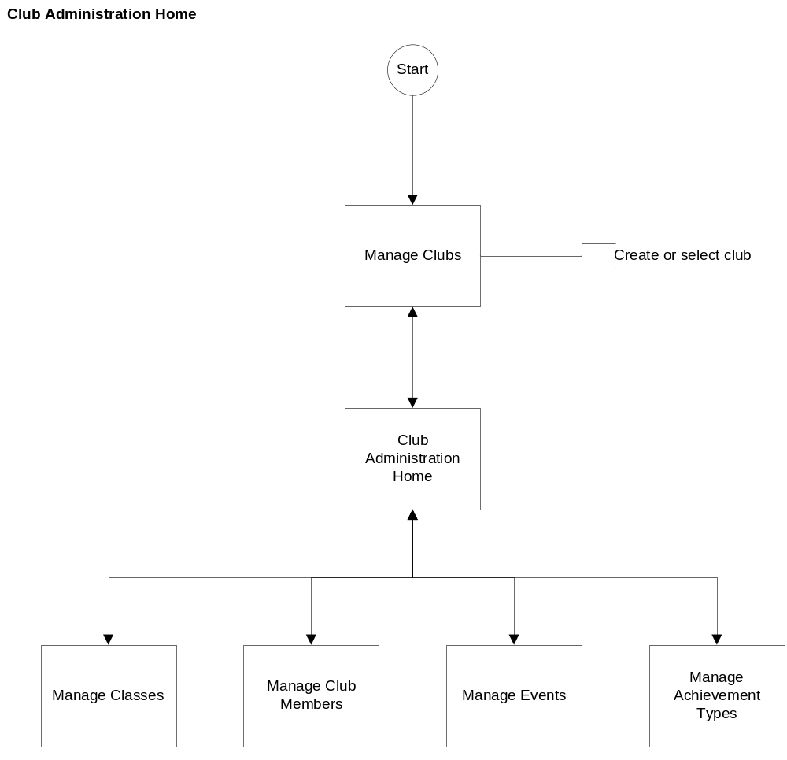

Administration Manage X
This map shows the pages that can be reached from a generic Manage X entity management page. For example, X could stand for Classes. In this example, Y represents an associated entity. For example, Y could be Club member, where the association would be the students in the class.

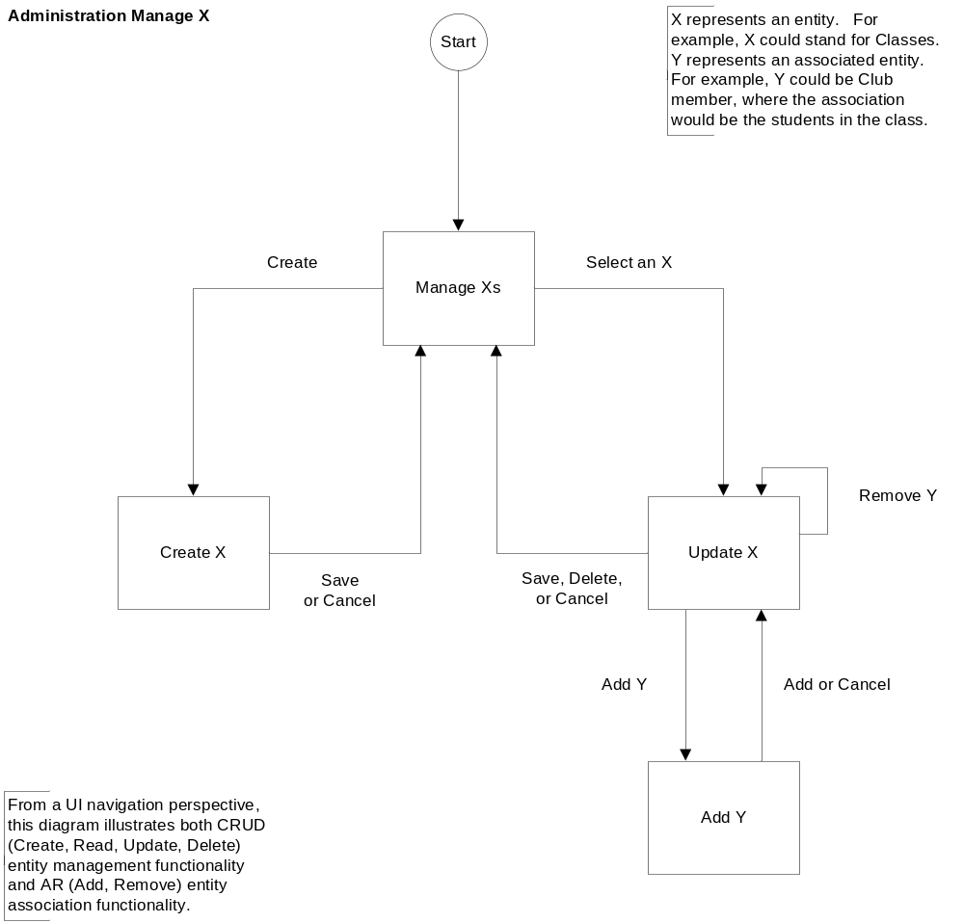

Page Mockups
The following sections provide mockups for several primary pages. To keep the scope of this design document from becoming too large for others to review, the mockups show only a select subset of the pages identified in the navigation maps section. All pages were captured at the 1024 x 768 screen resolution. Therefore, to see them better, you may need to increase Word's zoom level to 150%.

Youth Ministries Home Page
This is the highest-level entry point.

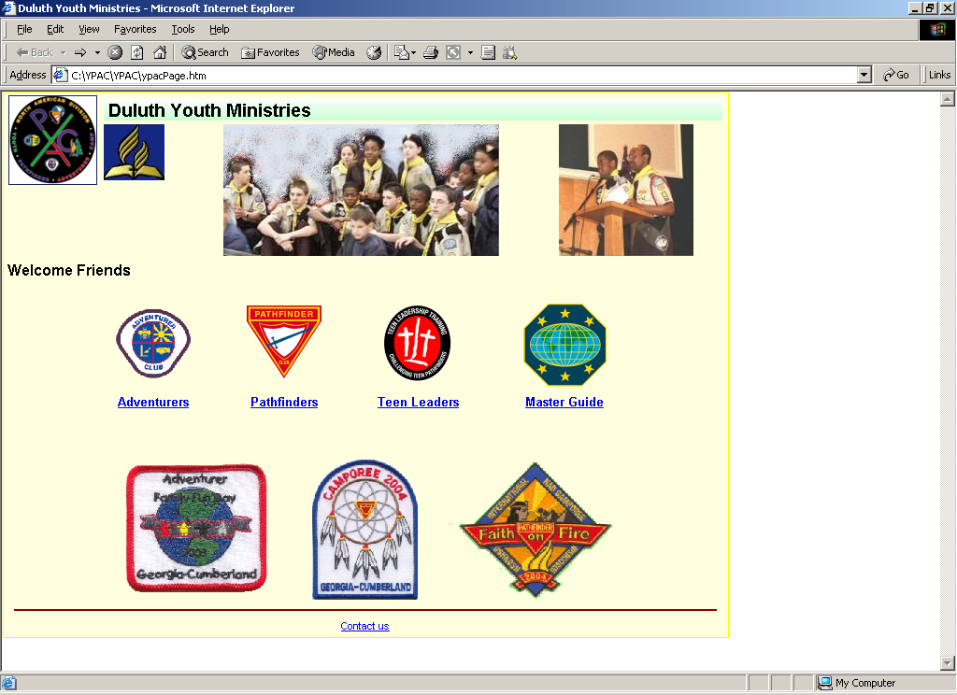

Pathfinders Visitor Home
This is the main entry point for the Pathfinder club site.

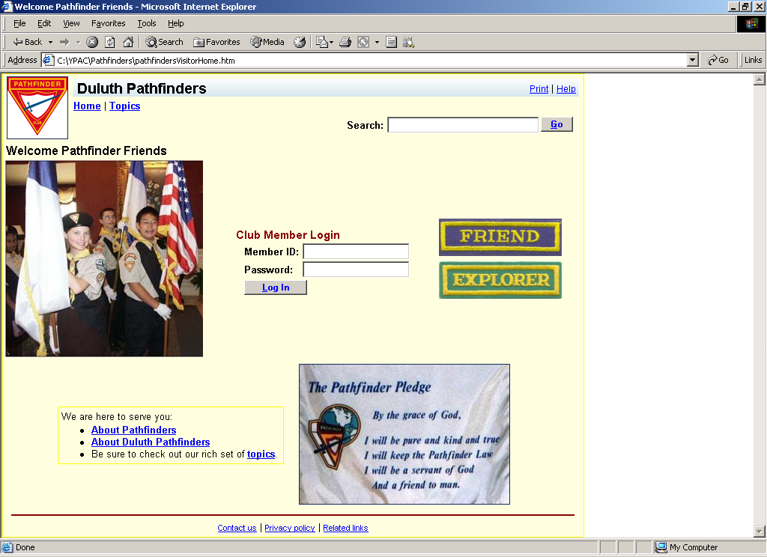

Pathfinders Club Member Home
This is where Pathfinder club members arrive after they log in.

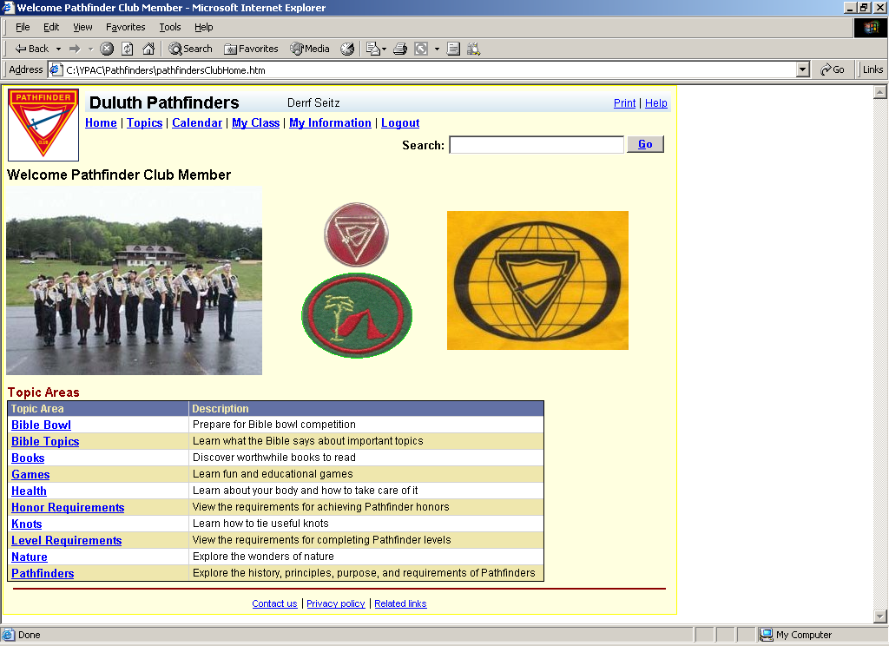

Pathfinders Knots
This is an example of a topic area menu.

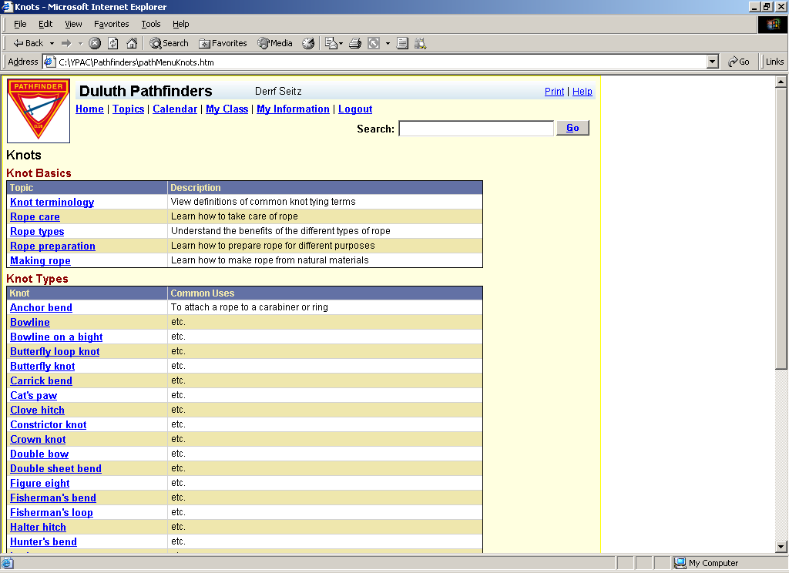
Below the fold:
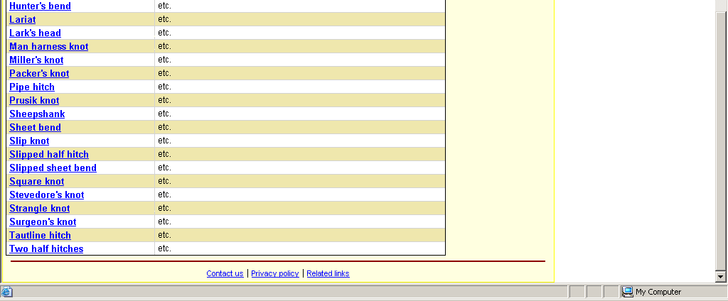

Pathfinders Calendar
This is the calendar for a month.

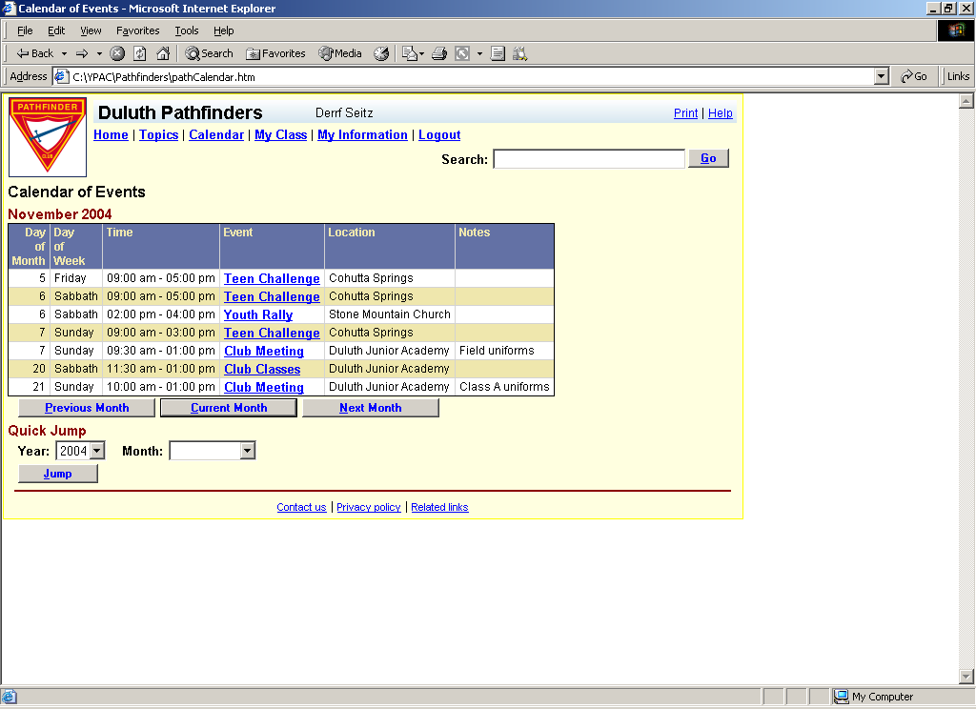

Pathfinders Event
This shows a popup window that appeared when the user clicked on the first thumbnail picture.

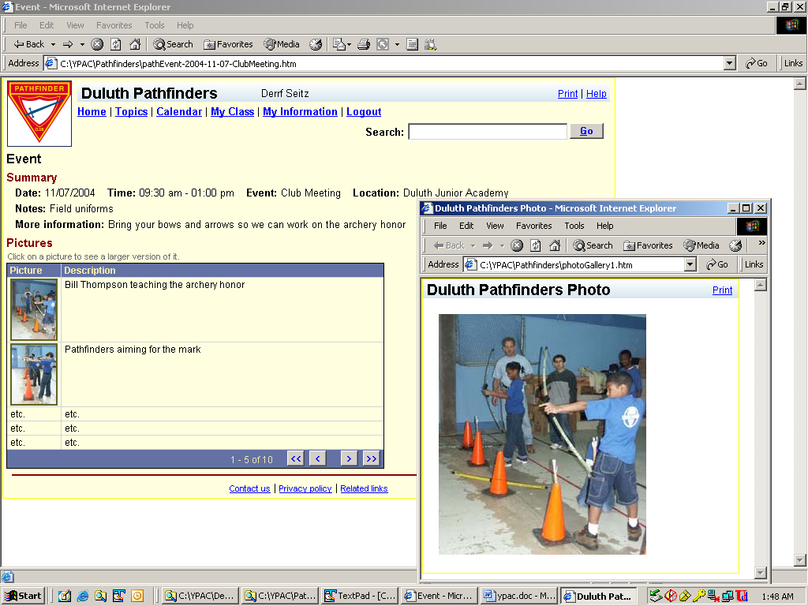

Pathfinders Club Member (View Mode)
This page appears when the user clicks on the My Information link.

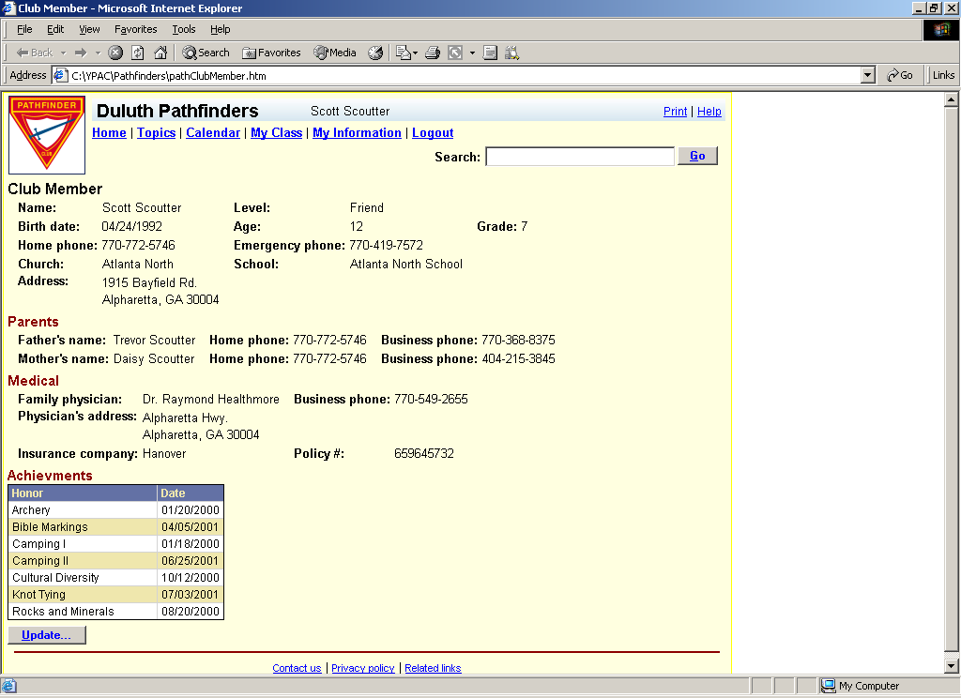

Pathfinders Class
This page appears when the user clicks on the My Class link.

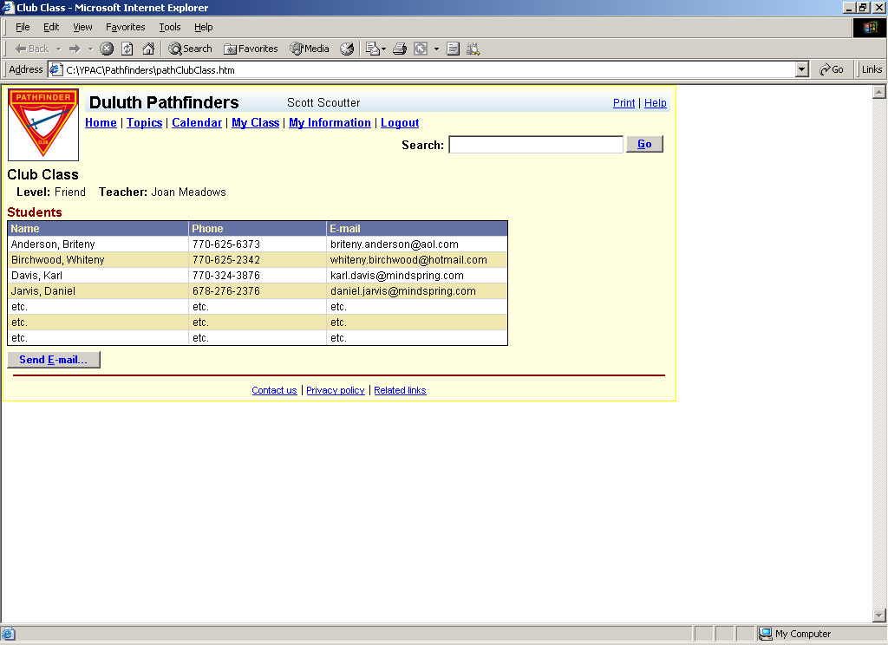

Adventurers Visitor Home
This is the main entry point for the Adventurer club site.

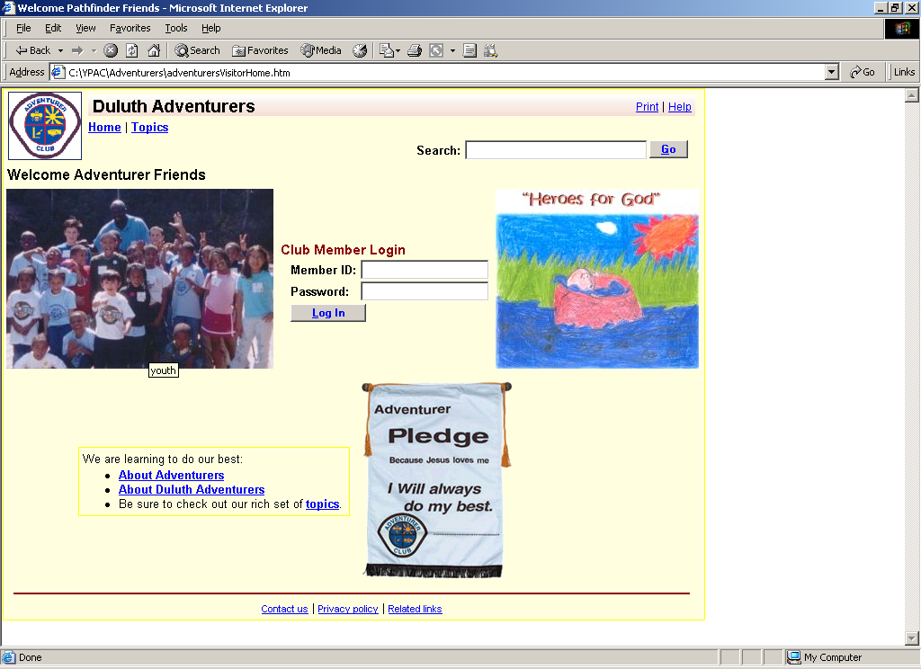

Club Administration Home
This is the home page from which a particular club site is administered.

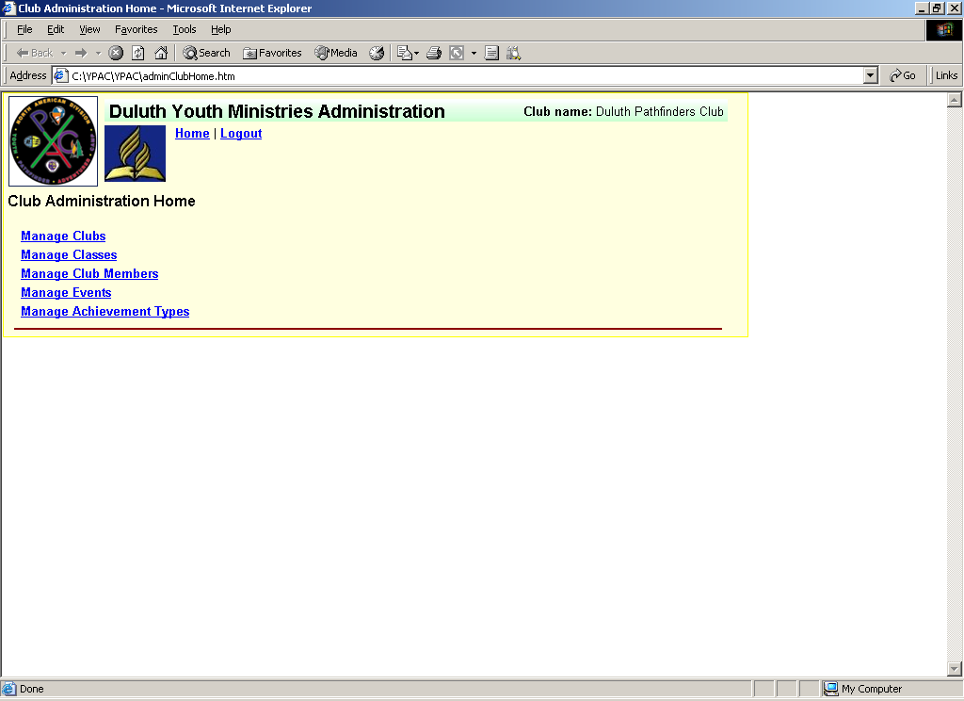

Implementation Constraints
This section outlines implementation constraints.

- The system must support the Microsoft Internet Explorer and Netscape Navigator browsers, but need only address recent versions of these browsers. More details on this will be considered later.

- The original site's web hosting company does not support Java middle-tier technology. More details on this will be considered later.

Futures
This section documents future enhancement ideas.

- Provide the capability to host secure chat to allow the youth to use the site as a point of communication. This should be done in such a manner so as to blend various Bible verses around the chat views.

- Implement a TLT site.

- Implement a Master Guide site

- Implement and host other new Pathfinders and Adventurers sites in a warehouse manner.

References
About Adventurers, North American Division Adventurers web site,
http://www.adventurer-club.com/Adventurers.htm

Who are Pathfinders?, North American Division Pathfinders web site, http://www.pathfindersonline.org/about/whoarepathfinders.htm

Views and Forms: Principles of Task Flow for Web Applications Part 1, Bob Baxley, Boxes and Arrows web site, http://www.boxesandarrows.com/archives/views_and_forms_principles_of_task_flow_for_web_applications_part_1.php

