**Laboratory Report Cover Page should be filled out and attached at the front.**

**Experiment Checklist should be filled out and attached after the cover page and before the report.**

**Report:**

Name

ELEC2210 (Day and time of your lab) (ex. TR 12-2pm)

(Experiment # and name of lab experiment) (ex. Experiment 1: Basic Logic Circuits)

Today’s Date

1. In first paragraph, discuss the lab objectives covered in the given lab document.
   1. At least 3 sentences.
2. For the next few paragraphs, discuss what you did in the lab along with any problems that occurred.
   1. Each part of the lab (i.e. Part 1, Part 2, etc.) should have a paragraph to itself.
   2. At least 3 sentences each paragraph.
   3. Make sure to include figures and tables that were significant for completing the lab after each paragraph. Figures and tables must be properly labeled and referenced in the text.

Examples:

Table 1. NAND gate truth table



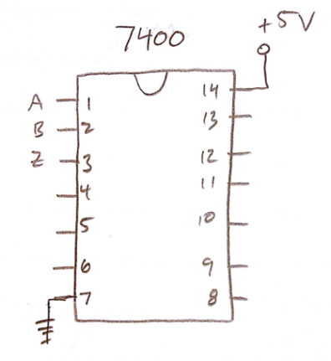

Figure 1. NAND gate chip circuit diagram.

1. In the last paragraph, conclude your report.
   1. Talk about anything you learned during the lab.
   2. Discuss any issues that occurred and how you resolved them.
   3. At least 3 sentences.