Daniel Milton
ELEC 7250
VLSI Testing
Term Project Report

Logic Simulator for Hierarchical BENCH Format

The objective for this semester project was to develop a logic simulator that used the BENCH netlist format as an input. For added convenience, the BENCH input was allowed to have hierarchy in the circuit netlist. Hierarchy is beneficial because it removes tedious work required to build a BENCH netlist for circuits that contain repeating sub-circuits. Noticing that none of the available tools can interpret BENCH with hierarchy, this functionality must be created. The design flow for this project is as follows: develop a BENCH syntax that adds an extension for hierarchy, develop a compiler to flatten the netlist and create a simulation table, and finally to implement a simulator that applies test vectors to the virtual circuit built from the BENCH netlist.
To aid in illustrating the hierarchical BENCH format, a 4-bit ripple carry adder will be designed using the format. Figure 1(a) shows the regular BENCH format that can readily be used in CAD tools such as HITEC. Figure 1(b) depicts the hierarchy BENCH format. In this figure, the input and output notation is the same; however, the gate instantiations are not component instantiations. The “USE” identifier is used signal the use of a component. In general, a component is instantiated with the following syntax:
INPUT(1)
INPUT(2)
INPUT(3)
INPUT(6)
INPUT(7)
OUTPUT(22)
OUTPUT(23)
10 = NAND(1, 3)
11 = NAND(3, 6)
16 = NAND(2, 11)
18 = NAND(11, 7)
22 = NAND(10, 16)
23 = NAND(16, 18)

INPUT(1) #LSB of A
INPUT(2)
INPUT(3)
INPUT(4) #MSB of A
INPUT(5) #LSB of B
INPUT(6)
INPUT(7)
INPUT(8) #MSB of B
INPUT(14) # initial carry in
OUTPUT(9) # LSB output
OUTPUT(10)
OUTPUT(11)
OUTPUT(12) # MSB output
OUTPUT(13) # Carry
USE FA:FA1(1,5,14)(9,c1)
USE FA:FA2(2,6,c1)(10,c2)
USE FA:FA3(3,7,c2)(11,c3)
USE FA:FA4(4,8,c3)(12,13)

(a)(b)
Regular BENCH format Hierarchy BENCH format
Figure 1
USE[component_name]:[component_instantation_name](INPUT NETLIST)(OUTPUT NETLIST)
Another restriction with this format is that the component name must correspond to a file with the same name. This file will contain a flattened “regular” BENCH format netlist. Note that only one level of components is allowed. The component cannot have its own components.
Now that a hierarchical BENCH format has been defined, a BENCH compiler is needed. The compiler has two functions: to “flatten” a component based BENCH netlist, and to generate a simulation table. Flattening the netlist requires the compiler to replace the component instantiations with a copy of the component netlist. Obviously, there may exist an issue with interconnection naming. The compiler must be able to provide a unique naming convention for each component that is flattened. The convention used is to concatenate the component instantiation name with the component signal automatically. Since no component can have the same name, this convention should ensure that each net in the netlist is unique. The second function of the compiler is to generate a simulation table for the flattened circuit or for the hierarchical version. This table contains the gate or component name, type, fan-in, fan-out, delays, and faults.
Implementing the COMPILER was partitioned into two subtasks: correctly parse the BENCH file, and generate the simulation table. Java was used to implement both functions. Java excels quite well at file parsing due to its easy to use string manipulation functions. As each line of the file was read in, the compiler builds an object called a SIM_circuit. The SIM_circuit is an array of SIM_NODEs. SIM_NODES contain the entirety of the simulation table for a gate or component. A visual representation of the Java Classes is given in Figure 2. The classes that begin with “COMP” are built when a simulation table is created from the non-flattened netlist.

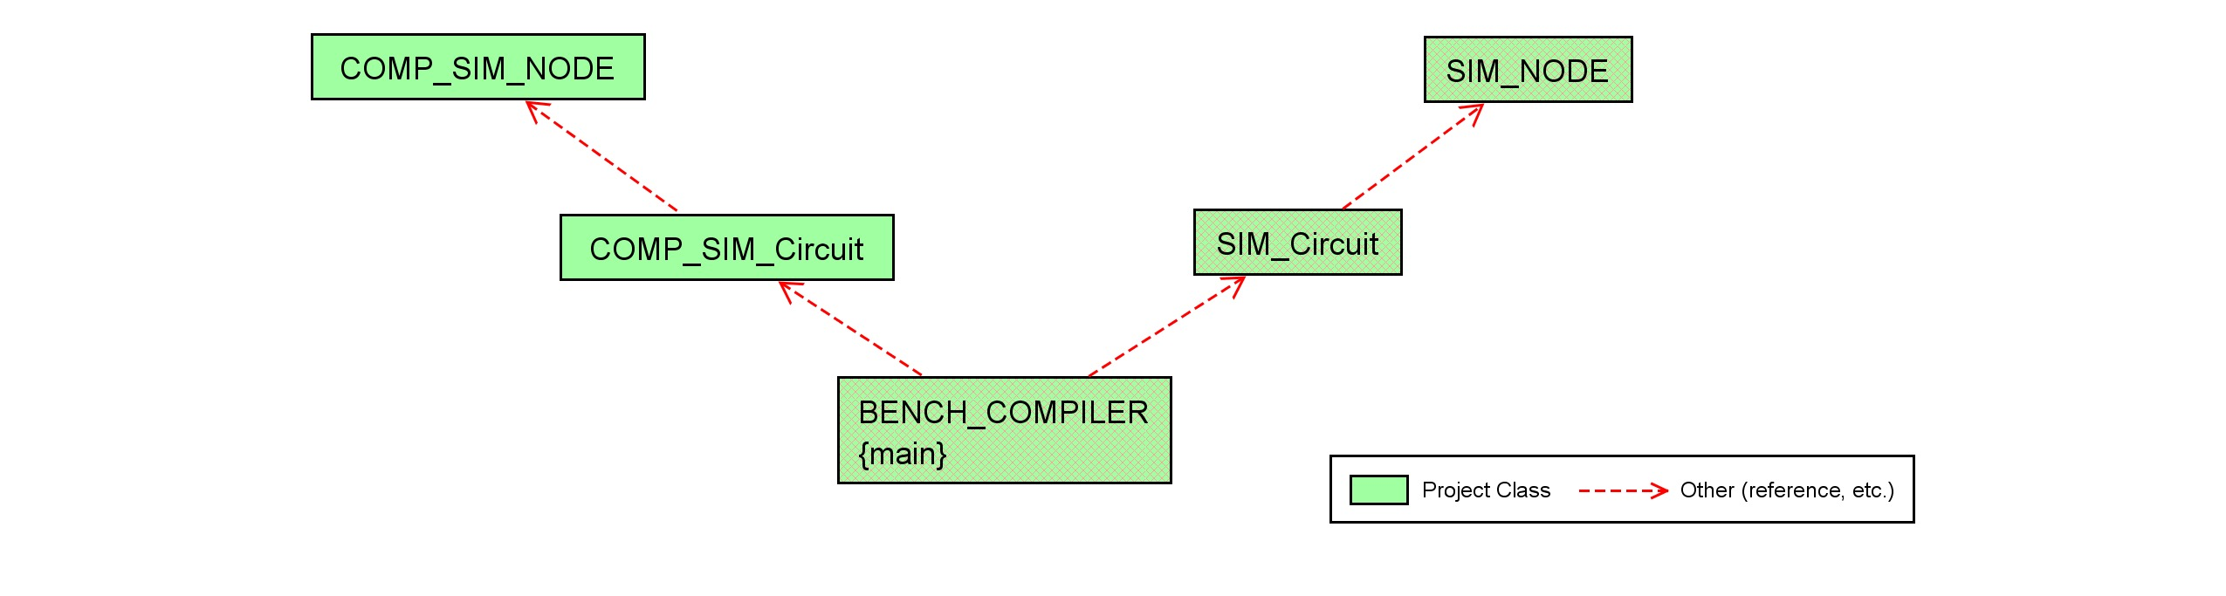
Figure 2 –Java Class Diagram

Figure 3 depicts the output of the compiler when the flatten option is selected. Notice that the signal fFA1 is a generated net. The ‘f’ term came from the BENCH file named FA.bench and was concatenated with FA1, the name of the full-adder. Appendix A contains output information for the simulation tables.

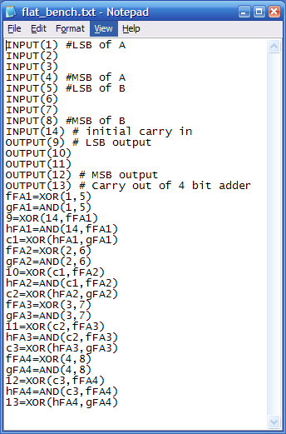
Figure 3 - Flatten BENCH results

The final phase of the project required the implementation of a logic simulator that used the hierarchical BENCH format as an input. Clearly, the previous portions of the project can be used immediately to convert the input file to a data object in memory. The simulator is built on top of the compiler in this implantation. Once the file has been parsed and a basic data structure built, the data structure is then manipulated to bring the data structure to a state that a simulation algorithm can use. The following are function calls within the java code that illustrate this manipulation:

sim.analyze()
sim.print();
sim.readyCIR_SIM();
sim.genALLVectors();
sim.initPIPO();
sim.cir_simulate();
sim.genRANDVectors();
sim.initPIPO();
sim.cir_simulate();

In this code example, “sim” is the SIM_circuit object which contains all of the gates in the circuit. The analyze function determines the fan-in and fan-out dependencies between all of the gate nodes. The print function generates the simulation table as seen in Appendix A. ReadyCIR_SIM, converts all of the nodes in the circuit to have fan-in and fan-outs of type SUB_NODES. Previously the fan-ins and fan-outs where dynamic array lists that contained the name of the net. For simulation purposes, a current logic value is also needed and information concerning if this net is a PI or PO in the entire circuit.
The function genALLVectors generates the entire test vector set for a given size of inputs. This vector array is stored in memory. Likewise, the function genRANDVectors generates 1000 test vectors with a vector width equal to the inputs of the circuit. The initPIPO function takes the first test vector from the list and drives it to the inputs of the circuit. The logic simulation is completed for all test vectors by calling the cir_simulate function. This function propagates the PI vales to the PO of the circuit. Figure 4 illustrates the class dependencies for the logic simulator implementation.
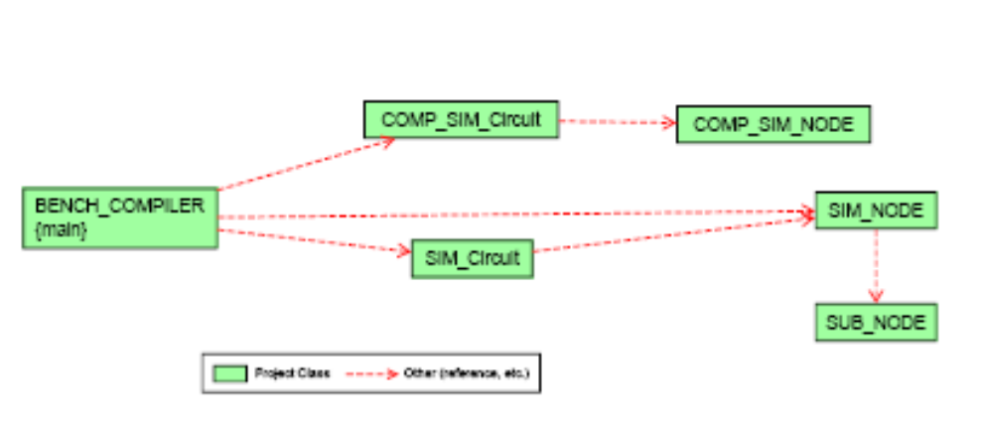

Figure 4: Updated Class Diagram for Simulator

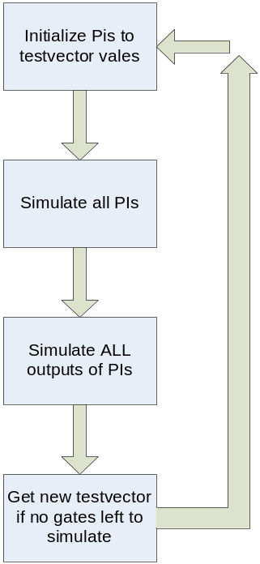 Figure 5 shows the steps the CIR_SIMULATE function completes as it simulates the circuit. When a gate’s inputs are simulated, the output value is recorded and all of the fan-ins from the recorded output are updated as well. Each time a fan-in is updated, that gate node is added to a list of nodes that can be simulated. Initially, all of the PI gates are simulated and the simulation node list grows. However, if the list already has the gate that needs to be added, another copy will not be added. Adding multiple gates could lead to an unending simulation scenario. Appendix B contains several uses of the simulator with easy to verify example circuits. The 4-bit adder was verified by initially verifying its component, the full-adder. Then the output was inspected and determined to be correct. It should be noted that the simulator does not read in an expected value for each test vector. This functionality was planned, but the implementation was never written due to time constraints. It should be further noted that the diagnosis of an injected fault was not implemented for the same reason. Simulation time results are given in the following Figures 6 and 7. From the ISCAS’85 performance, it is clear that the program takes much too long compared to what was expected and to what was given by classmates in their presentations. Much of the development time was geared toward speeding up the simulator. However, it has been concluded that the problem is twofold: using multiple arrays and searching through them is slow; and secondly, the Java virtual machine is slow and does not use the full potential of the host PC.
Figure 5: Simulation Algorithm
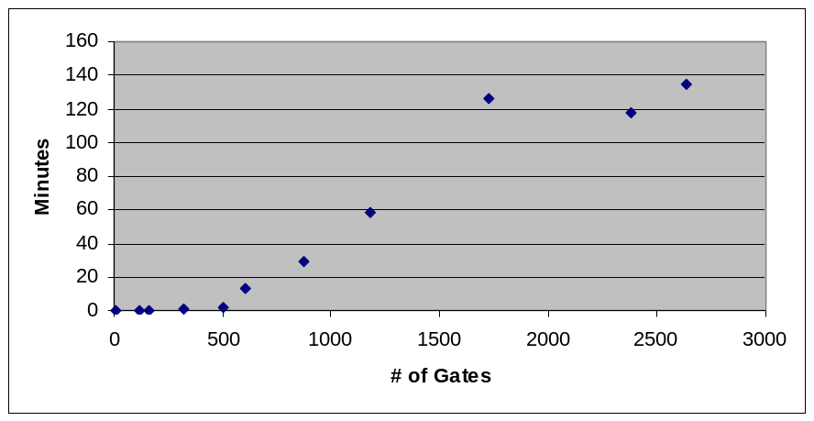

Figure 6: ISCAS’85 Simulation Performance
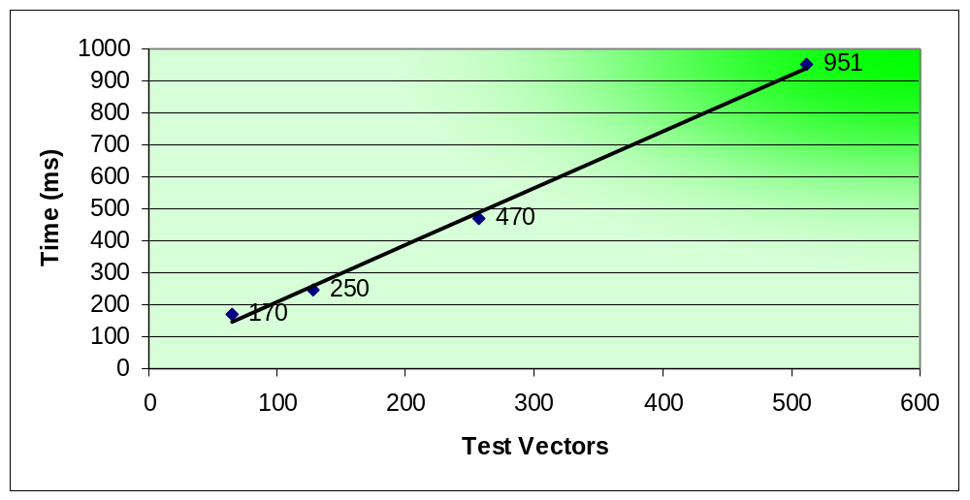
Figure 7: Simulation of 4-bit adder

From the above figures, the simulation time appears to closely follow a linear function of the number of gates simulated. However, at over 4 hours for the largest ISCAS circuit, simulation time complexity should be improved. Such improvements to the simulator include adding the aforementioned omissions and speeding up the performance. Data structures with faster than linear access time could be used to speed up simulation. Storing the circuit in a hash table or a tree structure with pointers would lower access time to constant time with a hash table and logarithmic time with a tree.

APPENDIX A

----Simulation Table----
=================================
NAME: fFA1
TYPE: XOR
Fanin: [1, 5]
Fanout: [fFA1, 9, hFA1]
Delays: 0
Faults: 0
=================================
=================================
NAME: gFA1
TYPE: AND
Fanin: [1, 5]
Fanout: [gFA1, c1]
Delays: 0
Faults: 0
=================================
=================================
NAME: 9
TYPE: XOR
Fanin: [14, fFA1]
Fanout: [9]
Delays: 0
Faults: 0
=================================
=================================
NAME: hFA1
TYPE: AND
Fanin: [14, fFA1]
Fanout: [hFA1, c1]
Delays: 0
Faults: 0
=================================
=================================
NAME: c1
TYPE: XOR
Fanin: [hFA1, gFA1]
Fanout: [c1, 10, hFA2]
Delays: 0
Faults: 0
=================================
=================================
NAME: fFA2
TYPE: XOR
Fanin: [2, 6]
Fanout: [fFA2, 10, hFA2]
Delays: 0
Faults: 0
=================================
=================================
NAME: gFA2
TYPE: AND
Fanin: [2, 6]
Fanout: [gFA2, c2]
Delays: 0
Faults: 0
=================================
=================================
NAME: 10
TYPE: XOR
Fanin: [c1, fFA2]
Fanout: [10]
Delays: 0
Faults: 0
=================================
=================================
NAME: hFA2
TYPE: AND
Fanin: [c1, fFA2]
Fanout: [hFA2, c2]
Delays: 0
Faults: 0
=================================
=================================
NAME: c2
TYPE: XOR
Fanin: [hFA2, gFA2]
Fanout: [c2, 11, hFA3]
Delays: 0
Faults: 0
=================================
=================================
NAME: fFA3
TYPE: XOR
Fanin: [3, 7]
Fanout: [fFA3, 11, hFA3]
Delays: 0
Faults: 0
=================================
=================================
NAME: gFA3
TYPE: AND
Fanin: [3, 7]
Fanout: [gFA3, c3]
Delays: 0
Faults: 0
=================================

=================================
NAME: 11
TYPE: XOR
Fanin: [c2, fFA3]
Fanout: [11]
Delays: 0
Faults: 0
=================================
=================================
NAME: hFA3
TYPE: AND
Fanin: [c2, fFA3]
Fanout: [hFA3, c3]
Delays: 0
Faults: 0
=================================
=================================
NAME: c3
TYPE: XOR
Fanin: [hFA3, gFA3]
Fanout: [c3, 12, hFA4]
Delays: 0
Faults: 0
=================================
=================================
NAME: fFA4
TYPE: XOR
Fanin: [4, 8]
Fanout: [fFA4, 12, hFA4]
Delays: 0
Faults: 0
=================================
=================================
NAME: gFA4
TYPE: AND
Fanin: [4, 8]
Fanout: [gFA4, 13]
Delays: 0
Faults: 0
=================================
=================================
NAME: 12
TYPE: XOR
Fanin: [c3, fFA4]
Fanout: [12]
Delays: 0
Faults: 0
=================================

=================================
NAME: hFA4
TYPE: AND
Fanin: [c3, fFA4]
Fanout: [hFA4, 13]
Delays: 0
Faults: 0
=================================
=================================
NAME: 13
TYPE: XOR
Fanin: [hFA4, gFA4]
Fanout: [13]
Delays: 0
Faults: 0
=================================
----End Simulation Table----
Keep Hierarchy Simulation Table Results
----Simulation Table----
=================================
NAME: FA1
TYPE: FA
Fanin: [1, 5, 14]
Fanout: [9, c1, FA2]
Delays: 0
Faults: 0
=================================
=================================
NAME: FA2
TYPE: FA
Fanin: [2, 6, c1]
Fanout: [10, c2, FA3]
Delays: 0
Faults: 0
=================================
=================================
NAME: FA3
TYPE: FA
Fanin: [3, 7, c2]
Fanout: [11, c3, FA4]
Delays: 0
Faults: 0
=================================
=================================
NAME: FA4
TYPE: FA
Fanin: [4, 8, c3]
Fanout: [12, 13]
Delays: 0
Faults: 0
=================================
----End Simulation Table----

APPENDIX B

NOTE: The TIME value represents the time in milliseconds for the program to execute

- Simulation of a Full Adder
‘d’ in the output file represents the sum and ‘e’ represents the carry
The LSB of the input (110 in the first output) is the carry in bit of the adder

110: d:0, e:1,
100: d:1, e:0,
100: d:1, e:0,
101: d:0, e:1,
110: d:0, e:1,
101: d:0, e:1,
011: d:0, e:1,
100: d:1, e:0,
100: d:1, e:0,
110: d:0, e:1,
110: d:0, e:1,
. //lines deleted
.
.
.

001: d:1, e:0,
101: d:0, e:1,
110: d:0, e:1,
100: d:1, e:0,
110: d:0, e:1,
101: d:0, e:1,
000: d:0, e:0,
101: d:0, e:1,
101: d:0, e:1,
010: d:1, e:0,
001: d:1, e:0,
111: d:1, e:1,
111: d:1, e:1,
100: d:1, e:0,
011: d:0, e:1,
000: d:0, e:0,
001: d:1, e:0,
110: d:0, e:1,
101: d:0, e:1,
110: d:0, e:1,
101: d:0, e:1,
101: d:0, e:1,
010: d:1, e:0,
101: d:0, e:1,
110: d:0, e:1,
110: d:0, e:1,
110: d:0, e:1, Time: 381

- Simulation of a 4 NAND implementation of an XOR gate.
‘3’ in the output is the netlist output in the BENCH input file.

00: 3:0,
01: 3:1,
10: 3:1,
11: 3:0, Time: 20

