Redesign Control FSM of a Multicycle MIPS Processor with Low Power State Encoding
Yu Zhang
Electrical and Computer Engineering Department
Auburn University, Auburn, AL, 36849

Abstract:

Power consumption has become one of the major challenges in IC design. In this project several power-saving methods are applied to MIPS control FSM design: state reassignment, state duplication, onehot encoding, and clock gating. The simulation with Powersim showed that about one fourth of power saving compared to the original FSM without low power state encoding. Especially onehot encoding gave the most power reduction of 68.7%.

Keywords: Low power state encoding, state duplication, onehot, clock gating.

1. Introduction
The prime objective of this project is to implement a power efficient control finite state machine (FSM) of a multicycle MIPS microprocessor. This objective was motivated by the fact that nowadays IC designs have become more complex; reducing power consumption has become the first factor to be considered for IC design. Especially, this demand is increasing for battery-based electronic systems, since we all wish our laptop can last for a whole business trip, or cell phones can still work after days of outdoor camping, in case we need to reach 911.
Finite state machine (FSM) is the most commonly used model for system’s sequential components. Traditionally logic synthesis tools which covert the behavioral description of FSM to a hardware implementation will try to optimize the design objectives such as area, delay, and testability. Leonardo, which was used as the logic synthesis tool in this project, will automatically optimize the behavioral model with respect to area, delay, or both. It will try to minimize the states of a FSM, which will not necessarily reduce power. In light of the well-known fact that digital CMOS circuit’s power dissipation is proportional to the switching activity, state encoding is then re-formulated to minimize the number of state bit switches per transition for low power FSM synthesis. This problem is NP-hard and cannot be done automatically in Leonardo. Many heuristic algorithms have been proposed mainly based on the idea of assigning codes with small hamming distance to pairs of states that have a high transition probability.
To further reduce power, just re-encoding is not enough, which has an optimal state assignment. Power cannot be reduced beyond this optimal state encoding. Thus, state duplicating, onehot encoding, and clock gating are also introduced in this project to further reduce power.

2. State Duplication

The state transition graph (STG) in Figure 1(a)^{[1]} represents a 2-intput 2-output FSM with five states {S1, S2, S3, S4, S5}. Each edge represents a transition with the input and output pair shown along the edge. The FSM has already been minimized.
We re-construct this FSM by introducing state S6 as shown in Figure 1(b). one can easily verify that these two STGs are functionally equivalent. In fact, state S6 is an equivalent state of S1. We then exhaustively check all the possible state encoding schemes for both FSMs and report the one that minimizes total switching activity in Figure 1.
Calculating the switching activity, we can get 7.9% reduction in the re-constructed 6-state FSM over the original 5-state FSM. Note that the encoding in the original 5-state FSM is optimal, which implies that we lose the most energy-efficient encoding for this FSM once it is minimized ^{[1]}.
Bear this in mind that state duplication may provide a bigger stage for power consumption performance; we know how to change the control FSM of a multicylce MIPS processor.

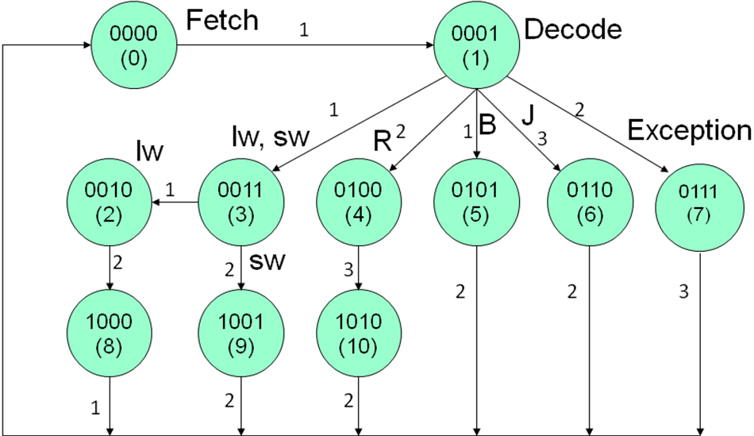
Figure 2(a) Control FSM without state optimization

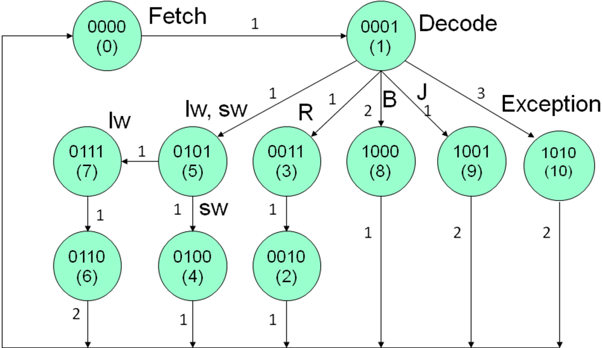
Figure 2(b) Control FSM with state optimization

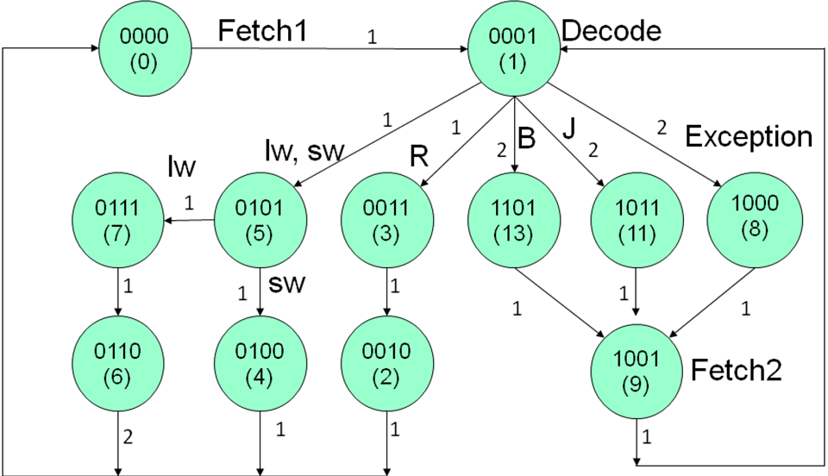
Figure 2(c) Control FSM with state optimization and state duplication

Compare these 3 STGs, transitions between states is greatly reduced by low power state encoding (assigning codes with small hamming distance to pairs of states with high transition probability, assuming R-type is the most frequently executed instruction) and further reduced by state duplication.

2.1 Implementation of State Encoding

module fsm_origin_binary(clk, reset, opcode, control_sig);
output [10:0] control_sig;
input [5:0] opcode;
input clk, reset;

parameter ifetch = 4'b0000,
decode = 4'b0001,
lw_or_sw = 4'b0101,
lw_readmem = 4'b0111,
lw_writereg = 4'b0110,
sw_writemem = 4'b0100,
r_alu = 4'b0011,
r_writereg = 4'b0010,
branch = 4'b1101,
jump = 4'b1011,
exception = 4'b1000,
fetch2 = 4'b1001,
$$⋮$$
$$⋮$$
always @(posedge clk or negedge reset)
if (!reset) state <= ifetch;
else state <= next;

always @(state or opcode)
begin
next = ifetch;
control_sig = 11'b10010100100;
case (state)
ifetch : next = decode;
decode :
begin
control_sig = 11'b01100000000;
case (opcode)
lw : next = lw_or_sw;
sw : next = lw_or_sw;
add : next = r_alu;
addi : next = branch;
beq : next = branch;
j : next = jump;
endcase
end

lw_or_sw :
begin
control_sig = 11'b11000000000;
if (opcode==lw) next = lw_readmem;
else next = sw_writemem;
end
$$⋮$$
$$⋮$$
The first part of the code is to define states with different coding. By defining parameters we can easily change the coding without modifying the rest of the verilog program.

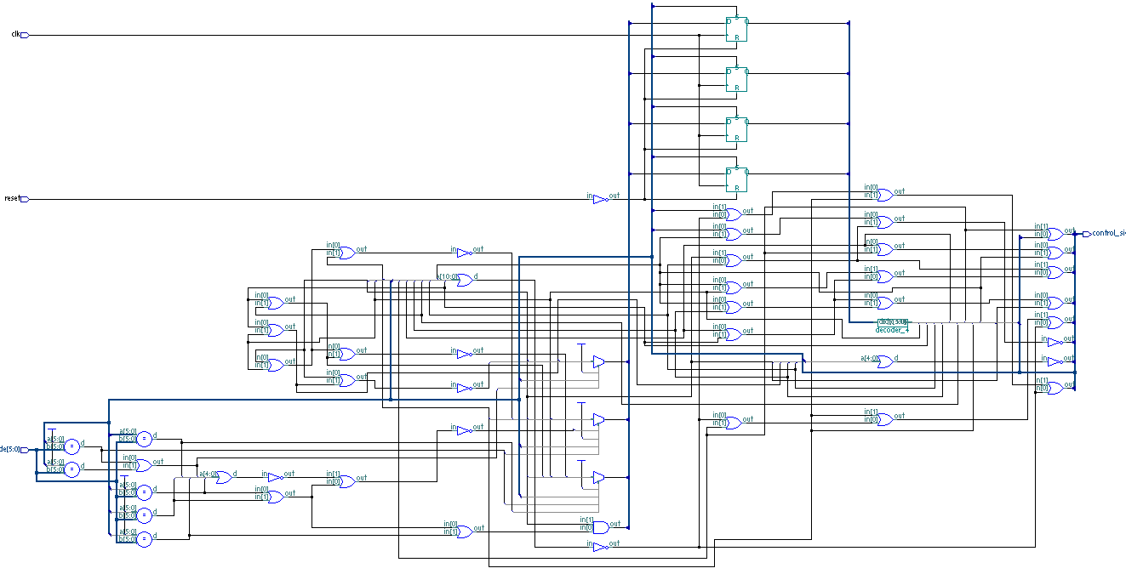
Figure 3 Synthesized result from Leonardo

Power saving will be reported in Part 5 Simulation Result.

3. One Hot Encoding

A binary-encoded FSM design only requires as many flip-flops as are needed to uniquely encode the number of states in the state machine. The actual number of flip-flops required is equal to the ceiling of the log-base-2 of the number of states in the FSM. An onehot FSM design requires a flip-flop for each state in the design and only one flip-flop (the flip-flop representing the current or "hot" state) is set at a time in a onehot FSM design. For a state machine with 9-16 states, a binary FSM only requires 4 flip-flops while a onehot FSM requires a flip-flop for each state in the design (9-16 flip-flops).

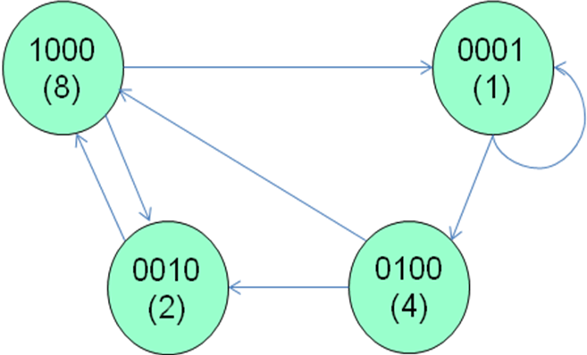
Figure 4 One hot FSM
FPGA vendors frequently recommend using an onehot state encoding style because flip-flops are plentiful in an FPGA and the combinational logic required to implement an onehot FSM design is typically smaller than most binary encoding styles. Since FPGA performance is typically related to the combinational logic size of the FPGA design, onehot FSMs typically run faster than a binary encoded FSM with larger combinational logic blocks ^{[2]}.

Advantages to using the one-hot design methodology[3]:
One-hot state machines are typically faster. Speed is independent of the number of states, and instead depends only on the number of transitions into a particular state.
A highly encoded machine may slow dramatically as more states are added.
You don’t have to worry about finding an “optimal” state encoding. This is particularly beneficial as the machine design is modified, for what is “optimal” for
one design may no longer be best if you add a few states and change some others. One-hot is equally “optimal” for all machines.
One-hot machines are easy to design. HDL code can be written directly from the state diagram without coding a state table.
Modifications are straightforward. Adding and deleting states, or changing excitation equations, can be implemented easily without affecting the rest of the machine.
Easily synthesized from VHDL or Verilog.
There is typically not much area penalty over highly encoded machines.
Critical paths are easy to find using static timing analysis.
It is easy to debug. Bogus state transitions are obvious, and current state display is trivial.

3.1 Implementation of One Hot

$$⋮$$
$$⋮$$
parameter ifetch = 0,
decode = 1,
lw_or_sw = 2,
lw_readmem = 3,
lw_writereg = 4,
sw_writemem = 5,
r_alu = 6,
r_writereg = 7,
branch = 8,
jump = 9,
exception = 10,
$$⋮$$
$$⋮$$
always @(posedge clk or negedge reset)
if (!reset)
begin
state <= 0;
state[ifetch] <= 1'b1;
end
else state <= next;

always @(state or opcode)
begin
next = 11'b0;
control_sig = 11'b10010100100;
case (1'b1)
state[ifetch] : next[decode] = 1'b1;

state[decode] :
begin
control_sig = 11'b01100000000;
case (opcode)
lw : next[lw_or_sw] = 1'b1;
sw : next[lw_or_sw] = 1'b1;
add : next[r_alu] = 1'b1;
addi : next[branch] = 1'b1;
beq : next[branch] = 1'b1;
j : next[jump] = 1'b1;
// default : next = exception
endcase
end
$$⋮$$
$$⋮$$
In this verilog program every state corresponds to one bit of an 11-bit binary vector. Only one bit of the vector can be “1” at a time.
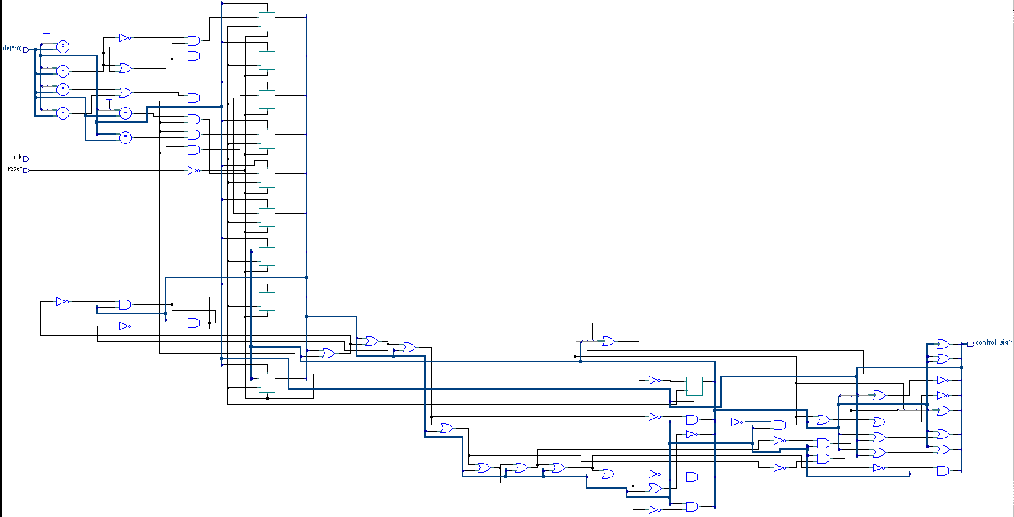
Figure 5 Synthesized result from Leonardo

In Figure 5 we can see that the combinational logic in onehot FSM is greatly simplified compare to the binary FSM in Figure 3.

4. Clock Gating

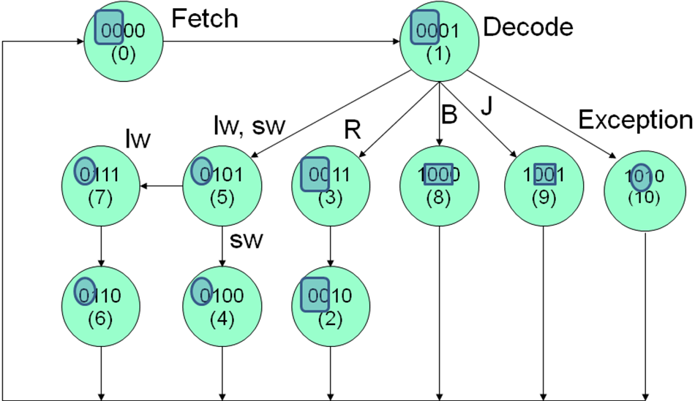
Figure 6 Clock gating scheme

In Figure 6 notice the outlined bits, which will not switch during shifting between a pair of states. So in the decode state we can generate additional control signals to gate the clock to certain flip-flops. This may be especially useful for onehot encoding because in onehot there are a lot of unused bits.

decode :
begin
control_sig = 11'b011000000000011;
/* last four bits are for gating for R-type instructions*/
case (opcode)
lw : next = lw_or_sw;
sw : next = lw_or_sw;
add : next = r_alu;
addi : next = branch;
beq : next = branch;
j : next = jump;
endcase
end
5. Simulation Result

Powersim are used to calculate power savings for these control FSMs.
Test vectors are based on a simple benchmark program which multiple two arguments in two registers and place the result in a third register.

Table1 powersim results
 | Random | Optimized | Onehot | State Duplicate
Average dynamic power | 6.8949 | 4.6450  (32.6%) | 0.5913  (91.4%) | 4.7089  (31.7%)
Average Glich Power | 6.8711 | 4.6303  (32.6%) | Na | 5.0878  (26%)
Average Leakage Power | 2.3153 | 2.2786 | 2.2918 | 2.3993
Total | 9.2103 | 6.9236  (24.8%) | 2.8831  (68.7%) | 7.0083  (23.9%)
No. of Gates | 93 | 97 | 82 | 98

From simulation results we can see that onehot gives the most power reduction (68.7%). And just by state optimization we can get 24.8% power savings. State duplication did not give us better power savings compared with optimized state encoding. This is because the duplicated states: Fetch2 in Figure 2(c) reduces the switching activity when the MIPS processor executes an exception. But in the bench mark program no exception occurs.

6. Future Work

In Leonardo we can also get the critical path of synthesized circuits which shows that onehot FSM has shorter delay. Also with fewer No. of gates the area should be smaller. And considering the fact that in onehot lots of flip-flops are inactive during state transition, clock gating may give us even more power savings. But clock gating is hard to implement using verilog (it will disrupt the always block). Another way to try out clock gating is to use Design Architect. Directly wire gating signal to an AND gate, as shown in Figure 7.
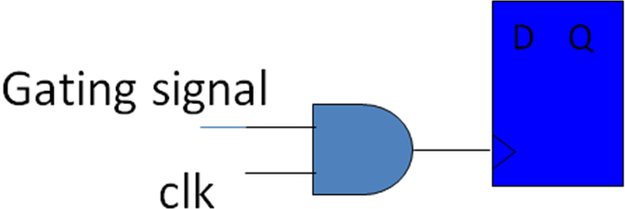
Figure 7 Clock gating

References:

[1] Lin Yuan, Gang Qu, FSM Re-Engineering for Low Power State Encoding, Design Automation Conference, 2005. Proceedings of the ASP-DAC 2005. Asia and South Pacific, Volume 1, 18-21 Jan. 2005 Page(s):254 - 259 Vol. 1

[2] Clifford E. Cummings, The Fundamentals of Efficient Synthesizable Finite State Machine Design using NC-Verilog and BuildGates, INTERNATIONAL CADENCE USERGROUP CONFERENCE, September 16-18, 2002, San Jose, California

[3] Steve Golson, State Machine Design Techniques for Verilog and VHDL, Synopsys Journal of High-Level Design, September 1994

[4] Jingpeng Lv, Xianzong Xie, Kyung Jin Park, Byong Wu “Bernard” Chong, Low Power MIPS Processor Design, www.cs.utah.edu/~bchong/VLSI/Final_Report_VLSI.pdf

