CHEN 3600 Computer-Aided Chemical Engineering
Department of Chemical Engineering
Auburn University, AL 36849

MEMORANDUM

Date: February 13, 2012
To: Dr. Timothy Placek
Subject: Interim Report 1

Executive Summary
Temperature data was collected every thirty seconds from six thermocouples in various locations in and around a kiln for two different types of firings. In addition, room temperature data for a typical firing was furnished. The data was to be analyzed and explained. Relationships between the readings at each thermocouple were also determined.

MATLAB was used to process the data given and manipulate it into usable forms, as well as to graphically display selected portions of the data to evaluate. MATLAB was also used to determine the rate of change of temperature data from one of the thermocouples for evaluation. Relationships between the data from each thermocouple were determined analytically by examining the graphs produced by MATLAB. Resources depicting typical behavior for each firing were also used, and the collected data was compared to the typical behavior.

Several relationships were determined by analyzing the graphs produced from the data. In general, the graphs for the data from the thermocouples outside of the kiln reflected the same temperature changes that occurred inside the kiln, but to a much lesser degree. For example, the temperature at the lid of the kiln peaked at the same time as the temperature inside the kiln, but at a smaller temperature. In addition, the bottom portion of the kiln was consistently cooler than the top portion during heating because the shelves near the bottom acted as heat sinks and absorbed more heat; at the start of cooling, the bottom portion was warmer than the top portion because the shelves had more heat to disperse. The data that was collected also closely correlates the typical behavior for each firing profile.

Theory and Analysis
Temperature data at six points in and around an L&L e23S kiln for two firing profiles were observed and analyzed. The two firing profiles were Slow Bisque Cone 05 and Fast Glaze Cone 6. The temperatures were measured using thermocouples secured at six locations: internal top and bottom, external top and bottom, floor just below the kiln, and the surface of the lid. (It is noted that room temperature data was available, but only for a separate Cone 05 firing, and the intervals of data-taking were different from the original data.) Students analyzed the trends at each location and the relationships between temperatures among multiple locations.

The original data was in comma-separated value format, and the data was loaded into MATLAB for analysis. Plots were used to visually compare the raw data and interpret the phases involved in the kiln firing process. Attachment 1 is the code written to upload and view the data.

Results and Discussion
The behavior of the kiln during separate firings was very similar, with major variations in “checkpoint” temperatures and durations of temperature changes. Therefore, the majority of this discussion regards both firings as one similar trial, and contrasts are discussed separately.

Phases in temperature changes
Figure 1: Internal temperature during Cone 05 Slow Bisque firing.

To start the Cone 05 Slow Bisque firing, the kiln heated up to 177°F and held that temperature for about 13 hours so the clay could dry up (see Figure 1). The clay that was fired in the Slow Bisque run was “virgin” clay; it had never been fired before. In order to carry out the reactions necessary to make glass, the clay needed to be completely dried. After the drying period was over, the kiln began heating. The temperature increased linearly for the first four hours of heating, and then the kiln slowed down the heating process for approximately an hour. Then the kiln resumed about the same rate of increase as before, and again it slowed until it reached its peak temperature of 1851°F. At that time, the kiln immediate began cooling.

The instruction manual for the temperature control gives “checkpoint” temperatures at which the kiln changes its heating rate. For Cone 05 Slow Bisque heating, the checkpoint temperatures are 250°F, 1000°F, 1100°F, 1641°F, and 1891°F (Dynatrol Reference Manual). Figure 1 shows changes that correspond to the expected changes for this firing profile.

Figure 2: Internal temperature during Cone 6 Fast Glaze firing.

The Cone 6 Fast Glaze firing did not need a drying period because the bisque clay had already been dried and fired one time before. This run was meant to fire the glaze coating on the bisque clay. At the start of the run, the kiln immediately began heating at a constant rate for approximately three hours, at which time it slowed the heating process, as shown in Figure 2. At its peak (2220°F), the kiln shut off and immediately began cooling.

The expected checkpoints for the Cone 6 Fast Glaze firing are 1978°F and 2228°F, both of which are closely matched in Figure 2 (Dynatrol Reference Manual).

Top and bottom internal differences
Figure 3: Top and bottom interior temperatures v. time (top graph) and the differences between these temperatures (bottom graph) for the Cone 05 Slow Bisque firing.

For both firings, the interior bottom temperature was consistently lower than the interior top temperature while the kiln was warming up. Then, as the kiln began cooling, the bottom temperature initially remained warmer than the top, until the top portion cooled more slowly and the bottom temperature dropped below that of the top for the duration of cooling. The bottom portion’s lower temperature was a result of more mass being concentrated at the bottom of the kiln. There were layers of plates within the kiln, and the uppermost shelf in the kiln allowed a gap of a few inches between the highest materials and the lid of the kiln (Placek, T. D., personal communication, February 8, 2012). The bottom shelf rested within two or three inches of the bottom of the kiln, thus increasing its concentration of mass.

As the kiln heated up, the bottom portion with more mass took longer to absorb the heat – resulting in a slightly lower temperature. As the kiln cooled, the bottom, more densely packed part of the kiln took longer to release its heat, resulting in a higher temperature – but only initially. The heat at the bottom eventually traveled upwards, causing the bottom temperature to drop below the temperature at the top.

Exterior top and bottom temperature differences
Similar to the interior temperatures, the top and bottom exterior temperatures were not equal. Again, the bottom section of the kiln was not as hot as the top section of the kiln. This direct correlation is expected, seeing as the exterior temperature changes were a direct result of the interior temperature changes.
Figure 4: Temperatures at auxiliary top, bottom, and lid surfaces for Cone 05 Slow Bisque firing.

Figure 4 shows that the lid temperature was significantly lower than the auxiliary temperatures. This is due to the positioning of the thermocouple. The thermocouples for the top and bottom auxiliary temperatures were wedged between stainless steel and the firebrick – a very well insulated location. The thermocouple at the lid of the kiln was placed into a small defect in the firebrick, which minimized airflow, and it was held down by a piece of clay. This position was exposed to the air and poorly insulated, which greatly decreased the temperature reading at that thermocouple.

Figure 5: Temperature difference between top and bottom auxiliary thermocouples in Cone 05 Slow Bisque firing.

When one looks at the differences in temperatures between the top and bottom thermocouples (Figure 5), one sees that the top thermocouple was consistently hotter. However, at about 24 hours, the bottom thermocouple began reading closer to the top thermocouple, and their temperatures were within 10°F of each other at about 27 hours. This trend reflects the same occurrence the differences between the interior thermocouples demonstrated. As the kiln began to cool, the bottom section with more mass took longer to release its heat. Then, as convection moved the heat upwards, the difference between the top and bottom again increased. As the kiln continued cooling, the top and bottom interior and exterior temperatures began to equilibrate.

Greatest rate of change in temperature
As the kiln heated up and cooled down, the rate of temperature increase/decrease varied according to the happenings inside the kiln. In the Cone 05 firing, the kiln remained at about 177°F to dry the clay to avoid an accumulation of water/steam. (This process is more important for the bisque firing than the glaze firing because the materials being fired for glazing are essentially dry since they have been cooked once already.) For the duration of the heating process, the rate of change is relatively constant. Then, as the kiln enters into the final phases of its heating process, the rate of change decreases.
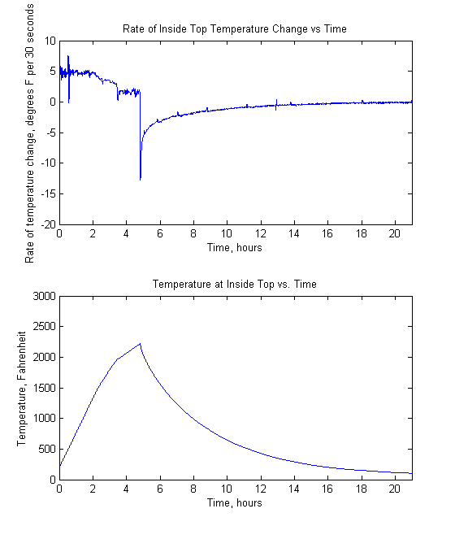
Figure 6: Rate of temperature change at the top interior thermocouple in the Cone 6 Fast Glaze firing (top graph) and temperature v. time in the same run (bottom graph).

The greatest rate of temperature change corresponds with the time at which the kiln stopped heating, as is visible in the graphs in Figure 6. The red line emphasizes the correlation between the drop in rate of temperature change and the peak of the kiln’s interior temperature. The drastic change in the rate of temperature change was a result of the temperature gradient between the kiln and its surroundings. The difference between the interior and exterior temperatures was greatest when the interior was hottest, thus the kiln lost the greatest quantity of heat in the shortest length of time at the moment when the kiln stopped heating.

Analysis of floor and room temperatures
The room temperature was remarkably low considering the small size of the room (roughly 250ft²) and the temperature of the kiln (up to 2220°F). The air temperature increased to a maximum of 75°F (approximately six feet away from the kiln). Three ventilation/cooling systems were employed to keep the room temperature down: air conditioner mounted at the wall approximately three feet from the unit, two small vent fans blowing outward towards the outdoors approximately two feet from the kiln, and a fan circulating conditioned air throughout the room approximately five feet from the kiln. These measures successfully prevented the accumulation of hot air in the room that would have resulted from the convection of heat from the kiln.

The low air temperature was also an indicator of the heat loss due to radiation. In other words, not all heat was lost to convection. Rather, the kiln radiated heat to every object in the room (e.g. the wall, floor, ceiling, desk, etc.). The largest of the objects acted as heat sinks by absorbing heat without undergoing a significant change in temperature. For example, the wall that adjoins the room to its neighbor could take in heat, but in doing so it created a temperature gradient between the two rooms. The heat transferred to the room next door – a vast space full of air – and thus the temperature at the wall remained relatively constant. Since virtually everything in the room was at a lower temperature than the kiln, each object absorbed the radiated heat. In most cases, the heat taken in by the objects had little to no effect on the convective heat in the room, and thus the room temperature remained low (Placek, T. D., personal communication, February 8, 2012).
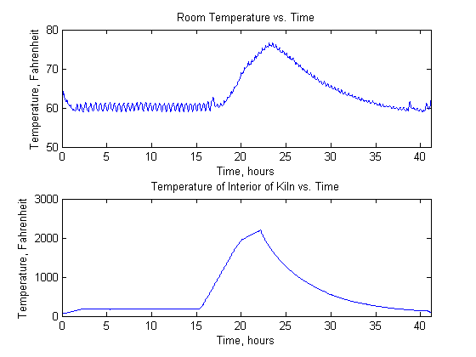
Figure 7: Room temperature v. time (top graph) and Cone 05 Slow Bisque top firing temperature v. time (bottom graph).

Despite the small change in room temperature, the behavior of room temperature was quite revealing about the happenings in the room. First, throughout the duration of the firing, the temperature oscillated up and down at a very consistent pace (see Figure 7 – top graph). This can be accounted for by the air conditioner turning on and off to maintain the room’s temperature at around 60°F. For the duration of the “drying” phase of the firing, the air conditioner maintained that temperature fairly well. Then, as the kiln heated up, the air conditioner struggled to maintain a consistent temperature in the room. In fact, the room temperature did not drop to its original temperature until the kiln was about at its drying temperature again. Air conditioners are understood to turn on when the room is too far above its set temperature and to turn off when the room is reasonably below its set temperature. However, the equally-spaced peaks in the “hill” of the graph demonstrate that the air conditioner did not wait until the room was the desired temperature to shut off. Rather, the air conditioner had an automatic cutoff to prevent it from malfunctioning.

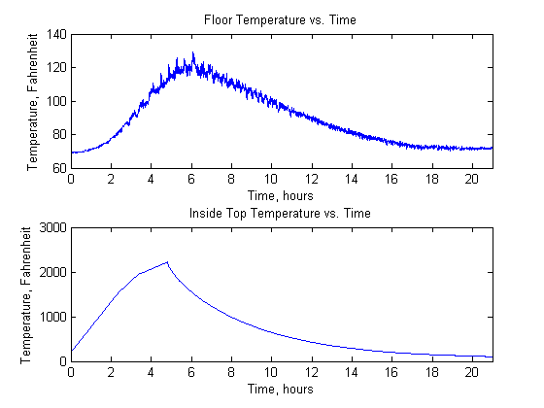
Figure 8: Floor temperature v. time (top graph) and interior top temperature v. time (bottom graph) for the Cone 6 Fast Glaze firing.

The temperature of the floor just below the kiln increased significantly during the firing. The thermocouple was placed on the surface of the floor – fully exposed to the air. Thus, the thermocouple measured the temperature of the air more than it did the temperature of the floor. Just as with the room temperature, the temperature below the kiln oscillated with the turning on and off of the air conditioner. The close proximity to the kiln (approximately eight inches) and the confined space caused the temperature in this region to be much higher than the temperature of the room.

Conclusions
Data for two typical firing profiles of an L&L Cone 12 Kiln were recorded, and the data was interpreted using MATLAB. Temperature was taken at six points in and around the kiln using thermocouples. The trends in the temperature represent the phases of the firing profiles, and the data reveal insightful peculiarities regarding the happenings in a kiln firing.

The temperature at the bottom of the kiln was consistently lower than that at the top of the kiln as a result of uneven mass distribution inside the kiln. This difference was reflected in the interior and auxiliary thermocouples.

The room in which the kiln was located was relatively small (about 250 ft²), but the temperature in the room did not exceed 77°F. The kiln reached a maximum temperature of 2220°F during the Fast Glaze firing, which makes for a remarkable contrast. The kiln had to have lost a great deal of its heat through convection and radiation. The heat lost to convection was allowed to leave the room via ventilation systems, and the radiated heat dissipated to surrounding rooms.

In firing clays in the kiln, one key factor in the success of the run is changing the temperature at an appropriate rate. If the kiln heats up or cools too quickly, there is potential for damage to the clay and/or the kiln. Therefore, it is important to monitor closely the trends in the kiln’s temperature changes (and the temperature of the kiln’s surroundings to avoid damaging the objects in close proximity to the kiln).

References
(2007). Dynatrol Reference Manual. Retrieved February 8, 2012, from http://www.bigceramicstore.com/Supplies/kilns/LLdynatrol-instruct-700.pdf.

Attachments
Attachment 1: Code Used to Process Data and Generate Graphs

