CHEN3600 – Computer-Aided Chemical Engineering Spring 2012

Chemical Engineering Department Lab 4
T.D. Placek Auburn University

Lab 4 – A Night at the Tables

Problem Statement
In this assignment, you will be developing a graphical representation of the outcome of spending a day at a casino and limiting your play to the game of roulette. Its purpose is to let you experience a Monte Carlo simulation as well as consider the consequences of certain betting/risk strategies. Without risking “real money”, you can see how much money you could expect to lose or gain if you used a particular betting system for an extended period.

Even-Money Roulette Bet, Explained
A roulette wheel has the numbers 1 through 36 plus 0 (as well as 00 in North America). So it has 37 spots in Europe and 38 in North America. We will assume a North American casino.
There are six even money bets on a roulette wheel:
- High (if ball lands on 19 thru 36)
- Low (if ball lands on 1 thru 18)
- Even (2, 4, 6, thru 36)
- Odd (1, 3, 5, thru 35)
- Red (half of 1 thru 36 are red; note: zeroes are green)
- Black (the other half of 1 thru 36 are black)
With an "even money" bet, you wager on one of the six categories above. If you win (e.g. the ball lands on "20" when you bet high), then you get you keep your original bet and the bank pays you the same again. If you lose (e.g. ball landed on "11" when you bet high), then the bank keeps your bet.
All "even money" bets lose if the ball lands on 0 or North American 00 (this the house advantage). In fact, in Europe (particularly France), you effectively only lose half your bet if the ball lands on zero (the so-called "in prison" rule).
Even money betting systems strive to overcome the house advantage by varying the bets in their own way. The MATLAB program you write will let you determine whether these systems actually succeed in overcoming the house advantage.

Starting Concepts

Assume, for simplicity, that you will be playing a “red” / “black” strategy where it makes no difference whether you choose red or black since they are equally likely to win. The probability of winning is 18/38 and the probability of losing is 20/38. If you were to sit back and just observe the “play”, you would see that as people make bets and put money on the table, all they are doing is “passing money back and forth between themselves” except 2/38 of the time when the money is picked up by the “house”. This is the basis for the “harmlessness” and “fun” of the game because ABOUT ½ of the time you win and ABOUT ½ of the time you lose.

Betting: The casio will pay you back $2 for each 1$ you bet if you win. If you lose, you lose your dollar. In the long run, if you were to bet $20 each time on 50 spins of the wheel, you would expect the following:

expected_winnings = -$52.6316

why???

%% The Wheel of Fortune (Roulette Demonstration)
games = 50;
p = 18/38;
wins_expected = games*p;
bet = 20;
expected_winnings = -games*bet + wins_expected*bet*2

Program Requirements

Your MATLAB script should implement the game of Roulette subject to the following requirements:

Given information | Typical Value*
Amount of money brought to the Casino | $200
Amount of money to bet each time the wheel is spun | $10
Amount of money you wish to win  (does not include money brought to play) | $100
Maximum number of games before quitting for the day (this is to prevent hovering around zero). Consider how often you think a Roulette wheel is spun and how long you will be willing to stand around the wheel. | 500 spins
* You will be selecting these parameters to answer the questions below.

The below graph shows a typical scenario where it was hoped to win $100 starting with $200 making bets of $10 per spin limited to 500 spins. This particular game ended when the player exhausted his/her resources. In reflection, this person is not particularly greedy, wishing only to leave with 50% more money than they came with. Most gamblers hope after one visit to the casino to have much more money than they arrived with.

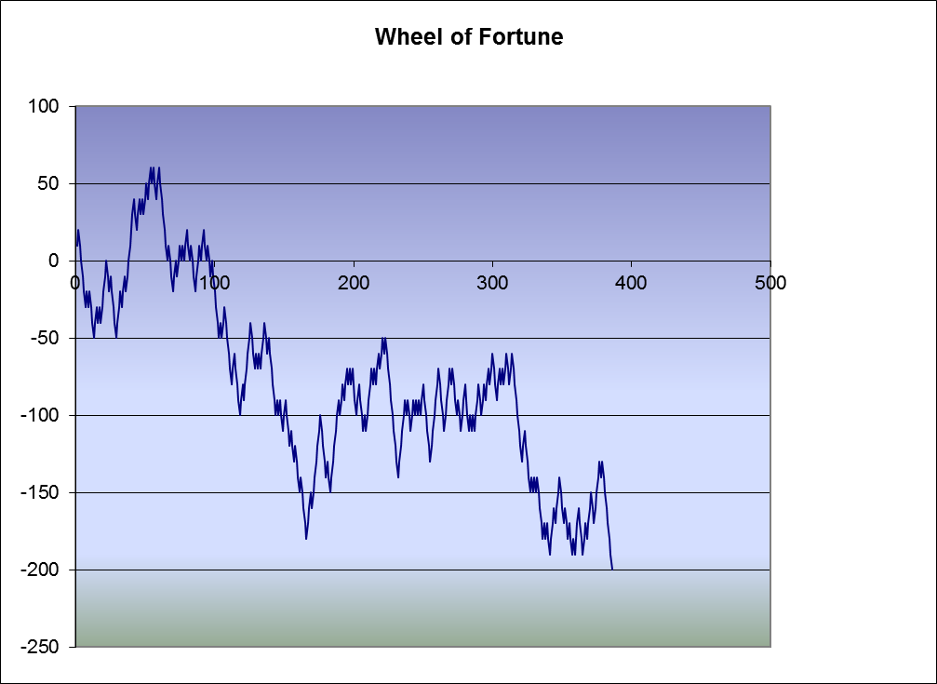

Your submission for this assignment is to be a pdf file of the script you develop including any external file functions (added as comments as per the exams).

Your solution must employ an EXTERNAL FILE named “one_day” which provides information on what occurred during a single trip to the casino. The returned information from this function will include all information about the “one day” including the record of “net_gain” versus “spin_number” (which is graphed above) as well as an indication of the “end_of_day_condition” meaning (1) you won your target amount and are leaving early, (2) you have lost all the money you brought with you and are leaving early, (3) you have stayed as long as you allowed but have neither won your target amount or lost all your money. It is from this information that you will be able to create “multiple day” simulations (Monte Carlo method) to address the issues below. Data provided to the “one_day” function include (1) your desired winnings, (2) your wallet, (3) your standard bet.

Other Features:
(1) Try to develop a program that can run “automatically” and collect information about the percentage of the times a particular set of game parameters yielded the desired winnings, percentage of times “busted” and the percentage of times quit because of “rain” (time to go to bed). You will probably wish to turn off (graphing) to allow this to run quickly.
(2)If possible, by testing various different values, develop a representation of the “greed factor”.

