CHEN3600 – Computer-Aided Chemical Engineering Spring 2012

Chemical Engineering Department Course Project
T.D. Placek Auburn University

Course Project – Analysis of Kiln Firing Data

During the following weeks, we will be considering several sets of data taken from a ceramics kiln used for educational and research purposes. In conjunction with MATLAB and heat transfer theory from CHEN3620, we will study a variety of heat transfer processes and concepts during several assignments.

Background: Approximately three years ago, Drs. Ashurst and Placek received a Breeden Grant to investigate how the undergraduate experience could be made “more effective” through the use of “make it real” equipment and associated data. In addition to funds from the fellowship, the department has purchased additional equipment and instruments to be employed for this purpose.

One of the major pieces of equipment is a professional-grade ceramics kiln which is used for glaze development research and related experiments. This kiln is computer controlled and currently produces a variety of data streams mostly dealing with the measurement of temperature via thermocouples. Other data (current drawn, voltage, power, relay state, etc.) have to be manually collected using the present setup.

Equipment description: (The student is encouraged to do additional web research to have a better understanding of the equipment and processes involved).

Kiln: L&L CONE 12 KILN: E23S-JH for Crystalline Glaze Firing (240V-1Ph)
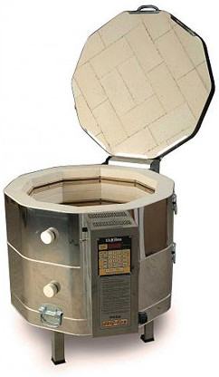

Digital Controllers / Data Acquision: Omega Engineering Series CN7800 Microprocessor Based Temperature Process Controller.
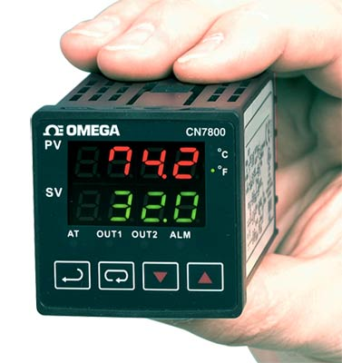

Thermocouples: Both Type K and Type S are employed. There are two Type S thermocouples which come with the kiln to measure the top zone and bottom zone temperatures and provide information to the on-board controller (EZ-Fire). These thermocouples are wired in parallel with CN7800 units to prepare the data for computer acquisition. All other thermocouples are Type K and are currently measuring the top section exterior temperature, the bottom section exterior temperature, the top surface (lid) exterior temperature, the temperature of the floor directly underneath the kiln, and room temperature.

Venting: Vent-Sure Downdraft Kiln Vent System
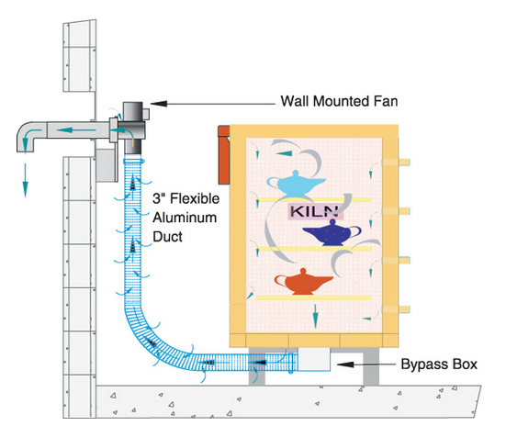

Bypass Box: Current Orifice opening approximately 50%.

Max Temperature: Cone 12, 2400F, 1315C

Firebrick: K25

Cone Information: See “Orton Pyrometric Cones” and “Heatwork”

Available Data: Currently there are two sets of data available for analysis:
- Slow Bisque Cone 05 Firing (2012-01-14).csv
- Fast Glaze Cone 6 Firing (2012-01-19).csv

Typical Materials Fired:
- Standard Clay 213 (Cone 6)
- Custom prepared/developed Glaze Recipes (Cone 6)
- Bisque firing to Cone 05

Interim Report 1:

Your first objective is to “make sense” of the two sets of data provided. You will be preparing a Technical Memo Report which includes an analysis of the data, informative plots, as well as basic descriptive information about the data sets.
Make appropriate technical commentary about the data. Attempt to summarize the characteristics of the temperature-time data in a meaningful way.

On this assignment, you may work by yourself or you may have a partner. Teams are limited to two persons (no exceptions). If you decide to work with someone else, there will be no resolutions of disputes, etc., by the instructor. I am not Solomon!

Future Work:

Throughout the remainder of the term, you will be submitting additional interim reports showing your progress toward a final project report that contains a comprehensive analysis of the provided data. These reports will have different requirements. Each should be a “stand alone”
report (that is, write as if the reader has not previously read the earlier reports). Of course, you can (properly) reference these reports, but do not assume the reader has knowledge of them.

