COMP-4640 Intelligent & Interactive Systems
Lecture #2

Agents

- An Agent is anything that perceives its environment via sensors and acts upon that environment via effectors.

- In this course, we will be interested in the design of rational agents, i.e. agents that do the right thing giving a sequence of percepts.

- In order to design rational agents (and also to be able to judge whether they are actually rational!) we must know:
- how to evaluate an agent’s success
- when to evaluate an agent’s success

- The how part is accomplished through the development of a performance measure.

- For the when part, it may be best to measure performance over an extended period of time; however, at times it may be advantageous to have intermediate performance measurements along the way.
COMP-4640 Intelligent & Interactive Systems
Lecture #2

- For an agent, one can determine rational behavior based on:

- the performance measure of the agent,

- the percept sequence (this is the collection of all of the percepts received by the agent),

- what the agent currently knows about the environment, and

- the set of actions that the agent can presently perform.

COMP-4640 Intelligent & Interactive Systems
Lecture #2

Ideal Rational Agents

- An ideal rational agent is one that performs any action that is expected to maximize its performance measure given its percept sequence and its built-in knowledge.

- Ideal rational agents are formed by ideal mappings from percept sequences to actions

- An ideal rational agent may have some sense of autonomy. That is, it may be able to learn, adapt, and operate successfully in a variety of environments.

COMP-4640 Intelligent & Interactive Systems
Lecture #2

Structure of Intelligent Agents

- The objective of AI is the design and application of agent programs that implement mappings between percepts and actions

- An agent can be viewed as a program that is developed to run on a particular architecture (some computing device).

- The architecture:
- makes percepts available,
- runs the agent program,
- sends actions to the effectors

- Types of Agent Programs

Intelligent systems are typically composed of a number of intelligent agents. Each agent interacts (directly or indirectly) with one or more aspects of an environment. This type of agent interaction is similar to what we see in sports, business, and other organizations that are composed of a number of different agents with different responsibilities working together for the common good.

- There are a number of different agent programs; however, many can be classified as one of the following:

- Simple Reflex (Reactive) Agents

- Goal-based Agents

- Model-based Agents

- Utility-based Agents

- Communication-based Agents
COMP-4640 Intelligent & Interactive Systems
Lecture #3

Simple Reflex Agent I

Performance Measure:
Get to the bowl

Percept Sequence:
(x,y) coordinates

Agent’s Knowledge of the Environment:
No Knowledge

Set of Actions:
0 1 2
7 c 3
6 5 4
Rule Base

R01: If at(5,0) ⇒ action(2)
R02: If at(6,1) ⇒ action(2)
R03: If at(7,2) ⇒ action(2)
R04: If at(8,3) ⇒ action(1)
R05: If at(8,4) ⇒ action(1)
R06: If at(8,5) ⇒ action(1)
R07: If at(8,6) ⇒ action(0)
R08: If at(7,7) ⇒ action(0)
R09: If at(6,8) ⇒ action(0)
R10: If at(5,9) ⇒ action(0)
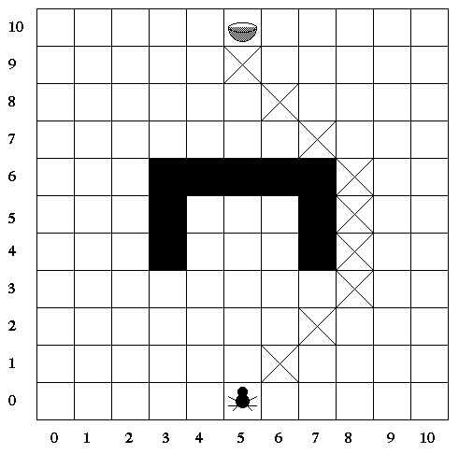

COMP-4640 Intelligent & Interactive Systems
Lecture #3
Simple Reflex Agent II
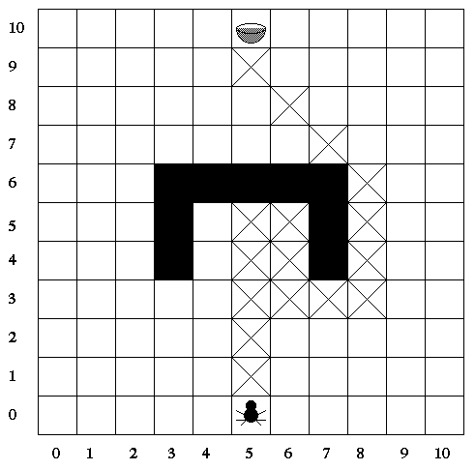

Performance Measure:
Get to the bowl

Percept Sequence:
(x,y) coordinates

Agent’s Knowledge of the Environment:
No Knowledge

Set of Actions:
0 1 2
7 c 3
6 5 4,

MTB (Move Towards
Bowl)

COMP-4640 Intelligent & Interactive Systems
Lecture #3

Simple Reflex Agent II (cont.)

Rule Base

R01: If MTB(x) ∧ clear(x) ⇒ action(x) ∧ remove(lastMove(y)) ∧ assert(lastMove(x))
R02: If MTB(x) ∧ ¬clear(x) ⇒ assert(escape_phase)
R03: If MTB(x) ∧ clear(x) ∧ escape_phase ⇒ action(x) ∧ remove(lastMove(y))∧ remove(escape_phase) ∧
assert(lastMove(x))

R04: If escape_phase ∧ ¬lastMove(5) ∧ clear(1) ⇒ action(1) ∧ retract(lastMove(_)) ∧ assert(lastMove(1))
R05: If escape_phase ∧ ¬lastMove(7) ∧ clear(3) ⇒ action(3) ∧ retract(lastMove(_)) ∧ assert(lastMove(3))
R06: If escape_phase ∧ ¬lastMove(1) ∧ clear(5) ⇒ action(5) ∧ retract(lastMove(_)) ∧ assert(lastMove(5))
R07: If escape_phase ∧ ¬lastMove(3) ∧ clear(7) ⇒ action(7) ∧ retract(lastMove(_)) ∧ assert(lastMove(7))
COMP-4640 Intelligent & Interactive Systems
Lecture #3

Goal-Based Agent
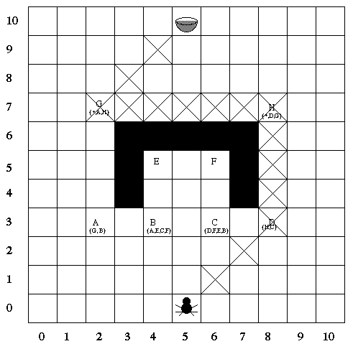

Performance Measure:
Get to the bowl

Percept Sequence:
(x,y) coordinates

Agent’s Knowledge of the Environment:
No Knowledge

Set of Actions:
0 1 2
7 c 3
6 5 4,
GeneratePath

Goal-Based Agent (cont.)

Rule Base

R01: If ¬path_ok ⇒ GeneratePath ∧ assert(path_ok)
R02: If path_ok ∧ getMove(x,y,a) ∧ clear(a) ⇒ action(a)
R03: If path_ok ∧ getMove(x,y,a) ∧ ¬clear(a) ⇒ retract(path_ok) ∧ retract(getMove(c,d,e))

COMP-4640 Intelligent & Interactive Systems
Lecture #3

Utility-Based Agent
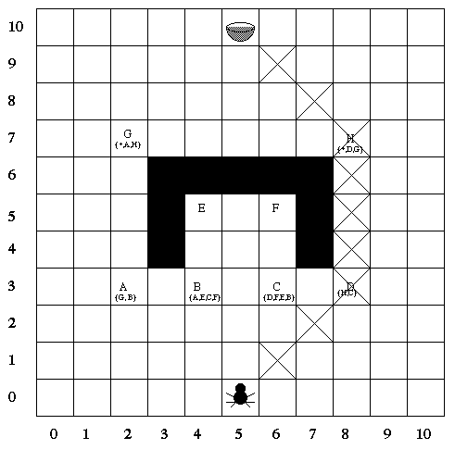

Performance Measure:
Get to the bowl
Using the Shortest
Path

Percept Sequence:
(x,y) coordinates

Agent’s Knowledge of the Environment:
No Knowledge

Set of Actions:
0 1 2
7 c 3
6 5 4,
GeneratePath

COMP-4640 Intelligent & Interactive Systems
Lecture #3

Utility-Based Agent (cont.)

Rule Base

R01: If ¬path_ok ⇒ GeneratePath(UF) ∧ assert(path_ok)
R02: If path_ok ∧ getMove(x,y,a) ∧ clear(a) ⇒ action(a)
R03: If path_ok ∧ getMove(x,y,a) ∧ ¬clear(a) ⇒ retract(path_ok) ∧ retract(getMove(c,d,e))

COMP-4640 Intelligent & Interactive Systems
Lecture #3

Agent Environments

- Accessible vs inaccessible

- Deterministic vs nondeterministic

- Episodic vs nonepisodic

- Static vs dynamic

- Discrete vs. continuous



