Automated Gang Lock
Altec – Corp 3



Group Members
Benjamin Mize
Richard Moyer
Justin Rutledge
Randy Turner
Michael Thompson

Midterm Report
Jason Labhart – Altec Sponsor
Dr. Beale – Comprehensive Design One – MECH 4240 – Summer 2007

Abstract
This report follows the concept development process of Corp 3 through until the final design concept is chosen. Altec a truck body company proposed the need for an automated gang lock to match the competitions feature list. This system needs to effectively lock and unlock all the body doors of the truck and provide a manual override in case of battery failure. Function, Cost, and Appearance are the concerns of the sponsor in order of importance.

Three directions of the system were proposed, which were then narrow to the two competing alternatives. One was to introduce movement into the current Altec design and remove the external handle that is an eye sore to the company and a magnet for thieves. This design focused on using a solenoid to move the bar and the use of an access panel for manual override. The other system is a new design that will add an additional lock to each door and be linked together through the using a wireless control hub. Each door will feature a key override similar to the existing key locks on the truck. A benefit and cost analysis will be conducted and a decision will be made between the two system.

Following the decision to choose the per door concepts two alternatives will be proposed. Further considerations need to be considered to make a sure decision between the two per door alternatives. Both of the concepts are viable and can meet the requirements put forth by the sponsor.

Table of Contents

Abstract 2
Introduction 4
The Company 4
The Problem 4
Specifications and Constraints 5
Relevant Criteria 5
Design Requirements 5
Specifications 5
Concept Presentation 6
Latch Redesign 6
(Randy turner)
Wireless Controller 6
(Justin rutledge)
Concept Ideas 7
Initial 7
Competing 7
Benefit Comparison 8
(Drew Mardis)
Cost Analysis 8
(Drew Mardis
Final Concept 9
Engineering Analyses 10
Economic Analysis 11
Recommended Design Concept 12
Linear per door 12
(richard moyer)
Rotational per door 12
(Ben mize)
Conclusions 14
Appendix 15

Introduction

The Company
Altec is a company with a manufacturing facility in Birmingham Alabama that produces truck bodies for a wide range of applications from the small business owner to industrial clients such as Alabama Power. The company also offers several other services, but as the focus of our project is on the truck bodies so we will concentrate on them.

The Problem
Altec has an existing manual gang lock that allows the user of the truck to lock all of the doors of a box segment at once. The company desires this action to be automated with a manual override and work similar to the remote entry system for a car. The system has to stay clear of the working area inside of the box and be of no or minimal interference to the users. The issues with the existing system are that it is not automated, the rings on the doors tend to rust, and the lock is clearly visible inviting dishonest people to break in. The goal is to fully hide the system while still retaining all of the function of the original.

The main use of this system is to allow the driver of the truck to be able to fully lock the truck and no other employee using the truck will be able to access the vehicle until the driver disengages the gang lock. Therefore the manual override cannot be simply hidden or have a trick to it or anyone using the truck would know the specifics and be able to disengage the system and gain access to the truck.

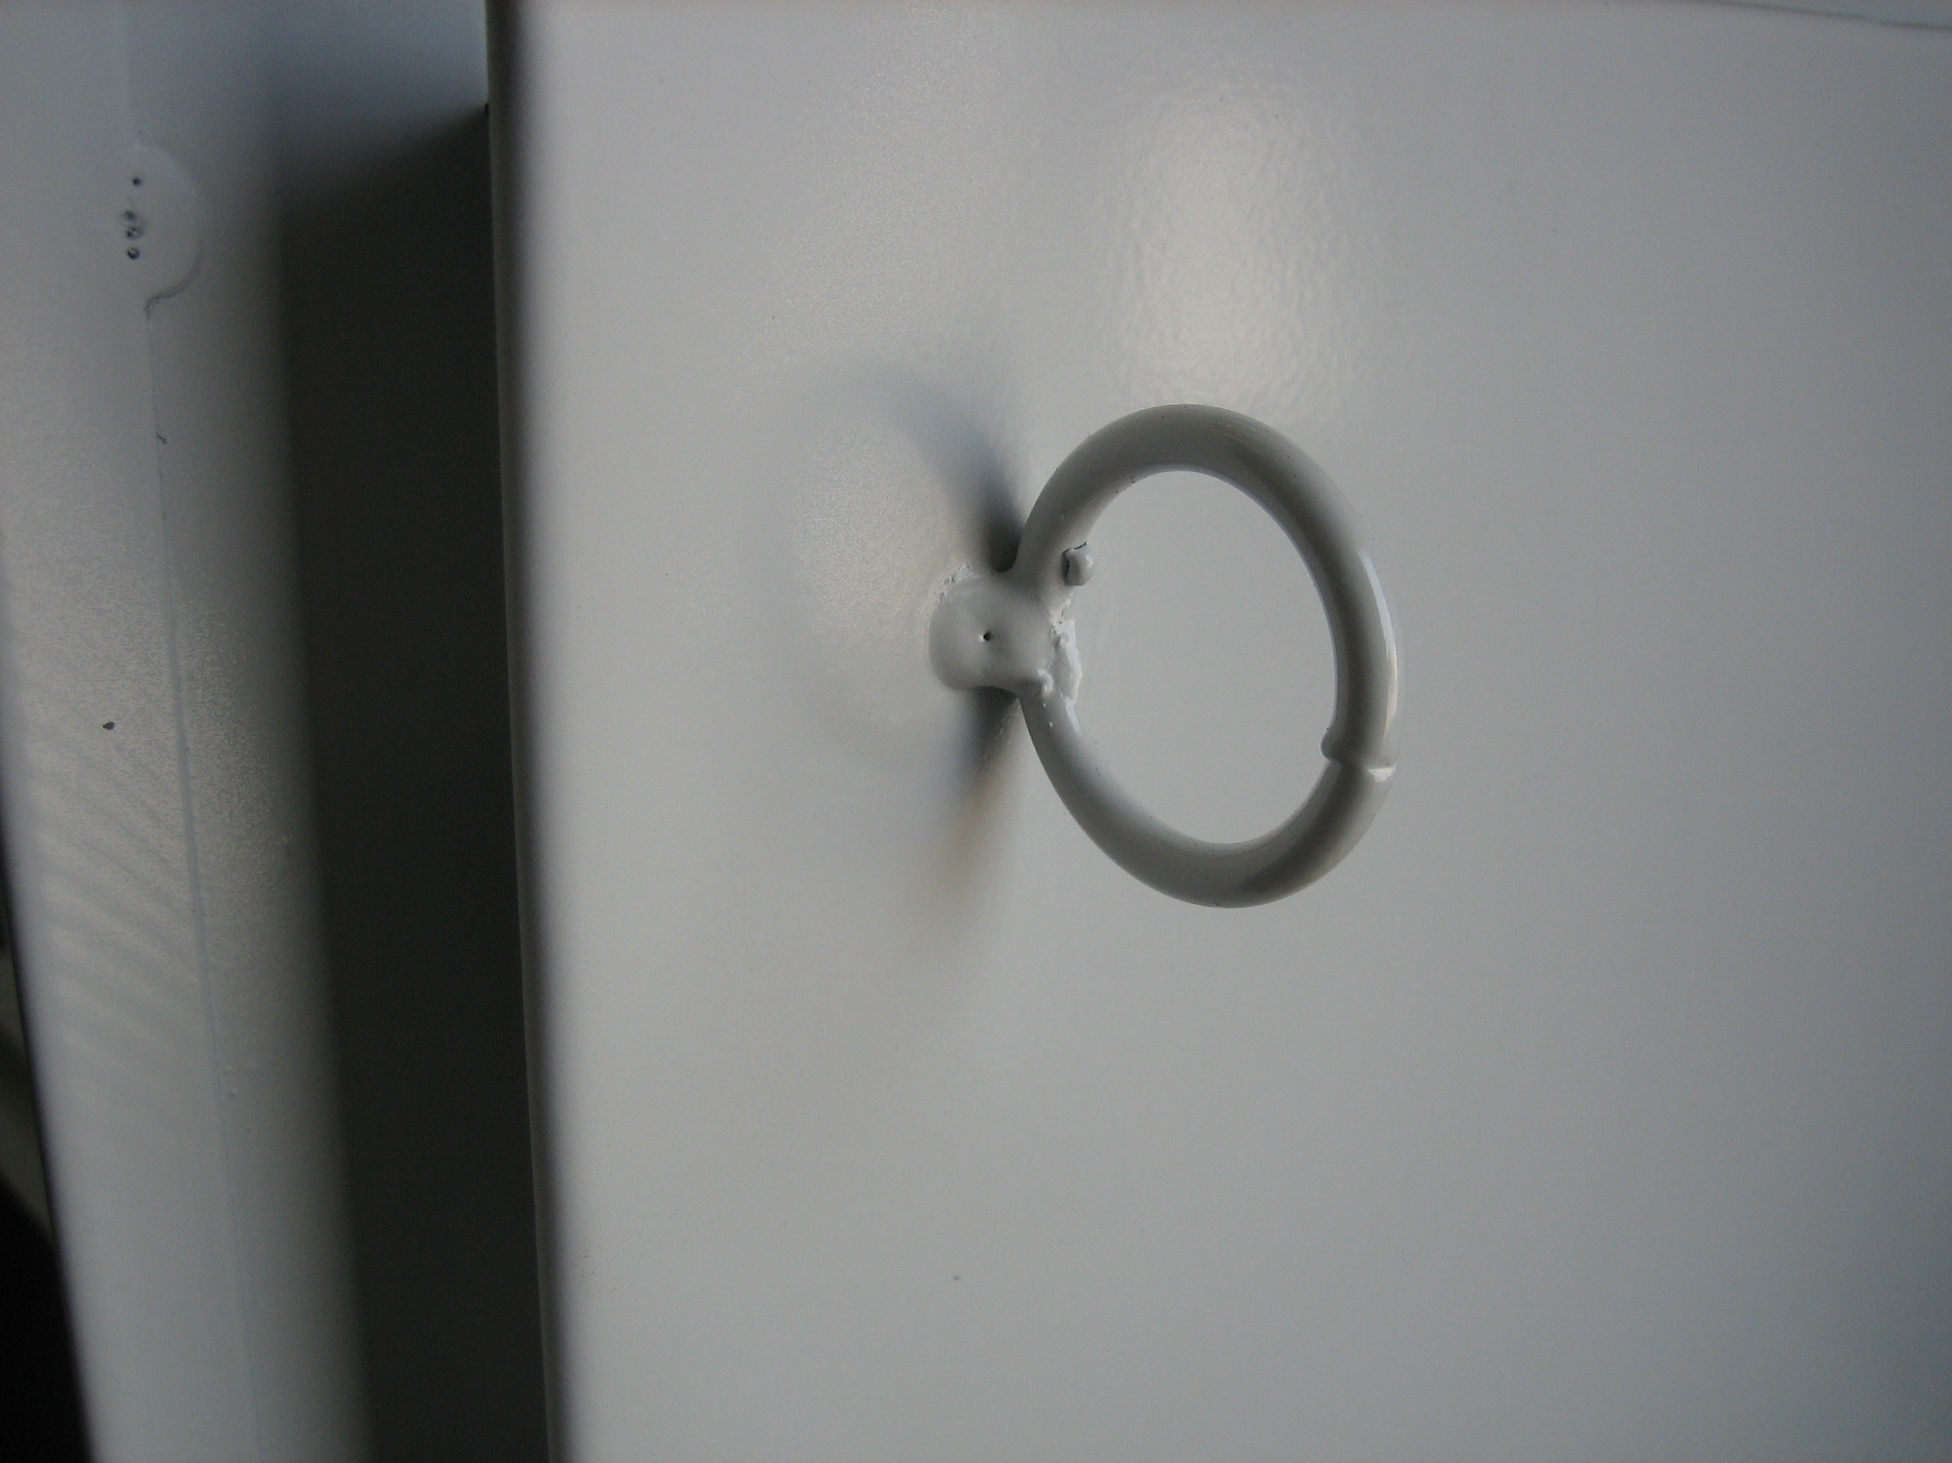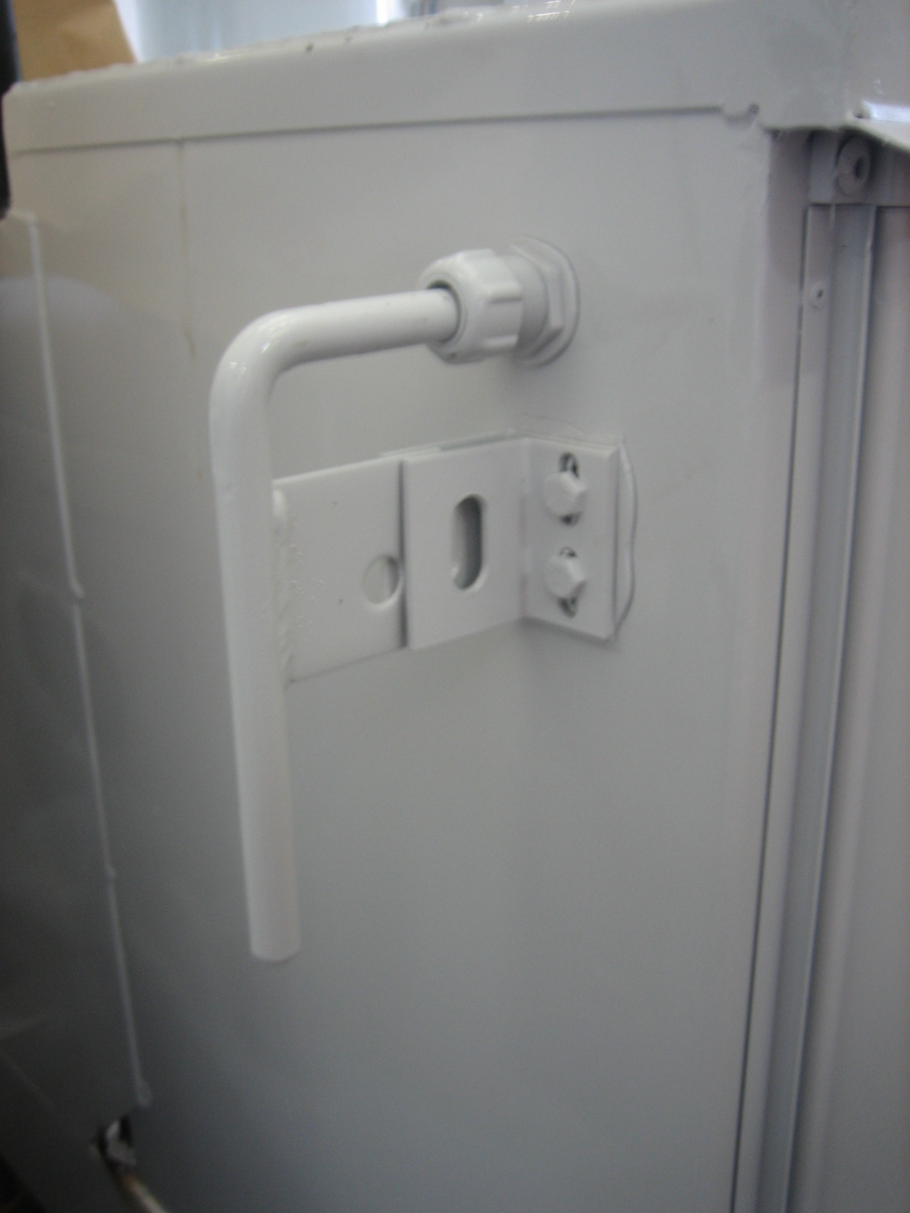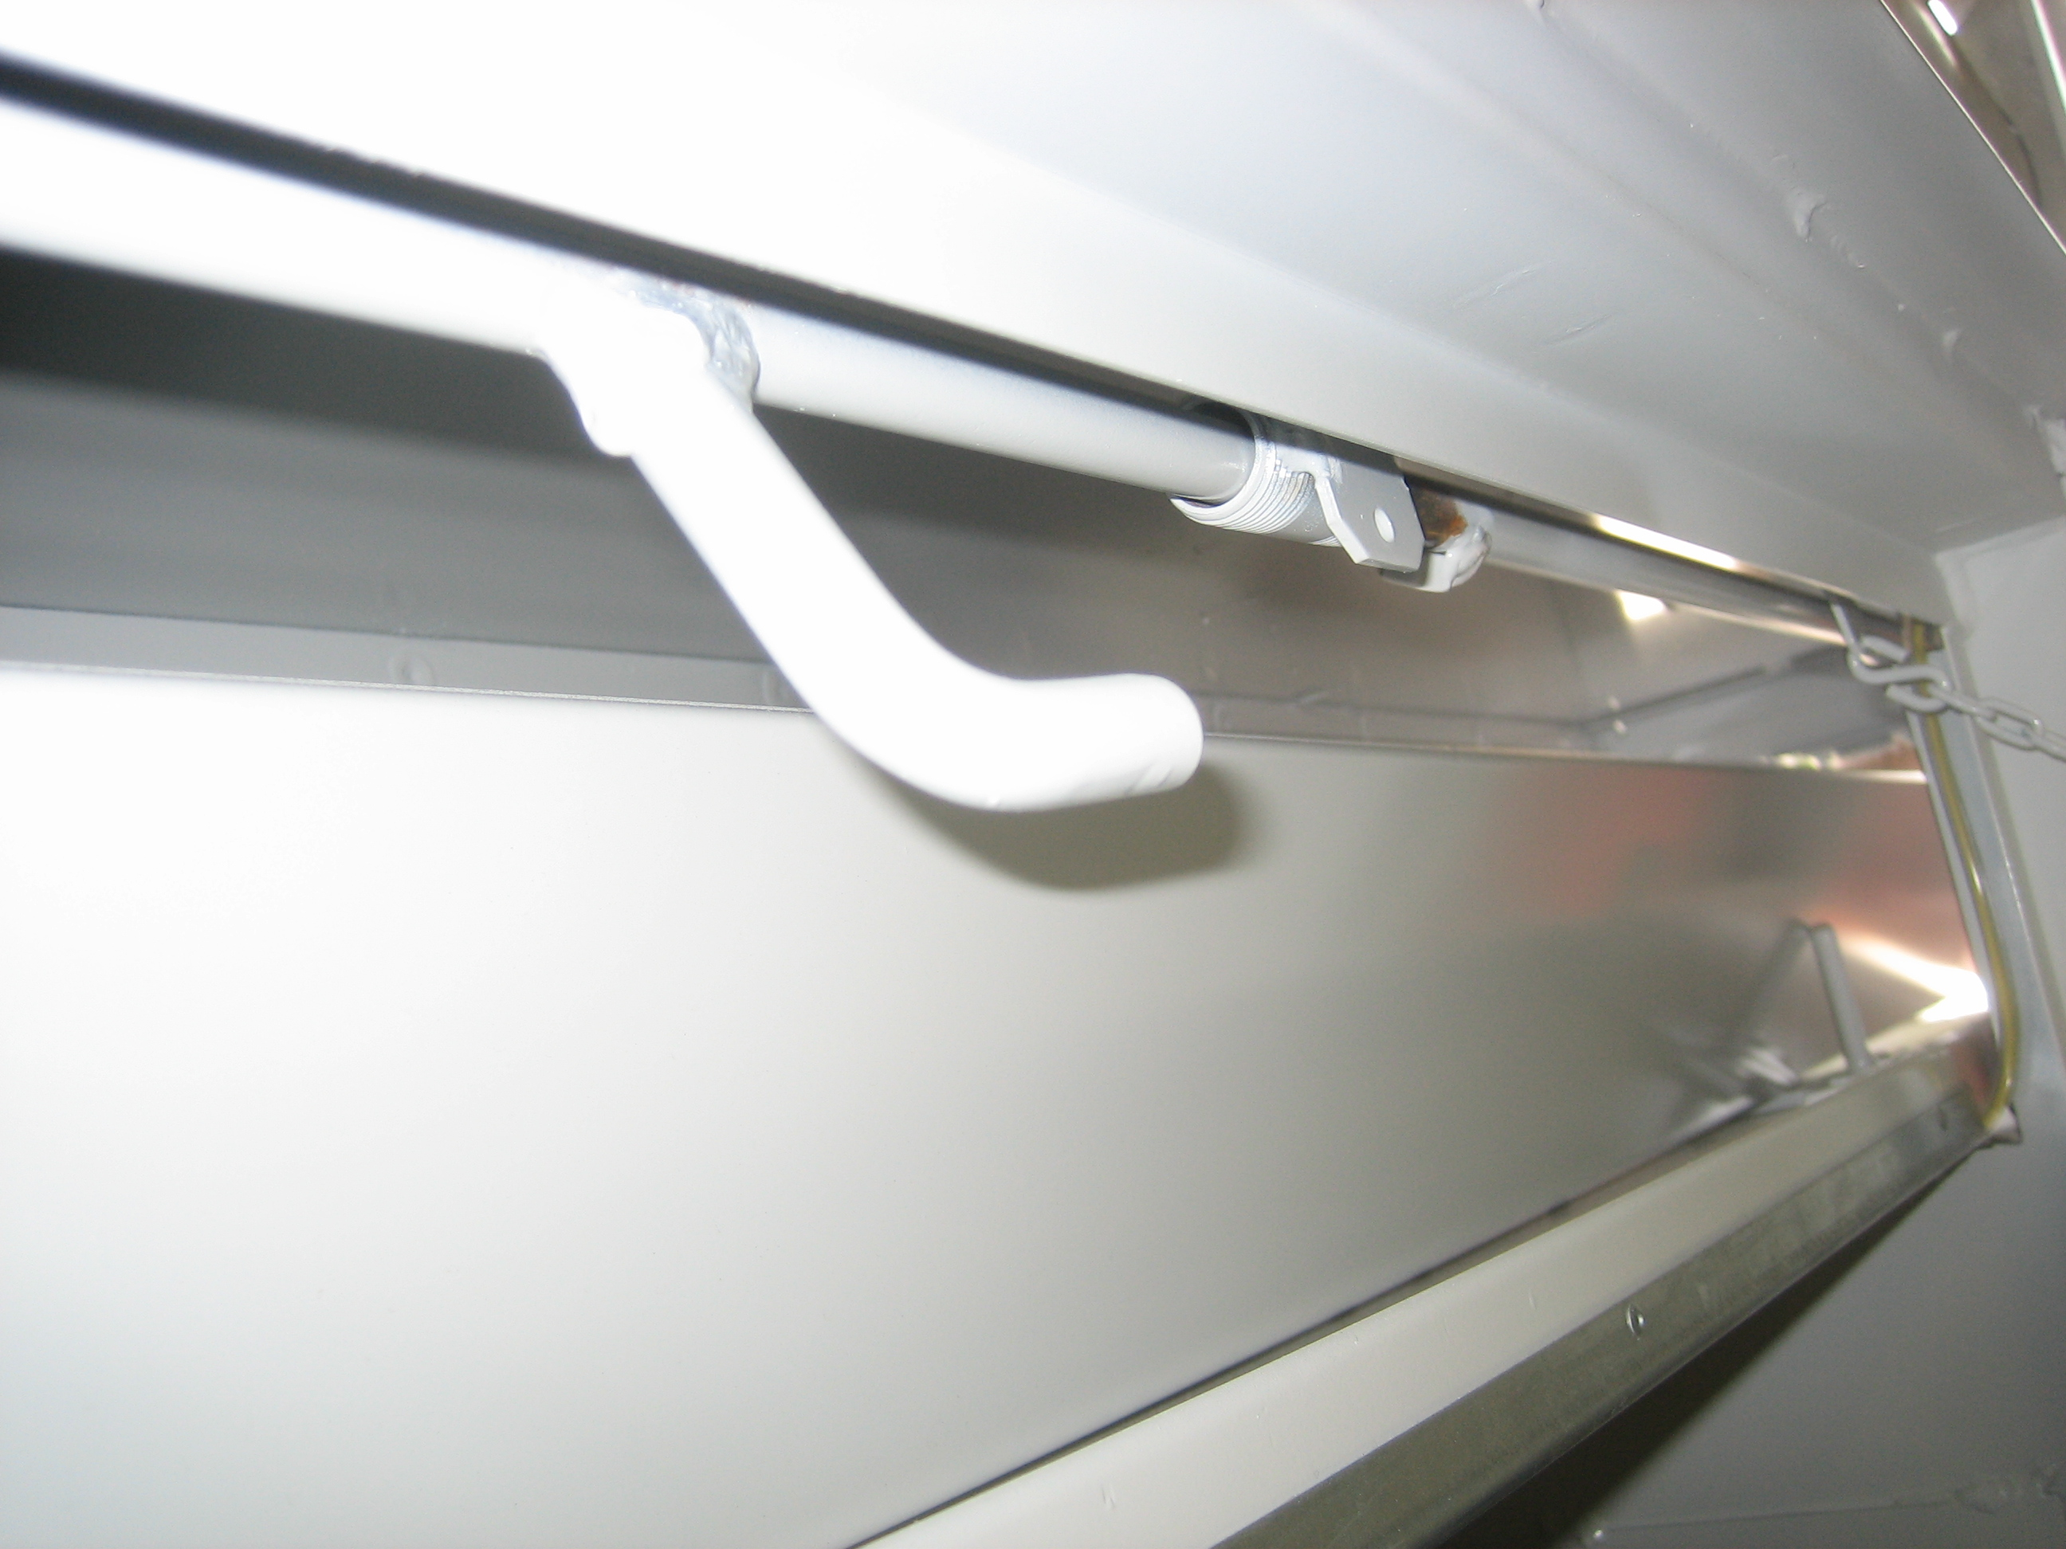
(Pictures of current design)

Specifications and Constraints

Relevant Criteria
The system should not have an environmental affect, it should not cause of create any toxic or harmful byproducts that could harm or affect the end user or working environment. The system should be easy to maintain and make replacement of any failure related problems simple. The product should ideally be able to be manufactured by Altec at the facility or be outsourced for an effective cost and then installed by Altec. The system should remain hidden and not create an opportunity for a user of the truck to catch any appendage in the workings of the system and harm them self. The working of the system should be covered with guard at all appropriate locations that and unsafe environment might be created.

Design Requirements
The industrial sponsor required the current manual gang lock to be automated and work off a key phob that the driver of the truck will carry. The system should also be able to integrate into the trucks existing power door locks if equipped for the vehicle. The order of priorities for the system should be function, cost and appearance. First, the system must function. Failure of the system is not an acceptable option. Second cost needs to be minimized as to allow for sufficient markup of the product itself, and for the system to appeal as a viable option to the consumer.

The latch design for the current manual system is a steel ring welded onto the inside of the door of the body. This lead to problems with the ring rusting due to it being welded on and the paint having difficulty covering the small crevasses created during welding. Also the ring seems obtrusive and could be better incorporated into the door design itself. A design that would allow for a simpler replacement of the latch if failure occurs would be beneficial. The new design for the latch should eliminate rusting concerns, along with improving durability, function, and replacement ease.

Specifications
The boxes the gang locks are used in can range from 18 inches to 220 inches. The truck bodies are warranted for a life of 10 years. Competitors of Altec already offer a remote gang locking system. The competitors warranted life of the electronic system is 3 years on parts and service, with the truck bodies carrying a 6 year warranty. This gives the system a half rating compared to the body of the truck itself. To match this, our new system should at least be warranted for 3 years, but ideally for 5 years, matching the half rating of the box life.

Concept Presentation

Latch Redesign
The manual system in use by Altec uses a ring welded onto the door as the latch (catch) for the hooks on the sliding bar to secure into. This ring keeps the doors locked even if someone has a key to the door itself, but the gang lock remains locked. As Altec conveyed concerns about this ring, and wanted a replacement for this design. The problems associated with the ring are that the paint cannot get into all the crevasses created by welding and the weld begins to rust. This ring also gets in the way of operation some times and can become bent or broken off. This latching mechanism needs to be replaced regardless of the automated system used, because several users will not opt for the more expensive locking system.

The idea first proposed was a simple square bent channel that could be welded or fastened to the door through the use of bolts or rivets. (See Fig. 1) Problems with alignment could cause this option to become unusable and another concept was sought. The second design was discovered from a hasp that is used in other locking applications. (See Fig. 2) This design occupied the same space as the ring and was very similar in dimensions; therefore we felt it could be a direct replacement of the ring. The new design will allow for easy replacement of the latch and it offers more durability than the ring.

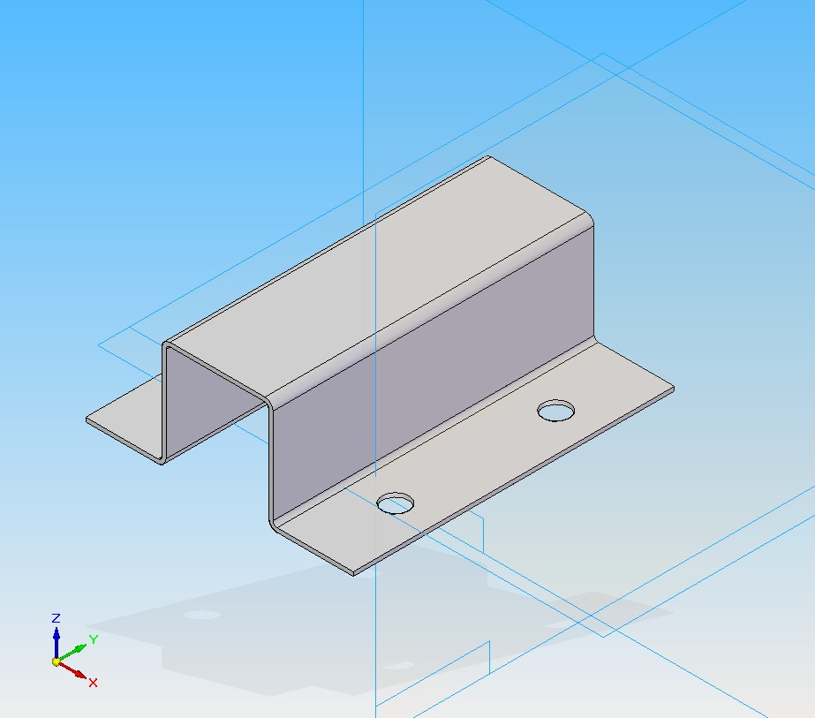
Figure 1
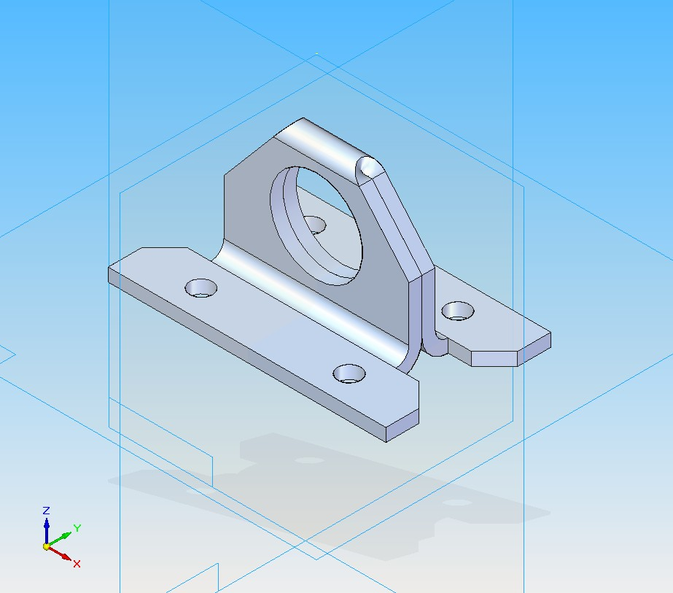
Figure 2

Wireless Controller
The wireless controller is going to be ordered from an existing supplier because of the sponsor’s desire for the system to be able to integrate into the truck’s existing power locks if equipped. The system is the Autoloc KL400; each system comes with two key fobs and has 4 channels so the existing power door locks can also be controlled. This is accomplished through the code learning capabilities of this particular system. This system also used Code Rolling Technology which adds another level of security. This technology allows millions of codes to be produced and transmitted so the same code is never used twice. The controller can be wired into and control numerous solenoids by use of relays. Schematics and wiring diagrams will be provided later.

Concept Ideas

Initial
There were three different categories of ideas as first overlook of the given problem. The three main concepts were to actuate the existing manual system of Altec term as the ‘linear concept’. The basis of this idea was to move the existing bar with the use of a strong solenoid to the locked position. When reaching the end of the travel a locking device would catch the bar and keep it locked until it was released by a second smaller solenoid. The bar is spring loaded so that upon release of the catch the bar will return to the open position. Manual operation of this concept would be done through the use of an access panel added to replace the obtrusive handle of the original system. Next, was to take the existing system and change the direction of locking motion to rotate into the latches instead of the sliding motion of the original design. This design was termed the ‘rotational concept’. This system would function by using a electric motor to rotate a spring loaded bar using a catch to lock the system into the closed position a solenoid would release the catch. The manual override would be accomplished through the use of a special key similar to the locking lug nuts on cars. The key would be attached to a handle and inserted through a weatherproofed hole in the box. Last was the idea to add an additional lock to each door that would lock simultaneously being termed ‘per door’. This lock would be very similar to have a car door lock works it would have a separate key for the lock itself and be actuated by a solenoid.

Competing
Through a democratic process the two ideas that stood out where the linear and per door. The two systems were further pursued and more details of functionality were gathered for both. The two ideas had CAD renderings made to better illustrate the two concepts. After deciding upon these two ideas an advantage / disadvantage chart was made. Following the benefit comparison a cost analysis was carried out on the two models and a decision was made.

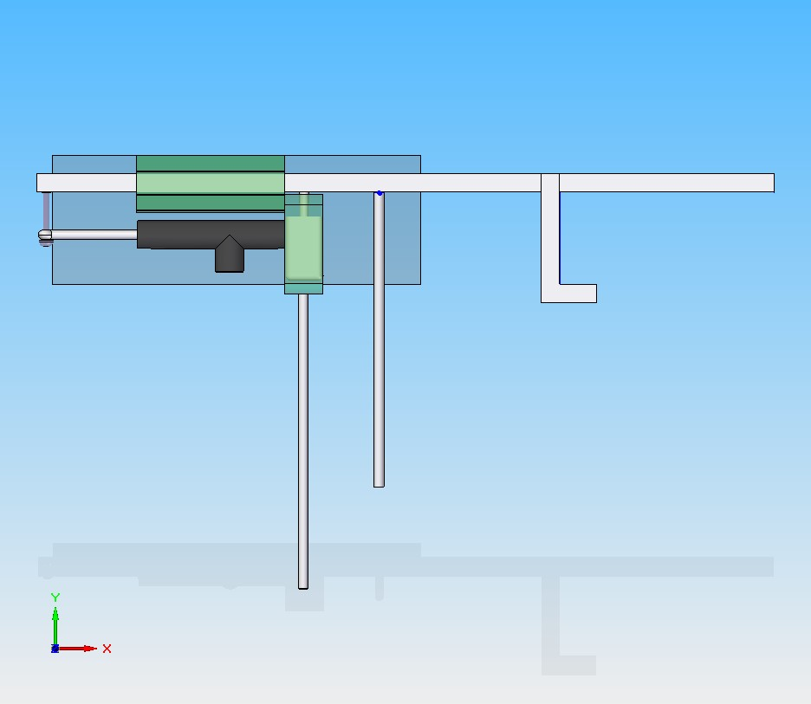
Figure 3
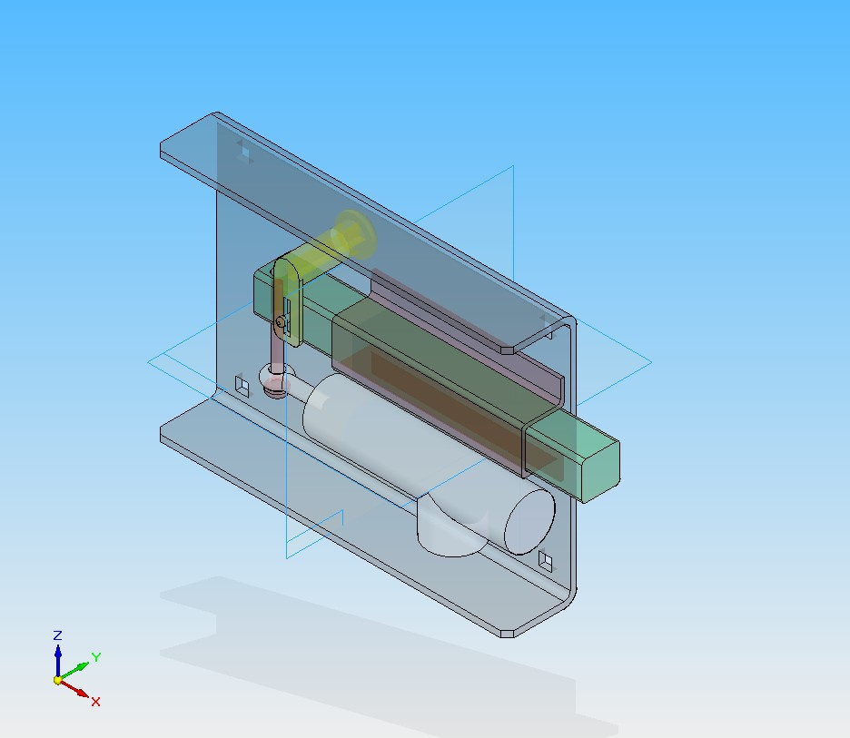
Figure 4

Benefit Comparison

Linear
Advantages
- Company has existing knowledge of installation
- Works similar to current manual system
- Smaller part count
- Simpler wiring of the solenoids
- Potentially cheaper

Disadvantages
- Does not work with every door setup
- Stacked doors need complicated bar additions
- Needs access panel for manual override
Per door
Advantages
- Will work potentially work with every door setup
- Stacked doors do not required complicated bar additions
- Does not need access panel
- Modular design allows for easy replacement
- Easier installation

Disadvantages
- More parts of the system could fail
- Higher part count
- Could be expensive
- Requires modification of door panel

The main concern with the two systems is function, cost, and to a lesser extent appearance. The per door has one advantage that stands out over the linear system. The idea that the per door system could work with every door regardless of its placement or design makes it an appealing option if the cost is comparable to the simpler linear concept. Next the need for an expensive access panel is removed, because each module of the per door concept will have its own keyed override. The main disadvantage is the modification of the door panel itself, which requires more working time and a different setup for the manual gang lock equipped truck bodies and the automated gang lock equipped ones. Despite this disadvantage of door modification the ability of the system to work with ever door make this our top choice if the pricing concerns are met.

Cost Analysis
The cost of each system was tabulated and is presented below.
Cost of Linear System |  | Bars | 2 | 3 | 4
Qty. | Disc. | Cost
1 | Wireless | $80.00 | $80.00 | $80.00 | $80.00
1 | Bar Solenoid | $44.00 | $88.00 | $132.00 | $176.00
1 | Latch Solenoid | $19.00 | $38.00 | $57.00 | $76.00
1 | Bar (existing sys.) | $10.00 | $20.00 | $30.00 | $40.00
2 | Springs | $1.00 | $4.00 | $6.00 | $8.00
1 | Access Panel w/ lock | $50.00 | $100.00 | $150.00 | $200.00
 |  | TOTAL: | $330.00 | $455.00 | $580.00

Cost of Per door System |  | Doors | 10 | 15 | 20
Qty. | Disc. | Cost
1 | Wireless | $80.00 | $80.00 | $80.00 | $80.00
1 | Solenoid | $10.00 | $100.00 | $150.00 | $200.00
1 | Panel Lock | $7.00 | $70.00 | $105.00 | $140.00
1 | Transfer Pin | $0.25 | $2.50 | $3.75 | $5.00
1 | Case | $2.50 | $25.00 | $37.50 | $50.00
1 | Bracket | $1.00 | $10.00 | $15.00 | $20.00
1 | Bar | $1.00 | $10.00 | $15.00 | $20.00
 |  | TOTAL: | $297.50 | $406.25 | $515.00

This led us to the conclusion that the per door concept was very comparable in price if not cheaper than the linear concept. Installation time may vary between the two systems, but should not vary significantly so that one takes longer to install than the other.

Final Concept
After the benefit and cost analysis the final decision was in favor of the per door concept where an extra lock will be added to each of the doors in the system. This system brings the ability to work with every door, with a simple manual override. The drawback is that the door for truck bodies with this system will have to be modified, but since most of the truck bodies are created on a custom basis we do not believe this to be a significant problem. This is fully explained in the ‘Recommended Design Concept’ section.

Engineering Analyses
The main objective of the project itself is to create a reliable remote activated gang lock that works by the use of a remote phob. To see the actual functioning of the system a trip was made to Altec manufacturing facility where we gained a better working knowledge of the product itself. The system above all else needs to function as failure of the system would be detrimental to any design. The basic principle of the locking device is simple, but there are concerns with placement, size, and cost that need to be considered in detail to produce an automated version of the current manual design.

The design requires that an actuating device lock and unlock all the doors or bank of doors in the truck body at one time. This can be done through any desired motion as stated by the Altec representatives. As long as the doors will lock and unlock the movement of the system was left completely open. The override of the system should be hidden or inconspicuous, as there is an existing problem with people noticing the visible external lock. This visibility gives thieves an obvious indication of how to break in and where to approach their entry.

After gaining a full understanding of how and what the requirements of the system were the group moved forward with developing a new system to meet these requirements. The design process included three variations that were narrow to a single concept. Then the group moved forward with finding actual parts to compose the system from and find were to acquire all parts that need to be custom made. Altec facility can produce just about any desired sheet metal part; therefore the goal was to keep the parts within Altec’s manufacturing ability. These parts were model in Solid Edge for 3D rendering of all of the parts needed for assembly, which will allow for Altec to take the files and directing be able to produce the parts.

Economic Analysis

The current manual gang lock system has a price breakdown as follows:

PART/ASSY | DESCRIPTION | U/M | COST
1350-00005 | PIPE,STD. 1/2 DIA. X 2 | EA | 0.20
1405-50013 | ROD,1/2" C.R. LOCKING | EA | 0.60
3171-02101 | HANDLE, SECURITY LOCK | EA | 4.00
2500-51261 | BRACKET,INNER GRID | EA | 0.50
2500-51262 | BRACKET,OUTER GRID | EA | 0.50
8001-01352 | FITTING,STRAIGHT BODY CABLE | EA | 3.53
8001-01353 | LOCK NUT,STEEL CONDUIT | EA | 0.05
8001-01566 | RING | EA | 0.35
no p/n, not on BOM | gasket, t&b (18-0116) | ea | 0.12
no p/n, not on BOM | locking rod gasket (18-0117) | ea | 0.14
 |  | Total Cost | $9.99

This shows that the parts cost for the current systems is $10.00. From a cost standpoint there is not a more cost effective means to make this manual system. The need for electronic actuation makes this figure incomparable with the new design, but is being given for reference and the latch design comparison. The new latch design created by the group is ready made and cost $0.25, from a local hardware store. We imagine the cost would be slightly less when ordered in bulk by the manufacture. As is stands the current ring design cost $0.35 (bulk) and the new latch cost $0.25 (retail). The new latch will however require to be attached through four fasteners (bolts or rivets) or be welded in place as both are viable options. This will raise the cost of the latch by the need for four fasteners. As quoted by Jason bolts cost about $0.03 EA. This makes the new design cost approximately the same as the existing and solves all problems associated with the current ring design.

As there is no basis of comparison for the electronic design we sought to see if other companies offered a similar option to the automatic gang lock. Reading offers a similar system for the retail cost of $800.00 and we will use this as the basis for comparison assuming a 50% mark-up. Note readings system is incorporated into the handle of each door itself so there will be some margin for discrepancy in pricing as Altec’s system will be a stand alone product. Assuming this basis the design purposed will break even with the Reading system at the 15 door mark based on the cost of parts alone. Altec also gave a rough estimate of the desired cost to be $300.00 to $500.00.

The design purposed would need to be assembled by a single employee of Altec or be outsourced to a competent company. The unit would be modular, as it would be able to be bolted onto any door with the correct modification for the unit. It would attach through four fasters (bolts or rivets) and then the wires form the unit connected to the wires leading from the controller into the doors. This will give a simple installation and not require the lengthy and sometimes complicated bar installation.
Recommended Design Concept
Following the benefits and cost comparisons the per door concepts was chosen as the best solution to the problem set proposed by the corporate sponsor. This concept was followed through with two design possibilities.

Linear per door
This design reduces the moment created by placing the deadbolt and the solenoid side by side. It also reduces the total footprint of the lock from 35 square inches to 32 square inches. A linking pin has been cut out of the design completely, removing one step from the assembly process. The case has been reduced down to two pieces of sheet metal with two 90 degree bends, and the bracket is similarly created, with four 90 degree bends. There is a large amount of space inside the case for ease of assembly. The system will be attached with four carriage bolts and four nuts. In the future, the bracket through which the deadbolt slides and the case itself could be made into one stamped sheet metal part, if Altec has the necessary facilities. As it stands, the design can be created with the sheet metal stamping machine at Altec, simple bending operations, a drill and a hacksaw.

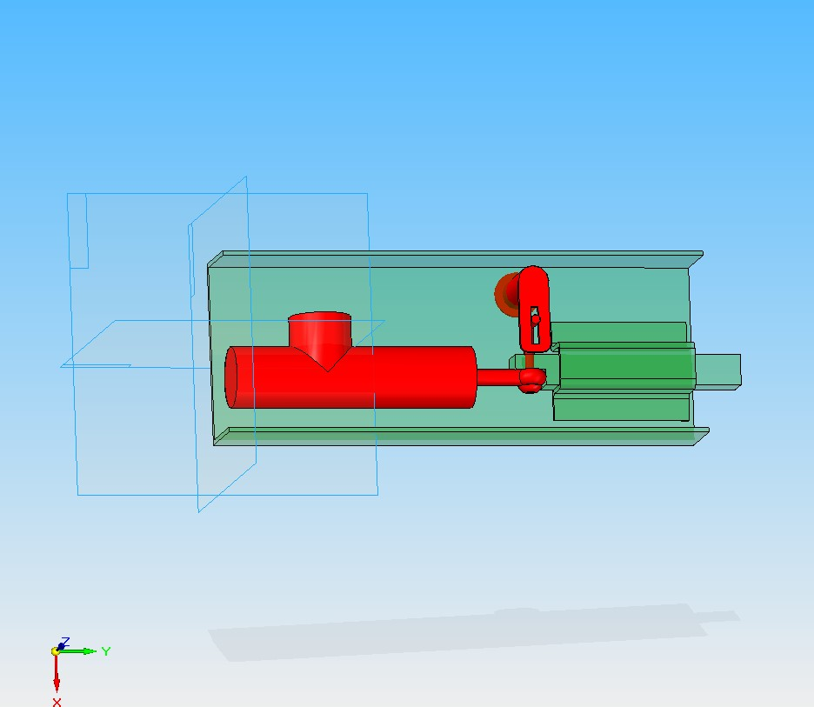
Figure 5

Rotational per door
This design allows for a small cost reduction as there are only two parts that are ordered while the rest of the parts can be made in house by Altec. A rotary motor swing a bar into a slot in the door frame that allows the door to me locked. The keyed override can be used to rotate the bar out or into the slot only working against the gearing of the motor. Obstacles in this design are that it is thicker that the sliding per door concept so it will not fit within the door itself. In addition the motor gearing is a concern so that when un-powered the key override will still be able to turn the motor.

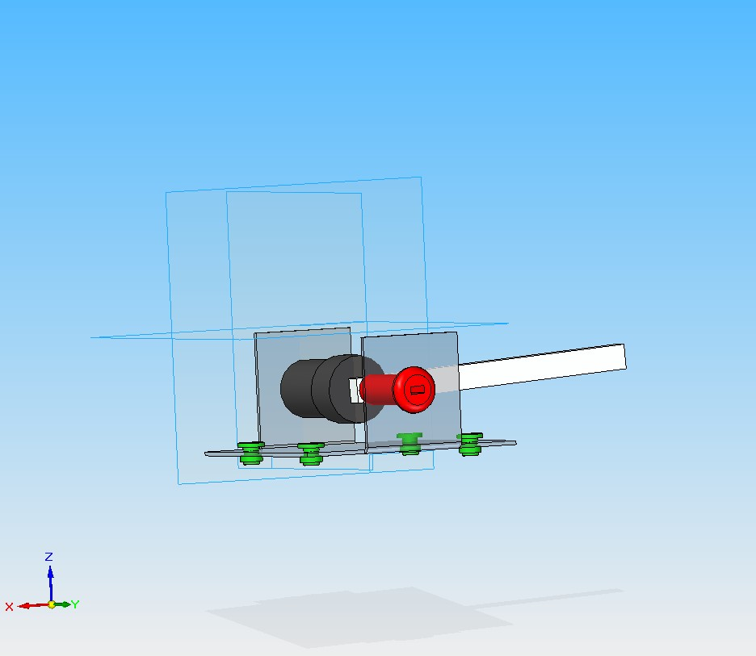
Figure 6
Conclusions
This report shows the final design concept purposed and how it will overcome the set requirements of the system. The per door concepts effectively solves the need for unlocking and locking ‘all’ doors at once, because this system truly can lock/unlock all the doors at once. The benefits of being able to be incorporated into every door design should be quite beneficial to the sponsor. As well as eliminating the hassle of installing a custom bar for each box these modular locks can be aligned simply and quickly on any door design to accept the installation. It also gives the truck a new clean appearance that was not provided by the manual system. The hidden locks also look more professional and add to the clean look of the body. The purposed design meets all given requirements of the sponsor.

