Final Project Report

ELEC7250 Spring 2006

Instructor: Professor Vishwani D. Agrawal

Fan Wang
Dept. of Electrical & Computer Engineering
Auburn University

April 29, 2006
1 Introduction 2
2 Project Objectives 2
3 Project Process 3
3.1 Circuit Description 3
3.2 Compiler Design 3
3.3 Logic Simulator Design 4
3.4 Diagnose the design error 5
5 Conclusion 8
6 References 8

1 Introduction
Currently, the CAD tools are very important for VLSI design because they handle the complexity and optimize the tradeoffs. The logic simulator is one of basic part to simulate the functionality of a circuit based on specific input. The complexity of logic simulator in sequential circuit is obvious. There are many research papers on this part in 1990s. Also, the compiler design in VLSI is a complex issue. Competition in the market is a driving force for CAD designer to make their tools much more convenient and effectively used by the users.

2 Project Objectives
This VLSI testing final project aimed at writing a program to analyze the circuit description; writing a compiler to flatten hierarchical bench format circuit and generate simulation table; use specific algorithm to design a logic simulator for combinational circuit and try to diagnose the design error.

3 Project Process

3.1 Circuit Description
Develop a hierarchical bench format for circuit description. Bench is a circuit description language used to describe the ISCAS85 and other benchmark circuits. Bellowing is the bench format for one bit full adder:

#FA , 1- bit full adder
#3 inputs
#2 outputs
#0 inverters
#5 gates
INPUT(ci)
INPUT(ai)
INPUT(bi)
OUTPUT(sumi)
OUTPUT(Ci+1)
1=XOR(bi, ai)
2=AND(ai, bi)
3=AND(ci, 1)
Sumi=XOR(1, ci)
Ci+1=OR(3, 2)
End

Bench format:
1. # :followed by the overall circuit description
2. INPUT and OUTPUT define the inputs and outputs pins.
3. XOR, AND, XOR est. are the primitive gates ,
1=XOR(bi, ai) equals 1=(bi and ai) and bi is the first input, ai is the second input of the and gate.

3.2 Compiler Design
The compiler has two functions: 1. for hierarchical bench format, the compiler can flatten it. 2. For a flattened bench format, the compiler can generate simulation table. For convenience, the implementation of this part is by Matlab because Matlab has imbedded function to read the netlist file line by line and generate the simulation table as efficient as we want for further use. Here is an example of simulation table:

Simulation table Example
(generated by Matlab)
INPUT: 0
INPUT: 1
INPUT: 2
OUTPUT: 15
OUTPUT: 16
Gatetype: XOR
Gatename: XOR1
Fanin_List: 2 1
Fanout_List: FA_1_1
/***************************/
Gatetype: AND
Gatename: AND1
Fanin_List: 1 2
Fanout_List: FA_1_2
/***************************/
Gatetype: AND
Gatename: AND2
Fanin_List: 0 FA_1_1
Fanout_List: FA_1_3
/***************************/
Gatetype: XOR
Gatename: XOR2
Fanin_List: FA_1_1 0
Fanout_List: 3
/***************************/

Simulation Table:
Simulation Table contains primary inputs (INPUT: )and primary output (OUTPUT: ), and the information of the gates in this circuit: Gatetype, Gatename, Fanin_List and Fanout_List. Notice every segment is separated by one space; this format is convenient for C program to read.

3.3 Logic Simulator Design
The function of logic simulator is to get vectors at primary inputs of the circuit and propagate the value from primary inputs to primary outputs for combinational circuit. The algorithm of implement logic simulation is bellowing:

- Read vector to the PI
- Initialize all the PO, Internal nodes as unknown states (-1).
- Propagate the value from PI to PO based on gate type of each gate.
For each unknown internal node, search the whole gates and do the propagation.
If all the POs get value, step 3 ends. Compare the simulated value with the
expected outputs value, see whether there are some design errors in the circuit.
- Repeat 1 to get the next vector until all the vectors are simulated.

Figure 1 shows the steps of logic simulation:
Figure 1

Comments:
The search based algorithm:
- Time complexity is O($n^{2}$), N: the number of gates. The worst case is if all gates are listed in bench format in reverse order. The time complexity is
O(The depth of circuit X $n^{2}$)
- If we consider the levelization of the circuit, the time complexity will be :
O( n )

For a big circuit, if we levelize it first and then do the logic simulation, we can save much time compared search algorithm. Also, better algorithm can be used: link list based algorithm. If we use link list to build up the circuit structure, we can use pointers to show the connections between each gates. Once one gate is simulated we delete this gate from the link list. This algorithm will be much efficient than search based algorithm.

3.4 Diagnose the design error
Modem process technologies and design tools allow the realization of very large and complex systems on a single chip. Because of the increased system complexity, defect diagnosis is necessary to improve the IC manufacturing yield. Logic defect diagnosis is to locate the defect spots in the integrated circuits on a system. Based on the analysis, diagnosis techniques are classified into two main categories: (1) cause-effect analysis and (2) effect-cause analysis. The cause-effect analysis, attempts to build a fault dictionary that stores the faulty response of every modeled defect in the circuit under diagnosis. During the diagnosis process, the output responses are compared with the stored syndromes in the fault dictionary. The effect-cause analysis, try to locations of faults by observing the faulty behaviors and the fault-free behaviors.
In this project, I try to diagnose the design error by find the sensitized path segmentation from the PI (primary inputs) to PO (primary outputs) and trace back to the error PO to PI. The algorithm is bellowing:

- Check PO, see whether the PO get values as expected
- If error happens:
a. To trace back from the error PO to PI to check the paths (PATH 1)
b. To check which path is sensitized by the vector from PI to PO (PATH 2)
PATH2 = path_1 ∩ path_2 …∩ path_i (path_i means the paths set which are sensitized by PI_i)
- The error is on the path : PATH 1 ∩ PATH2

Figure 2 shows an example.
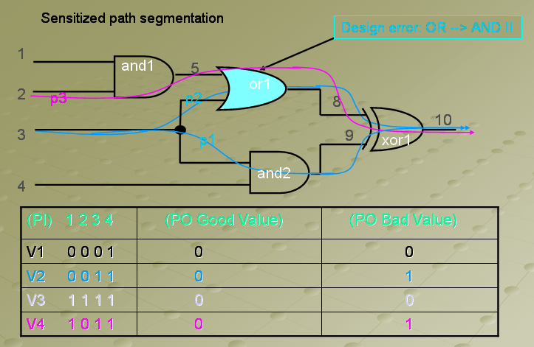
Error detected path
E1 detected path
Figure 2

Based on different input vectors we noticed that the value of PO is sometimes different from expected value. So we detected the there is design error in this circuit. We pick up some failing vector and good vectors to diagnose the error. Because there is only one PO, so the step 2.a, the trace back paths (PATH1) will contain all the paths of this circuit. Then, we do the sensitization path tracing, the V1-> V2, cause the error occurring in PO. Comparing the V1 and V2 we find the PI 3 changed value. So, in this case we can definitely say the error is on the paths which are sensitized by PI 3. So we trace from PI 3 to PO, we get the path p2, p1. At the same reason, from V3->V4 we get path p3.
So, PATH2 = (p1 + P2) ∩ (P3). The design error is on the paths: PATH1 ∩ PATH2 = E1.
In this diagnose algorithm, first we need find the specific vectors V_error which make the error occur on PO_i and V_good which can’t observe value at PO_i. If for PO_i, all vector are failed, we can’t derive sensitized paths in this case. Also, if vector V1-> V2 make PO_i error free to error present, we can’t say the sensitized path is error free. So, we need to store all the vectors and simulated outputs in logic simulation for diagnosis use. This method uses less memory compared fault dictionary based method. But, for big circuit, we first need to find the minimum hamming distance vectors which cause PO changed, this algorithm is not so convenient for big circuit.

4 Results
First, I use logic simulator to simulate the 4-bit ripple full adder circuit using exhaustive vector sets. The result is in figure 3.
Figure 3

The second experiment is simulate the CPU time vs. number of gates for ISCAS’85 circuits each simulated for 1,000 random vectors. See Figure 4. We can see the time complexity is exponentially when the number of gates increases.

5 Conclusion
From this project I improved my programming skill and understand the complexity in VLSI testing. From the result listed above, the logic simulator is successfully implemented by C program but there is much redundancy in my algorithm which can be improved. Also, the logic diagnosis is not fully implemented. Finding the minimum hamming distance vectors which provide faulty PO in VLSI is complex. There are much more better algorithms can be applied in diagnosis.

6 References
1 Essentials of Electronic Testing for Digital, Memory and Mixed-Signal VLSI Circuits by Bushnell and Agrawal, Springer, 2000.

2 S. K. Lu, J-L Chen, C. W. Wu, “Combinational Circuit Fault Diagnosis Using Logic Emulation”, Circuits and Systems, 2003. ISCAS '03. Proceedings of the 2003 International Symposium on Volume 5, 25-28 May 2003 Page(s):V-549 - V-552 vol.5

