Organization Website Update Guide

Click the heading to go to that section

Update Profile 2
Upload and Update Picture 5

For questions or assistance, contact:
Jenny Sconyers, Student Initiatives Administrator
jenny.sconyers@auburn.edu
334-844-2510

Update Profile

WARNING: Do NOT update any fields in the profile other than the following:
- Organization Name
- Organization Abbreviation
- Organization Category
- Organization Related Major
- Profile Picture
We cannot track important information if you update fields other than these.

- Log in to Cascade: https://auburn-admin.cascadecms.com/
  - You may need to be logged onto a university computer or use VPN to access

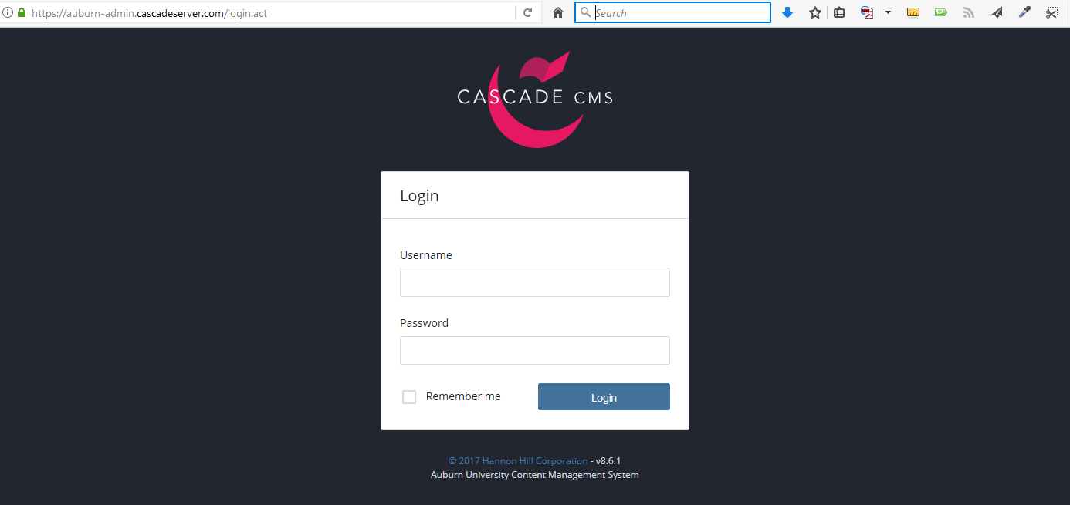

- Use your organization’s unique login information provided to you
  - If you are a new organization or lost it, email griffgj@auburn.edu to obtain it.

- To edit your profile information, click the site name (Samuel Ginn College of Engineering)

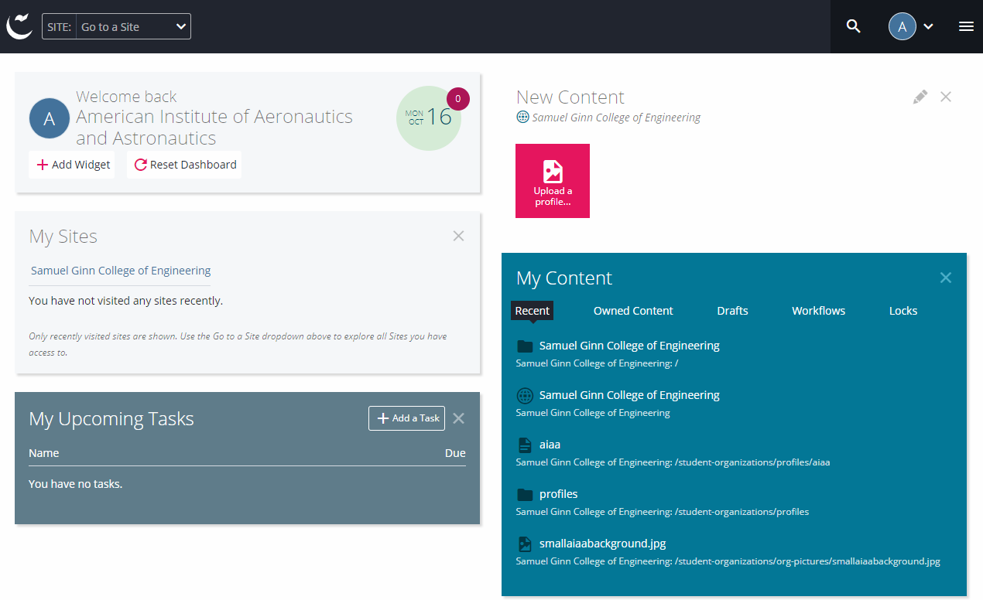

- Click on the folder “student-organizations” then “profiles” to expand folders and display your profile.

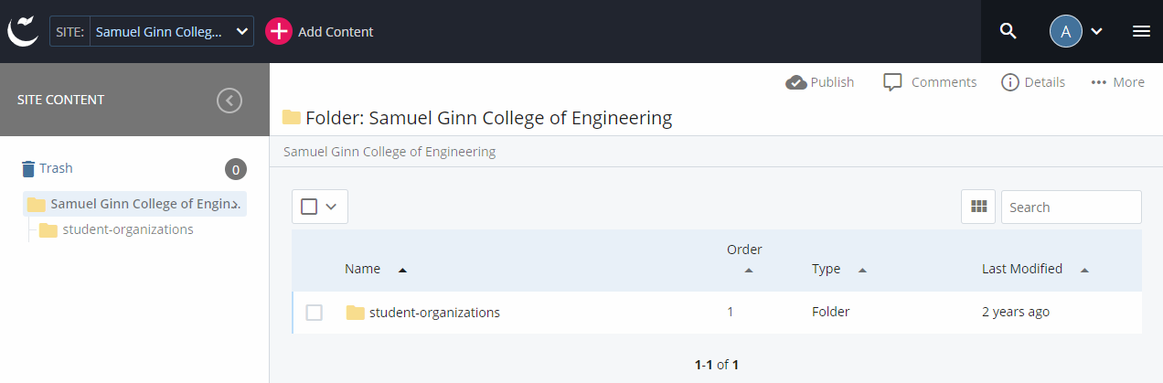

- Now click on your profile and click the “Edit” icon

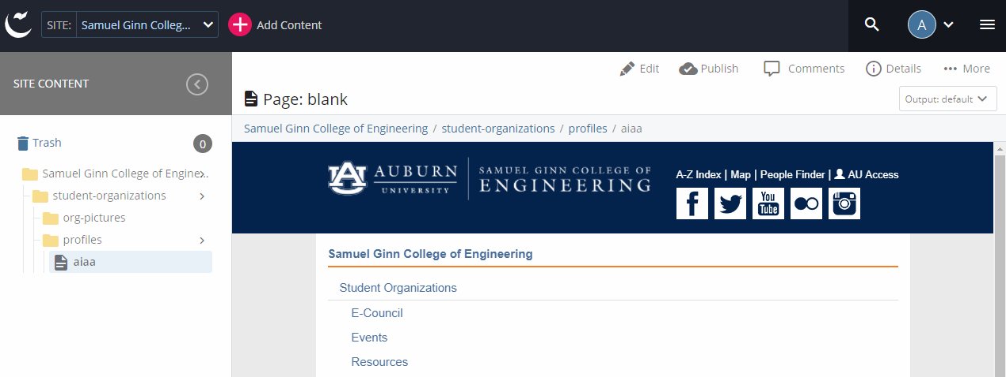

- Fill out all required fields and as many optional fields as you desire
  - In order to update picture, please see instructions below
  - Be sure to hit submit two separate times to save changes (once to submit form, once to accept spelling errors, if any)

Note: The preview within Cascade you see will be reflected on the public CoE site within 24 hours (ie updates are not made immediately public).

Upload and Update Picture

- Picture recommendations
  - Displays best as 1100px x 600px
  - For a good, free online photo editor, try: pixlr.com

- Upload picture – Select “Add Content” -> “Upload a profile picture”

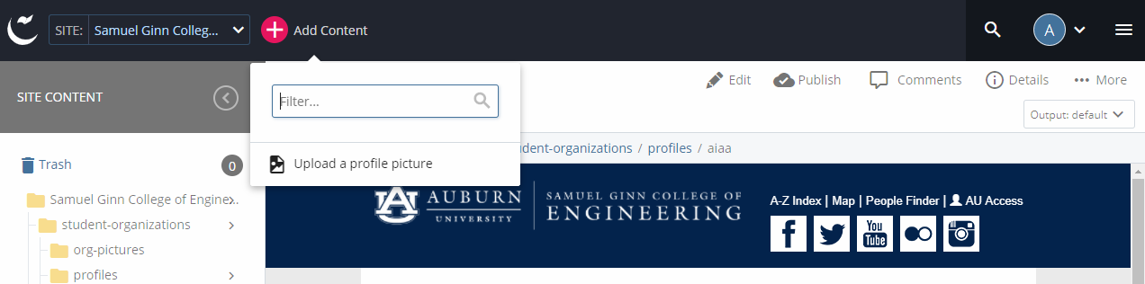

- Either drag a picture into the “Drop file here” area or click “Choose File” to select a picture to upload. Click submit when finished.
  - Rename picture if desired in “File Name” box
  - Picture will be uploaded to proper directory automatically – do not change “Placement Folder” address

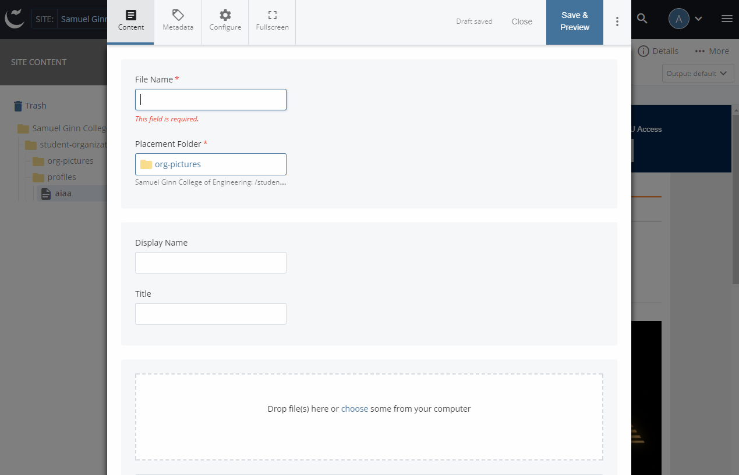

- Edit profile form (see instructions above) and select picture just uploaded. Submit form when finished.

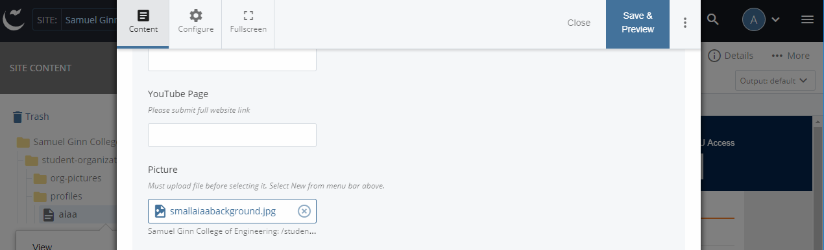

Note: The preview within Cascade you see will be reflected on the public CoE site within 24 hours (ie updates are not made immediately public).

